**Can adopting seasonal grazing to protect grassland degradation also conserve the microbial communities?**

Muhammad Usman, Fujiang Hou*

State Key Laboratory of Herbage Improvement and Grassland Agro-ecosystems; Key Laboratory of Grassland Livestock Industry Innovation, Ministry of Agriculture and Rural Affairs, Engineering Technology Research Center for Ecological Restoration and Utilization of Degraded Grassland in Northwest China, National Forestry and Grassland Administration, College of Pastoral Agriculture Science and Technology, Lanzhou University, Lanzhou 730020, China

**\*Corresponding author:**

***E-mail address:*** [cyhoufj@lzu.edu.cn](mailto:cyhoufj@lzu.edu.cn)

**Abstract**

**Application:** Seasonal grazing (SG) is applied to protect the grassland degradation. We aimed to study the microbial community under seasonal yak grazing to study how the changes in grazing regime would impact the diversity and composition of the microbial community.

**Introduction:** Grasslands cover over 40% of the terrestrial ecosystem and are among the most vulnerable ecosystems due to climate change and anthropogenic activities (Liu & Lu, 2021). Livestock grazing is the largest land use of the grassland (Yao et al., 2023). Grazing changes the soil's physical and chemical properties by trampling, removing plant biomass, and the addition of feces and urine. To protect the grassland ecosystem, several strategies are adopted such as stripped grazing, separating paddocks for different seasons, and adjusting the stocking rate to provide rest to the grassland for recovery (Khalil et al., 2019). Soil microbial communities are an important component of the ecosystem that runs the biogeochemical cycle and keeps the nutrient balance. The changes in the environment (such as rainfall and temperature, animal activity) and physiochemical properties of soil (such as pH, soil carbon, nitrogen, etc.,) can highly influence the diversity, composition, and functioning of soil microbial community (Yao et al., 2023).

**Aim and Methodology:** Seasonal yak grazing has been applied in the alpine meadows along with two other grazing regimes including all-year grazing (A-YG) and no grazing (NG), at Maqu Research Station of Lanzhou University in Maqu County, Gansu Province, China (33.96°N, 101.83°E; 3500 m a.s.l.) since 2016. We sample the soil (composed of five cores) during the peak growing season from each season’s grazing pastures (three replicates). The bacterial and fungal communities’ analyses were carried out by standard protocols of Majorbio Bio-Pharm Technology Co. Ltd., (Shanghai, China) by using 338F and 806R primers for bacteria and ITS1 and ITS2 primers for fungi. The online platform of Majorbio Bio-Pharm Technology was used to determine the microbial alpha diversity (Shannon index) and beta diversity via Principal Co-ordinates Analysis (PCoA) using the Bray-Curtis dissimilarity matrix.

**Results:** The bacterial and fungal alpha diversity (Shannon) was observed to be higher at A-YG and NG than SG. The SG decreased the alpha diversity of microbes in alpine meadows but the change was not significant (Fig. a & b). The grazing changed the beta diversity of both bacteria and fungi (*p*<0.01) (Fig. c & d). The bacterial and fungal bacterial communities of summer grazing were clustered separately in PCoA. The composition of bacterial and fungal phyla had a different response to the grazing. The bacterial phyla did not show significant variation in response to the different grazing practices (Fig. e). The differential biomarker taxa in the bacterial community were 131 with the highest in A-YG (39) followed by autumn (26), summer (24), winter (17), NG (14), and spring (11). On the other hand, the fungal community composition was highly affected by the changes in grazing. The Ascomycota were the highest in soil grazed during summer and lowest during the winter season. Basidiomycota, on the other hand, was highest in winter and lowest in summer and all-year grazing pasture (Fig. f). In the fungal community, 89 differential biomarkers texa were observed, with the highest in NG (31) followed by autumn (25), A-YG (13), summer (12), spring (5), and winter (3). Livestock grazing changes the soil chemistry and plant community resulting in changes in the microbial richness and diversity in soil (Ma et al., 2019). Warm and cold grazing both change the composition of bacteria and fungi differently as different taxa respond differently to changes in environment resulting in different diversity responses during different seasons of grazing (Zhang & Fu, 2021). Livestock grazing has a significant effect on the beta diversity of bacteria and fungi than the alpha diversity (Jing et al., 2023). Ma et al. (2022) reported that seasonal grazing has no significant effect on the alpha diversity of bacteria and fungi and the overall ecosystem.

**Conclusion:** Based on the findings, we conclude that A-YG increased the diversity which can change the overall functionality of the grassland ecosystem. SG also alters the microbial community significantly and might lead to changes in the ecosystem and loss of biodiversity. Other studies support that seasonal grazing might be appropriate for protecting grassland biodiversity. Further in-depth studies with a large sampling area and diverse grasslands understand how seasonal grazing affects the grassland ecology.

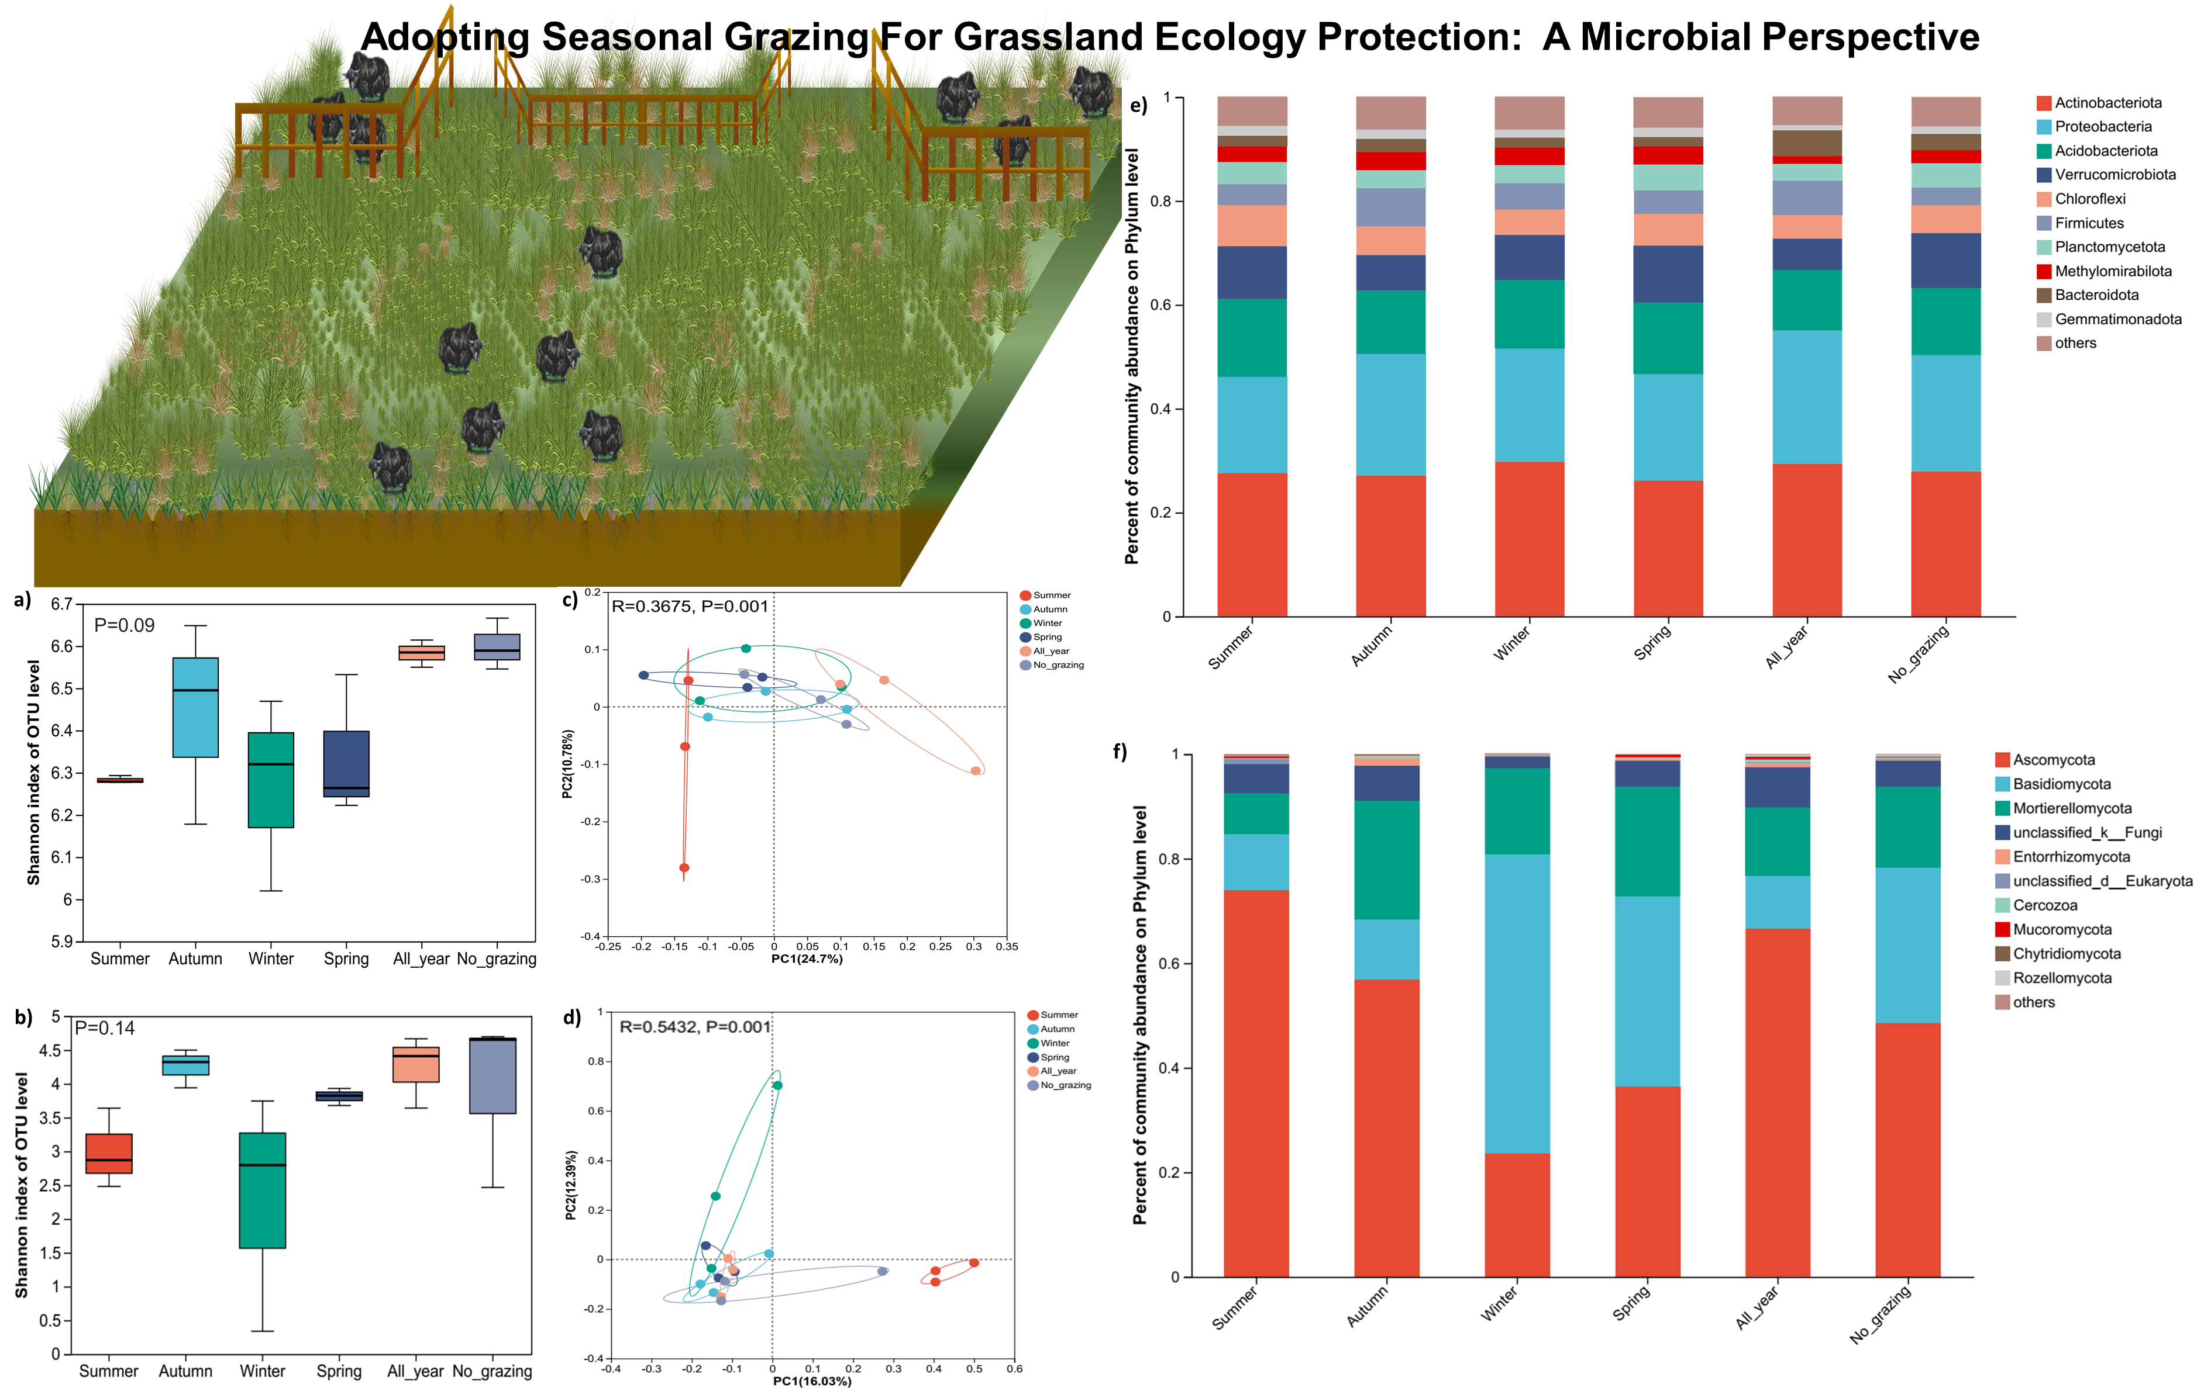

**Fig.** Effect of seasonal, all-year, and no grazing on the bacterial and fungal alpha diversity (a-b), beta diversity (c-d), and community composition (e-f) in alpine meadows.

**Acknowledgments**

This study was conducted with the support of the Research Fund for International Young Scientists, National Natural Science Foundation of China (RFIS-32250410308).

**References**

Jing, L.H., Mipam, T.D., Ai, Y., Jiang, A., Gan, T., Zhang, S.H., Liu, J.Q., Tian, L.M. 2023. Grazing intensity alters soil microbial diversity and network complexity in alpine meadow on the Qinghai-Tibet Plateau. *Agriculture Ecosystems & Environment*, **353**.

Khalil, M.I., Francaviglia, R., Henry, B., Klumpp, K., Koncz, P., Llorente, M., Madari, B.E., Muñoz-Rojas, M., Nerger, R. 2019. Strategic management of grazing grassland systems to maintain and increase organic carbon in soils. *CO2 Sequestration*, 1-20.

Liu, Y.Q., Lu, C.H. 2021. Quantifying Grass Coverage Trends to Identify the Hot Plots of Grassland Degradation in the Tibetan Plateau during 2000-2019. *International Journal of Environmental Research and Public Health*, **18**(2).

Ma, C.H., Hao, X.H., He, F.C., Baoyin, T.G., Yang, J.J., Dong, S.K. 2022. Effects of seasonal grazing on plant and soil microbial diversity of typical temperate grassland. *Frontiers in Plant Science*, **13**.

Ma, X.Y., Zhang, Q.T., Zheng, M.M., Gao, Y., Yuan, T., Hale, L., Van Nostrand, J.D., Zhou, J.Z., Wan, S.Q., Yang, Y.F. 2019. Microbial functional traits are sensitive indicators of mild disturbance by lamb grazing. *Isme Journal*, **13**(5), 1370-1373.

Yao, Z.Y., Shi, L.N., He, Y.C., Peng, C.J., Lin, Z.R., Hu, M.A., Yin, N., Xu, H.K., Zhang, D.G., Shao, X.Q. 2023. Grazing intensity, duration, and grassland type determine the relationship between soil microbial diversity and ecosystem multifunctionality in Chinese grasslands: A meta-analysis. *Ecological Indicators*, **154**.

Zhang, H.R., Fu, G. 2021. Responses of plant, soil bacterial and fungal communities to grazing vary with pasture seasons and grassland types, northern Tibet. *Land Degradation & Development*, **32**(4), 1821-1832.