Chance of nil returns: a novel indicator to measure the changing impact of climate volatility on grassland productivity and support on-farm decisions
Application: The message that our climate is becoming more volatile is often communicated to farmers in a confusing and inactionable manner. To support proactive climate adaptation, this study proposes a novel indicator of pasture growth volatility that is clear, transparent and directly usable for on-farm decision making.
Introduction: As with many temperate grassland regions in the world, ruminant production in Northern Ireland is predominantly pasture-based, wherein 92% of the farmed land area is currently classified as grassland. Increasing occurrences of extreme weather events and erratic weather patterns is therefore likely to have a substantial impact on grassland productivity and its consistency, with farmers repeatedly advised to ‘prepare’ for climate change. However, the majority of these communications remain ambiguous about what the ‘preparation’ actually entails, creating a sense of anxiety and mistrust within the farming community. The present study was designed as a measure to overcome this issue.
Materials and methods: We employed AFBI GrazeGro pasture growth model (Barrett et al., 2005) to predict the daily grass growth rates for the whole of Northern Ireland over a 200-year period (1900-2100) under UK Met Office UKCP18 (RCP8.5/HadGEM3) climate change projections (Met Office, 2019). The model was pre-calibrated with 20-year controlled plot trial data, originating from AFBI Hillsborough (Co. Down) and CAFRE Greenmount (Co. Antrim), for a reseeded pasture dominated by perennial ryegrass (Lolium perenne) on a moderately drained soil. Mirroring the typical grazing management on commercial farms in the study region, the baseline model was run under a 10-way split nitrogen fertilisation, totalling to 270 kg N ha⁻¹ year⁻¹, each following a simulated 21-day rotational grazing cycle. Following the initial run, a similar task was repeated for 10 more iterations, but each time removing one of the 10 fertilisation events to quantify the marginal grass yield (kg DM ha⁻¹) attributable to that particular event. Once all outputs have been collated, fertilisation events associated with < 200 kg DM ha⁻¹ of marginal grass yield were marked as ‘nil return events’, on the basis that the investment was unlikely to have been fully rewarded. Finally, the entire procedure was repeated for all 15 sets of UKCP18 projections (i.e. 3000 annual weather patterns), to account for uncertainty with respect to both long-term trend and short-term volatility.
Results: The baseline (fully fertilised) model predicted a substantial (~2 t DM ha⁻¹ year⁻¹) increase in the expected annual yield between 2024 and 2100; however, the yield volatility also increased as indicated by the wider range of the 95% confidence interval (Figure 1). Within each season, grass production in early spring and late autumn (where the current limiting factor is primarily the low temperature) demonstrated a clear pattern of higher growth rates into the future, whereas that in mid-summer was found to become more erratic and often lower than the current average (figure not shown). The analysis of marginal yield suggested that the occurrences of nil returns will become substantially more common as a result of climate change, with the probability increasing more than threefold (5.3% to 16.7%) between 2024 and 2100 (Table 1). Cost-effective climate adaptation strategies, such as model-assisted adaptive fertilisation programmes and greater incorporation of legumes and other non-grass species (Hopkins & Del Prado, 2017), are therefore likely to be the key to minimise the economically unfavourable use of fertilisers.
Conclusions: In order to encourage actions and perseverance towards climate adaptation by farmers, the clarity of messages matters. It is hoped that the concept developed herein can be utilised as an effective communication tool to make climate science feel more relevant to the farming community.

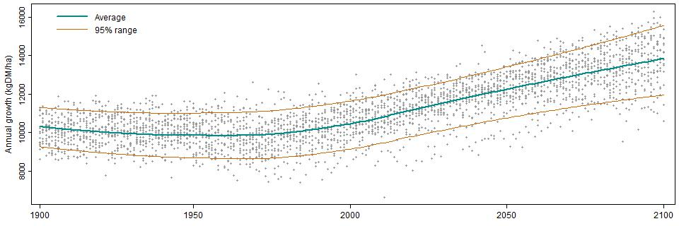
Figure 1. Annual yield prediction (1900–2100) for Northern Ireland

Table 1. Probability of ‘nil returns’ to fertilisation events
Marginal yield | 2024 | 2100
< 100 kg DM ha⁻¹ | No case | 2.7%
< 200 kg DM ha⁻¹ | 5.3% | 16.7%
< 300 kg DM ha⁻¹ | 22.0% | 30.7%

Acknowledgements: Funding sources are withheld to ensure the blind review.
References:
Barrett et al., 2005. European Journal of Agronomy 23: 37-56.
Hopkins & Del Prado, 2017. Grass and Forace Science 62: 118-126.
Met Office, 2019. UKCP18 Science Overview Report.

