**Application**

Presently, the beef carcass carries the entire environmental loading with all non-carcass ~offal components avoiding the allocation process**.** This disadvantages the ‘carcass’ as it unfairly carries the entire emission burden.

**Introduction**

Global demand for beef and animal-derived protein continues to rise. In addition to the dressed carcass, animal non-carcass components or co-products are also produced, which includes edible co-product meats that have a nutritional value comparable to lean meat (Soladoye et al., 2022). Most life cycle analysis studies, to date, have not considered the valuable contribution of animal co-products when calculating greenhouse gas (GHG) emissions or the additional protein generated in the co-product components and subsequently allocated all emissions directly to the final beef carcass (Dominguez Aldama et al., 2023). Using data generated from a dairy-beef cattle experiment conducted at Teagasc Grange Research Centre, the objectives of this study were to augment the existing Grange Dairy Beef System Model (GDBSM) and subsequently partition total animal GHG emissions into carcass and non-carcass using the economic allocation approach.

**Materials and Methods**

Sixty-six male spring-born Aberdeen Angus × Holstein-Friesian calves were sourced from commercial farms and reared in a standard calf-rearing system at Grange Research Centre. Animals were rotationally grazed on predominantly perennial ryegrass swards as one group. After 86 days at pasture, steers were weighed and blocked on weight and date of birth and assigned to one of three grazing treatments for 112 days: (i) grazed grass only (GG-0), (ii) GG plus 1.5 kg concentrate per animal daily (GG-1.5), and (iii) GG plus 3.0 kg concentrate (GG-3.0). At the end of this period, half of steers from each grazing treatment were slaughtered (mean age, 18 months - Early-Finish: EF), and the remainder were accommodated indoors and offered *ad libitum* concentrates for 89 days following which they were slaughtered (mean age, 22 months Late-Finish: LF-0, LF-1.5 and LF-3.0). Post-slaughter, individual animal hide, fore and hind feet, liver, head, lungs, kidneys, heart, empty reticulo-rumen and intestines, as well as perirenal and retroperitoneal fat were weighed. Overall, these organs accounted for 61% of the total differential between the mean pre-slaughter weight and the mean carcass weight. The weight of blood, tail, tongue, spleen, gall bladder and ‘full’ reticulo-rumen (25%) and miscellaneous non-carcass components (i.e. tonsils, brain, spinal cord, scrotal sack, pizzle, pharynx, water, esophagus and ‘other’; 14%) was estimated based on previous research (e.g. McGee et al., 2008; Campion et al., 2009). These miscellaneous non-carcass components were classed as non-edible and excluded from the allocation process. The data collected was incorporated into the Grange Dairy Beef System Model (GDBSM; Kearney et al., 2022) to include an emission allocation sub-model, incorporating the contribution of non-carcass components. The economic value of the edible non-carcass co-product components was then determined using international market price data published by the United States Department of Agriculture for 2022 (USDA, 2023). These prices, denominated in US dollars, were converted to euros (€) using published exchange rates, and the price per kg for each co-product was determined. These prices were multiplied by the measured or estimated weights of each co-product component to provide a total value per component and a combined carcass value. This exercise then allowed an economic allocation to be performed to assign the proportions of GHG emissions, in line with ISO (2006) guidelines, to the co-products. The allocation was obtained by expressing the monetary value of the non-carcass components, and expressing it relative to the total monetary value (carcass plus non-carcass) as determined by the price obtained upon slaughter within the model.

**Results**

The mean value of non-carcass components for the EF animals was €162 and for the older, heavier LF animals was €198 (Table 1). The total GHG emissions allocation on a per animal, carcass and non-carcass (co-products) basis are presented in Figure 1. As a proportion of total GHG emissions per finished animal carcass to non-carcass components showed a similar mean allocation ratio of 85:15 across the six treatments. In other words, approximately 15% of the animal emission allocations were attributable to the non-carcass components. This process does not increase nor reduce emissions per animal but merely reflects a fairer distribution for the valued non-carcass components.

|  |  |  |  |  |  |  |
| --- | --- | --- | --- | --- | --- | --- |
|  | Pasture supplementation | | |  | Finishing strategy | |
|  | GG-0 | GG-1.5 | GG-3.0 |  | Early | Late |
| *Economic allocation* |  |  |  |  |  |  |
| Beef price1 (€/kg) | 4.73 | 4.72 | 4.78 |  | 4.43 | 5.07 |
| Carcass value (€) | 1201 | 1225 | 1255 |  | 1025 | 1429 |
| Non-carcass value (€) | 176 | 180 | 182 |  | 162 | 198 |
| Combined total (€) | 1377 | 1405 | 1437 |  | 1187 | 1627 |

1Beef price varied according to carcass grading (conformation and fat) and seasonality (date of slaughter)

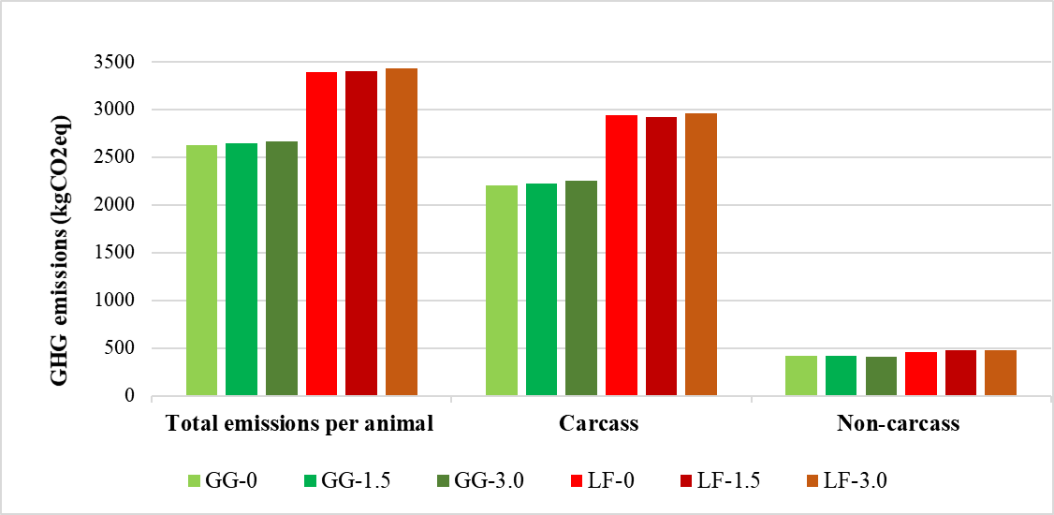

**Fig. 1.** Emission distribution for carcass and non-carcass components expressed relative to total emissions per animal

**Conclusion**

In the current study, the economic allocation distributed emissions on a mean 85:15 ratio across the six individual treatment groups. The non-carcass component is a substantial share of the total animal emissions. To enhance beef sustainability in a bio-circular economy, policymakers should consider the novel practice of allocating emissions to co-products as non-carcass co-products have avoided this process. Doing so would offer a much fairer distribution pattern.

**References**

Campion, B., Keane, M.G., Kenny, D.A., Berry, D.P., 2009. Livest. Sci. 126, 87–99.

Dominguez Aldama, D., Grassauer, F., Zhu, Y., Ardestani-Jaafari, A., Pelletier, N., 2023. J. Cleaner Prod., 421, 138488

ISO 2006. ISO 14040:2006, ISO. Available at: https://www.iso.org/standard/37456.html (Accessed: 19 January 2024).

Kearney, M., O’Riordan, E.G., McGee, M., Breen, J., Crosson, P., 2022. Agric. Systems 203, 103530.

McGee, M., Keane, M., Neilan, R., Moloney, A., Caffrey, P., 2008. Irish J. Agric. Food Res. 47, 41-51.

Soladoye, O., Juárez, M., Estévez, M., Fu, Y., Álvarez, C., 2022. Comprehensive Reviews in Food Science and Food Safety, 21, 1439-1461.

USDA (2023) Ams_2829.Pdf [online], By-Product Drop Value (Steers) (Cattle) (NW_LS441 / 447), available: https://www.ams.usda.gov/mnreports/ams_2829.pdf [accessed 29 Nov 2023].