Effect of feeding brown seaweed to dairy cows on the ammonia emissions from slurry during storage
A. DABIRI^{1, 2, a}, K.R. BARAL², T. GILFEDDER², J. MCILROY², K. BARNES¹, S. HUWS¹, T. YAN², X. CHEN², M. HAYES³, K. THEODORIDOU¹

¹Queen’s University Belfast, Belfast, UK.
²Agri-Food and Biosciences Institute, Hillsborough, UK.
³ Teagasc Food Research Centre, Ashtown, Dublin, Ireland.
ª adabiri01@qub.ac.uk

Application: Feeding brown seaweed to dairy cows reduces ammonia (NH₃) emissions from slurry during storage.

Introduction: Agriculture, particularly dairy cow farming is a major contributor to NH₃ emissions. Animal slurry releases substantial amounts of NH₃ into the atmosphere, especially during the storage, handling, and field application of slurry. The release of NH₃ has negative environmental impacts including acidification, eutrophication, and production of particulate matter which affects human health (Mahmud et al., 2021). To mitigate these emissions and reduce the environmental footprint of dairy farming, alternative nutritional strategies are being explored, including brown seaweed species. Seaweed not only offers a sustainable feed source but also provides carbohydrates that promote gut health and contain bioactive compounds beneficial for animal well-being (Makkar et al., 2016, Muizelaar et al., 2023). Recent studies have investigated the potential of seaweed to reduce methane emissions from ruminants (De Bhowmick and Hayes, 2023). However, there are no studies on the potential of seaweed to reduce NH₃ from slurry in dairy cows. One of the mechanisms by which seaweed can mitigate NH₃ emissions is through the presence of phlorotannins, which bind to proteins, inhibit their degradation in the rumen, and reduce NH₃ emissions from animal waste. This study aimed to investigate the impact of the inclusion of brown seaweed in the diet of dairy cows on NH₃ emissions from slurry storage, providing valuable insights into the potential of seaweed as a sustainable solution in dairy farming.

Material and Methods: Fifteen late lactation multiparous Holstein-Friesian cows were evaluated in a 3 (diet) x 3 (period) Latin square design experiment with 21 days/period. The three groups of cows (five cows/group) were balanced by parity, body weight, and average milk yield. The animals were blocked into five subgroups with three cows per subgroup according to their parity, bodyweight, milk yield and body condition score, and then the three cows within each subgroup were randomly allocated to the three treatment diets. Total Mixed Ration diets consisted of 40% concentrate on a dry matter basis with 60% grass silage as the control diet, 56% grass silage and 4% dried Himanthalia elongata in the whole seaweed diet, and 56% grass silage and 4% Himanthalia elongata extract in the seaweed extract diet. Each cow was equipped with a specialized system for separate collection of urine and faeces (Katongole and Yan, 2022). From each cow within each treatment group, 12 kg of faeces and 8 kg of urine were collected separately based on the 2:3 ratio of urine to faeces typically observed in dairy cows (McIlroy et al., 2019). Samples were collected in triplicate and following the mix of corresponding faeces and urine, the slurry was placed in 30-litre plastic containers. The static chamber method was used to measure NH₃ emission (Baral et al., 2023). NH₃ was measured over six weeks. To assess the cumulative NH₃-N flux among the treatments, a one-way analysis of variance was conducted. Subsequently, post-hoc Tukey tests were performed to identify any significant differences in the means of the treatments. A significance level of P < 0.05 was considered statistically significant for all tests conducted.

Results: Daily NH₃ flux (mg N/m² per day) over the 36-day measuring NH₃ from the slurry is shown in Figure 1. Figure 2 shows the cumulative NH₃ flux (mg N/ m2) among the groups. In comparison to the control group, the whole seaweed and seaweed extract groups reduced NH₃ emissions by 43.92 ± 4.82% and 29.93 ± 1.95%, respectively. There was a significant difference in pH levels of slurry among the groups (P < 0.05), while there was no difference in dry matter content (P > 0.05). Additionally, there was a highly significant difference in the ash and organic matter content among the groups (P < 0.001).

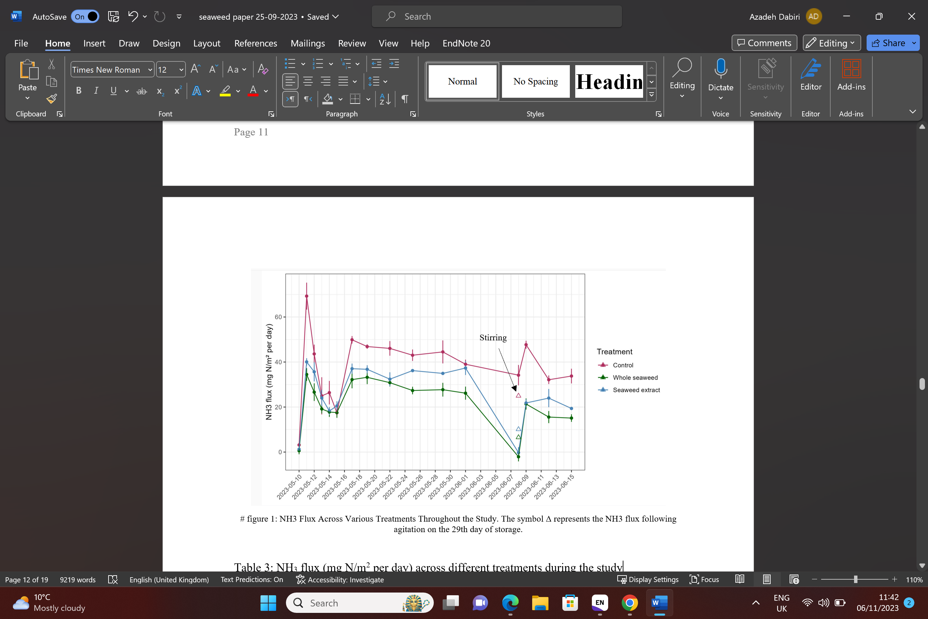
Figure 1: Daily NH₃ flux in the control, whole seaweed and seaweed extract groups (∆ indicating the NH₃ flux after stirring on the same day)

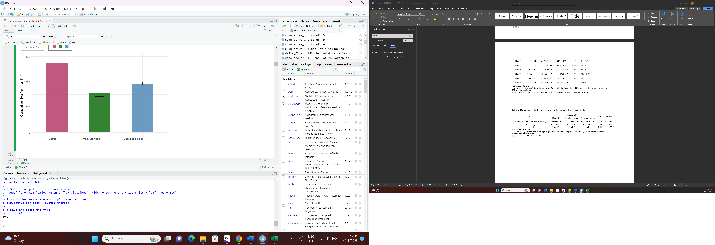
Figure 2: Cumulative NH₃ flux across control, whole seaweed and seaweed extract groups

Conclusions: This study demonstrated that including brown seaweeds in the diet of dairy cows could be a viable and novel strategy for mitigating NH₃ emissions during slurry storage. Future research should focus on a realistic storage period of 4-6 months and explore the potential of different seaweed species and the mechanism of action of phlorotannins on NH₃ reduction.

Acknowledgements: Technical assistance of Agri-Food and Biosciences Institute, Hillsborough, UK.

Financial support: Department of Agriculture, Environment and Rural Affairs and ‘SEASOLUTIONS European project. European Union’s Horizon 2020, under grant agreement No 696356.

References:
- Baral, K. R., McIlroy, J., Lyons, G. & Johnston, C. (2023). The effect of biochar and acid activated biochar on ammonia emissions during manure storage. Environmental Pollution, 317, 120815.
- De Bhowmick, G. & Hayes, M. (2023). Potential of Seaweeds to Mitigate Production of Greenhouse Gases during Production of Ruminant Proteins. Global Challenges, 2200145.
- Katongole, C. B. & Yan, T. (2022). The effects of dietary crude protein level on ammonia emissions from slurry from lactating Holstein-Friesian cows as measured in open-circuit respiration chambers. Animals, 12, 1243.
- Mahmud, K., Panday, D., Mergoum, A. & Missaoui, A. (2021). Nitrogen losses and potential mitigation strategies for a sustainable agroecosystem. Sustainability, 13, 2400.

- Makkar, H. P., Tran, G., Heuzé, V., Giger-reverdin, S., Lessire, M., Lebas, F. & Ankers, P. (2016). Seaweeds for livestock diets: A review. Animal Feed Science and Technology, 212, 1-17.
- McIlroy, J. P., McGeough, K. L., Laughlin, R. J. & Carolan, R. (2019). Abatement of ammonia emissions from dairy cow house concrete floor surfaces through additive application. Biosystems Engineering, 188, 320-330.
- Muizelaar, W., Van Duinkerken, G., Khan, Z. & Dijkstra, J. (2023). Evaluation of 3 northwest European seaweed species on enteric methane production and lactational performance of Holstein-Friesian dairy cows. Journal of Dairy Science, 106, 4622-4633.

