Title: Effects of grazing contrasting grass swards on lambs’ performance and an approach to calculate their grass intake

O. Cristobal-Carballo, X. Chen, D. Patterson, S. Huws, A. Aubry, K. Theodoridou and T. Yan

Application
Grazing multispecies swards increases the rate of weight gain and final body weight of finishing lambs. Estimations of total ME requirement and forage ME content is a useful tool to estimate grazed grass intake of lambs.
Introduction
In the UK, grass-based systems are fundamental to the sustainability and production of the ruminant livestock sector. The simplification of grass seed mixtures used has resulted in monoculture grazing systems. The productivity and reliability of these systems are heavily dependent on high inputs of nitrogen fertilisers, which increases the risk of air and water pollution, greenhouse gas emissions and biodiversity loss. In grazing swards, the inclusion of legume and/or herbs has been shown to reduce the dependency on nitrogen input whilst increasing animal production efficiency. However, there is only limited evidence of the effects of grazing multispecies swards on the performance of finishing lambs and no evidence of predicting grazed grass intake whilst grazing these contrasting sward types. This study aimed to assess the effect of three sward compositions on animal performance and herbage intake of finishing lambs during the mid to late growing season.
Materials and Methods
Sixty crossbred ewe lambs were randomly allocated to one of the three grazing groups (n= 20 lambs), which were balanced in terms of initial body weight and date of birth. The grazing swards consisted of: perennial ryegrass (RG, control); perennial ryegrass/white clover (R/WC); and multispecies mixed sward (MSS; perennial ryegrass, white clover, red clover, timothy, plantain, chicory and trefoil). Lambs were grazed for nine weeks under a rotational grazing management system. The herbage biomass of each sward was estimated using the rising platemeter (RPM) and 0.25m² quadrat clips, and then used to calculate the grazing area allocation for each lamb grazing group as part of the rotational grazing system. Representative sub-samples of herbage from each sward were collected, dried and milled periodically for NIRS and wet chemistry analyses. Measured grazed herbage intake (kg DM/d), in each group, was estimated using the difference of sward height before and after grazing (using the RPM) and the biomass density of the sward. From each group, individual lamb herbage intake (kg DM/d) was then calculated using the group measured grazed herbage intake (kg DM/d) value multiplied by the proportion of individual sheep ME requirement over the sum of group total ME requirements. The individual sheep ME requirement was predicted as a sum of ME requirements for maintenance (Yang et al., 2020), live weight gain and grazing allowance (AFRC, 1993). Live weight was recorded weekly in the mornings. Response variables were analysed using a linear mixed model via REML, with grazing sward as the fixed effect and lamb ID as a random effect. Pairwise differences between treatments were examined using the Tukey’s test (P≤0.050).
Results
Performance results are summarized in Table 1. At the start of the study, the average body weight of lambs was 34.1 kg, with no differences (P = 0.940) between lambs allocated to each of the sward types. After 9 weeks of grazing, lambs in the MSS showed a ~30% higher (P<0.001) rate of average daily gain (ADG) when compared to the RG and R/WC. Pairwise comparisons showed 4.4-4.7% heavier final BW (P≤0.0495) in MSS lambs than their counterparts in the RG or R/WC. Despite the greater ADG for lambs on MSS, their DM intake (DMI) was similar to lambs on RG, whilst DMI of lambs grazing R/WC was 17% and 20% lower (P < 0.001) that the RG and MSS, respectively.
Table 1. Effects of grazing perennial ryegrass (RG), ryegrass/white clover (R/WC) and multispecies (MSS) swards on body weight (BW), average daily gain (ADG) and grazed herbage DM intake (DMI; measured grazed herbage) measured by finishing ewe lambs
 | RG | R/WC | MSS | SED | P-value
Initial BW (kg) | 34.19 | 34.04 | 34.05 | 0.446 | 0.933
Mean BW (kg) | 36.97 | 36. 74 | 37.55 | 0.611 | 0.386
Final BW (kg) | 40.08a | 40.18a | 41.95b | 0.895 | 0.071
ADG (kg/d) | 0.126a | 0.119a | 0.165b | 0.0120 | <0.001
DMI (kg/d) | 1.277a | 1.096b | 1.319a | 0.0599 | <0.001

Figure 1 shows the estimated grazed herbage DM intake calculated from herbage ME content and ME requirements for maintenance, body weight gain and activity allowance, against measured grazed herbage DM intake as described previously. The estimated DMI was 11% lower (P<0.050) than measured DMI for RG, whilst no significant differences (P>0.050) were observed for R/WC (-1.0%) and MSS (3.0%).
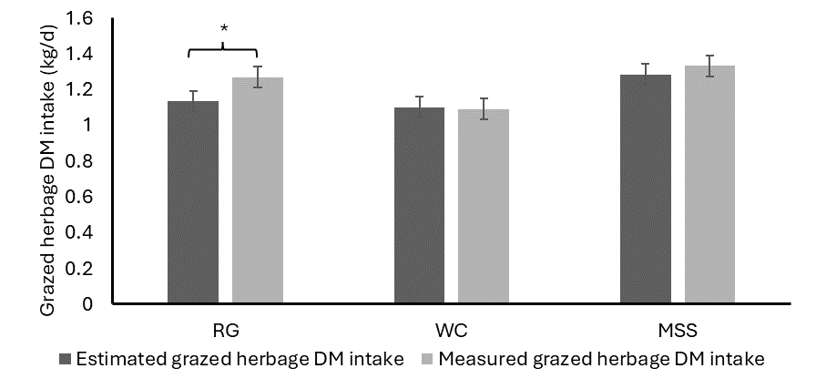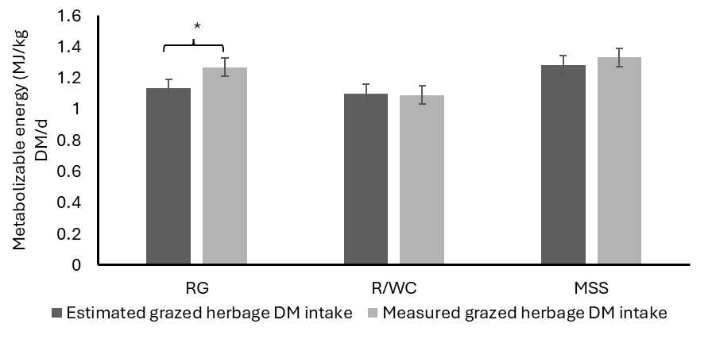

Figure 1. Estimated grazed herbage DM intake (dark grey bars: calculated from herbage ME content and ME requirements for maintenance, body weight gain and activity allowance) against measured grazed herbage DM intake (clear grey bars: calculated from group intake measured by rising platemeter and quadrats, multiplied by the proportion of individual sheep ME requirement over the sum of group total ME requirements).
Conclusions
Grazing multispecies swards in finishing ewe lambs increase the ADG resulting in heavier lambs at slaughter when compared to ryegrass and ryegrass/white clover swards. The grazed herbage DM intake calculated from the ME requirement of lambs and forage ME content and that estimated from rising platemeter and quadrats are comparable and the former method can be used to predict grazed herbage DM intake for grazing lambs.
References
Yang, C. T., Wang, C. M., Zhao, Y. G., Chen, T. B., Aubry, A., Gordon, A. W., and Yan, T. (2020). "Updating maintenance energy requirement for the current sheep flocks and the associated effect of nutritional and animal factors." Animal 14 (2), 295-302.
Eggleston, H. S., Buendia, L., Miwa, K., Ngara, T., & Tanabe, K. (2006). 2006 IPCC guidelines for national greenhouse gas inventories.
AFRC (1993). Energy and protein requirement of ruminants. CAB International, Wallingford, UK.

Answers to Comments from Reviewer
Figure 1 y-axis label seems to be incorrect? Yes, the figure in the abstract was incorrect
Surely this is just "Dry Matter Intake (kgDM/d)"? Figure amended

Was there any difference in the nutritional analyses? There were slightly differences in the nutritional composition between the dietary treatments. These were as follows: CP was higher in WC and MSS, whilst NDF and WSC were higher in RG. Ash was higher in MSS. GE and ME were very similar between diets.
 |  | RG | WC | MSS
Wet Chemistry | ADF_wc | 286.7 | 271.0 | 277.6
 | Ash_wc | 78.1 | 86.7 | 105.4
 | Ether Extract_wc | 36.1 | 37.0 | 38.7
 | Gross Energy_wc | 18.4 | 18.5 | 18.1
 | NDF_wc | 579.6 | 499.8 | 452.6
 | CP_wc | 126.9 | 158.5 | 150.7
 | Oven Dry Matter_wc | 919.8 | 920.6 | 917.0
 | WSC_wc | 179.7 | 146.4 | 137.0
NIRS | ADF_nirs | 304.8 | 288.3 | 272.9
 | Ash_nirs | 86.2 | 90.1 | 104.4
 | CP_nirs | 87.8 | 102.8 | 113.9
 | DOMD_nirs | 72.0 | 71.9 | 71.2
 | NDF_nirs | 483.2 | 454.8 | 417.5
 | WSC_nirs | 201.8 | 170.0 | 141.2
 | ME_nirs | 11.53 | 11.50 | 11.39

This may explain some of the difference in growth? The better conversion rate in lambs grazed on MMS and WC might be explained by the higher CP content in these diets when compared to RG.
You state the study lasted 9 weeks (63 days) yet the ADG by calculation from Table 1 would suggest a much shorter time frame? 44 days in the case of RG. The AGD in each lambs was calculated using a linear regression analysis between time (y-axis; weekly weight for 9 weeks) relative to body weight (x-axis).
Using the initial and final BW of the lambs over a period of growth, as suggested by the reviewer, the statistical results are as follow:
 | RG | R/WC | MSS | SED | P-value
ADG (kg/d) | 0.099a | 0.105a | 0.134b | 0.0098 | 0.024

