Application
Encouraging the responsible use of antibiotics as part of the sustainable intensification of dairy production in Bangladesh may reduce the irrational usage of antibiotics in Bangladeshi dairy farms, and ultimately the associated resistance to these antibiotics.
Introduction
Antibiotic resistance (AR) is a growing concern in Bangladesh because of the indiscriminate and widespread use of antimicrobials in its dairy industry (Imam et al., 2020). While no direct relationship has been demonstrated, antibiotic use in livestock production is considered one of the main causes of the evolution of antibiotic-resistant bacteria (Hölzel et al., 2010). About half the processed milk production in Bangladesh comes from the co-operative ‘Milk-Vita’, with average dairy herd size being 3.5 head of cattle (The Dairy Site, 2013). However, there are few data on antibiotic usage and prevalence of AR in the Bangladeshi dairy industry. The aim of this study was therefore to determine the association between sociodemographic characteristics of Bangladeshi dairy farmers, their management system, use of antibiotics and prevalence of phenotypic AR in samples of E. coli taken from their farms.
Materials and Methods
A total of 30 dairy farms with two contrasting dairy farming system (based on high and low input feed supplement) were chosen from the emerging milk production area (as identified by Milk-Vita, Bangladesh). High input systems also used a ‘cut and carry (CCS)’ whereas low input systems used a ‘pastoral (PS)’ system of forage provision. A cross-sectional snapshot survey was conducted from August to October 2023 to ascertain the age and education level of the farmer, their system of dairy farming, and their use of feeds and medicine for their cows. At the same time, samples of cow faeces, soil, feed and water were collected from the farmyard and surrounding environment. Isolates of E. coli bacteria were prepared from each sample by growing on eosin-methylene blue agar. Phenotypic resistance of these E. coli isolates to gentamycin, ampicillin, tetracycline and erythromycin was determined by incubating each isolate with nutrient broth, the antibiotic and resazurin dye indicator in a 96-well microtiter plate. A colour change of resazurin dye from blue to pink (indicating metabolic oxidation) was regarded as evidence of resistance to the particular antibiotic. Associations between farmer socio-demographic characteristics, antibiotic use and phenotypic AR were analysed by Pearson Chi-Square test using IBM SPSS (version: 29.0.2.0). The effect of farming system on milk production was analysed by Student’s t-test.
Results
Most of the dairy farms were managed by men (CCS and PS farms: 88.8% and 83.4%, respectively), who were young (20-39 years) to middle aged (40-59 years). CCS farmers had attained a significantly (p=0.003) higher level of education than PS farmers (percentage attaining primary level or below was 83.3% for PS but only 33.3% for CCS). A larger proportion of CCS farmers identified dairying as their main occupation (44.4%) over agriculture (16.7%) and other businesses (27.8%), whereas most PS farmers chose agriculture as their main occupation (58.3%) over dairying (41.7%) and other businesses (0.0%); (effect of system, p=0.028). Annual milk production and milk yield of CCS farms was significantly higher than PS farms (production 71300 ± 23080 L/yr, 8240 ± 3467 L/yr, p=0.036; yield 3235 ± 278 L/yr, 1281 ± 417 L/yr, p<0.001 for CCS and PS, respectively). Overall frequency of antibiotic use was significantly greater (p< 0.001) by CCS farmers, who used a wider range of antibiotic classes, but between 20% and 50% of all farms used β-lactam and/or macrolide antibiotics (Figure 1). A high prevalence of resistance to ampicillin (approximately 80%) was observed in all samples, but resistance to tetracycline and erythromycin was greater on PS farms (Figure 2).
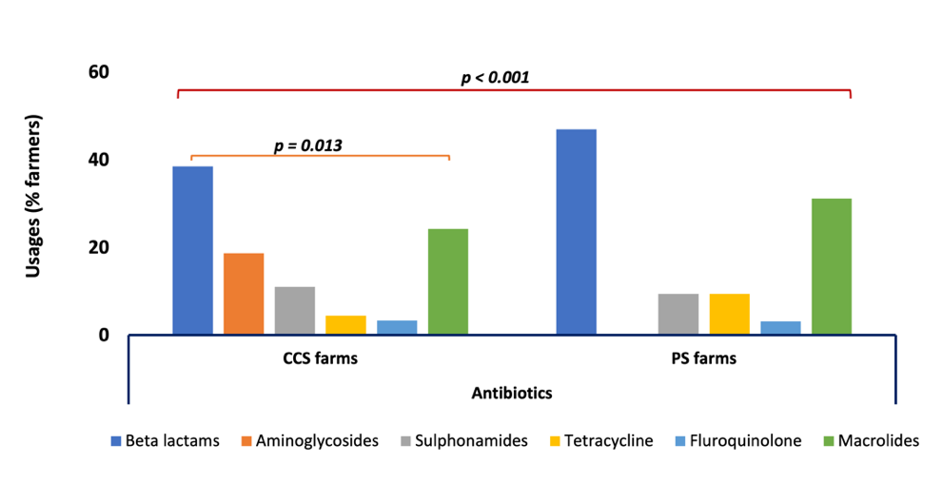
Figure 1 Frequency of usage (%) of antibiotics by different dairy farming systems

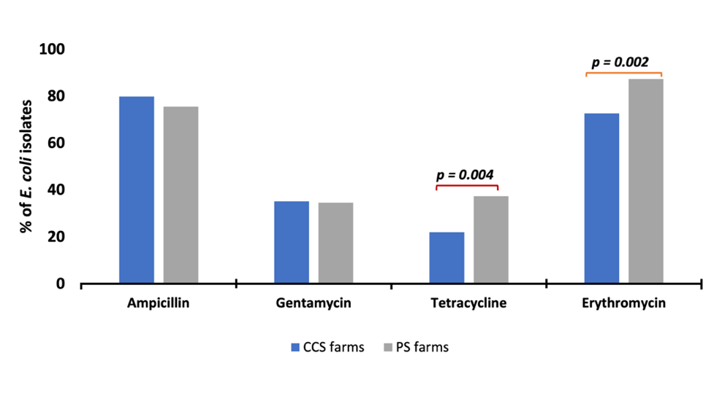
Figure 2 Effect of farming system on phenotypic resistance by E. coli to antibiotics

Conclusions
Higher input dairy systems in Bangladesh were associated with farmers with a higher level of education, and a greater frequency of administering antibiotics to their cows. However, regardless of level of input, most farms used β-lactam and many used macrolide antibiotics, and this was associated with a high prevalence of AR to these antibiotics. The higher prevalence of resistance to tetracycline and erythromycin with lower input systems may suggest that, when these antibiotics have been used on these farms, correct guidelines for their use may not have been followed.
References
Imam, T., Gibson, J. S., Foysal, M., Das, S. B., Gupta, S. D., Fournie, G., Hoque, M. A., and Henning, J. 2020. Frontiers in Veterinary Science, 7, 576113.
Hölzel, C. S., Schwaiger, K., Harms, K., Küchenhoff, H., Kunz, A., Meyer, K., Müller, C., and Bauer, J. 2010. Environmental Research, 110, 318-326.
The Dairy Site 2013. The Bangladesh Dairy Market: Times of Change. 09 July 2013. https://www.thedairysite.com/articles/3633/the-bangladesh-dairy-market-times-of-change/

