Title
Sex effects on porcine microbiota impact on alternative treatments for post weaning diarrhoea.

Application
Differential microbiota composition between males and females may indicate that sex-specific therapeutical intervention approaches could improve their efficacy.

Introduction
We previously described that the broad-spectrum antimicrobial-alternative peracetic acid (PAA) derived by precursor hydrolysis was able to decrease diarrhoetic symptoms in piglets (Galgano et al., 2023), in similar fashion as zinc oxide (ZnO). Here, we further explored possible interactions between these interventions and piglet sex.

Materials and methods
Four treatments (control, 3100ppm in-feed ZnO, 50ppm and 150ppm of in-water PAA), were administered to 6 pens/treatment (14-day trial) with 2 pigs per pen, 6 rooms (4pens/room) and balanced for sex. In-water PAA treatments were prepared daily from mixing different ratios of PAA precursors. We report here data on stomach and caecal microbial composition via 16S rRNA sequencing (515Fb-816Rb). Linear mixed model was carried out in R via using the package lme4 for performance and MaAsLin2 for taxonomical data, including fixed (treatment and sex) and random effects (rooms/pens/pigs).

Results
The taxonomical analysis of the composing genera through the gut locations analysed revealed both compositional differences between sexes and in response to treatments in males and females. In the stomach, the relative abundance of both Fibrobacter and Sharpea variated significantly when analysing the microbiota of males and females (P < 0.05, Q < 0.05). Moreover, 97 genera were significantly differentially abundant as a consequence of treatment administration in either males or females. Of these, Actinobacillus was found to be significantly less abundant (P < 0.05, Q < 0.05) in the males given 150ppm of PAA (0.1% ± 0.1%) compared to all other treatment-sex combinations (0.8% ± 0.6%)
In the caecum, the relative abundance of 27 genera was significantly different when comparing the microbiota of males and females in general (P < 0.05, Q < 0.05), amongst which Lactobacillus was significantly enriched in females (23.57 % ± 8.53 %) compared to males (14.21 % ± 8.63 %). In parallel, 135 genera were significantly differentially abundant (P < 0.05, Q < 0.05) in the interaction of treatment and sex. Amongst these genera, Ruminococcus was less abundant in males given ZnO (0.09%± 0.07%) compared to all other treatment-sex combinations, and in the caecal content of females administered ZnO (0.42%± 0.42%) compared to control females (1.65%± 1.04%).

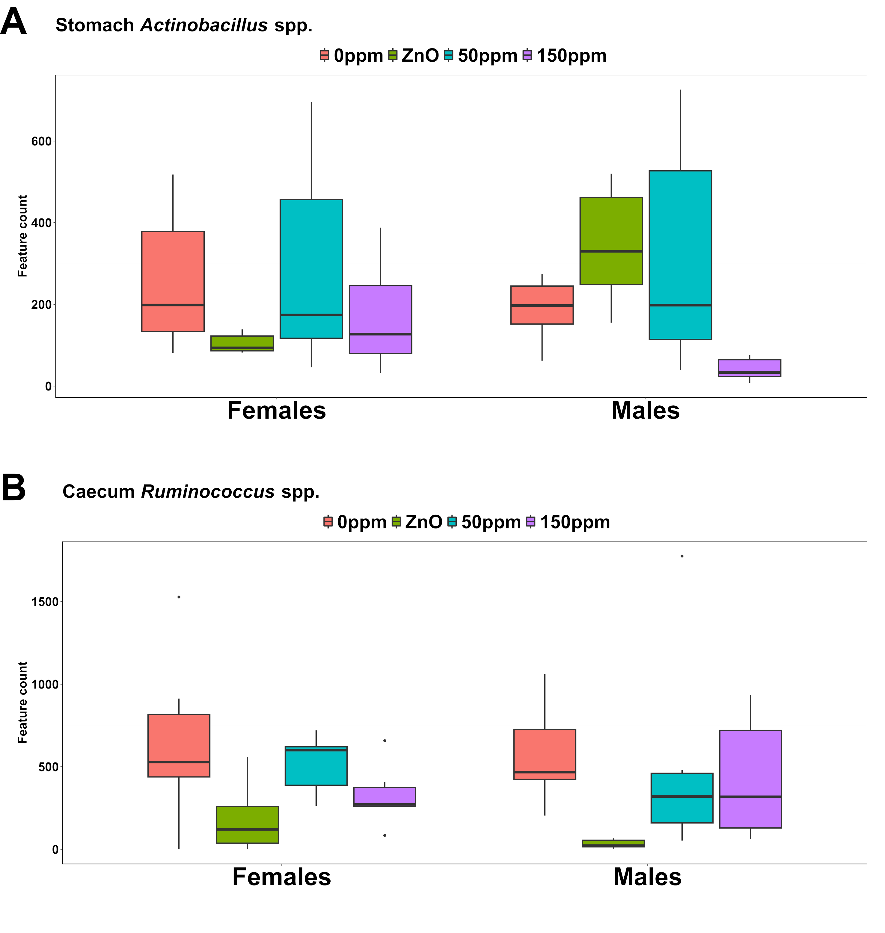
Figure 1. Feature count of Actinobacillus spp. in the stomach (A) and Ruminococcus spp. in the caecum in males and females through the different treatments.

Conclusions
Treatments targeting the modulation of gut microorganisms could achieve different effects in males and females, likely due to differences in microbiota composition between the two sexes. Amongst others, we found that 150ppm of PAA resulted in a reduction of Actinobacillus in the stomach of male pigs. Interestingly this genus had previously been found in association to infection in porcine epidemic diarrhoea (Tan et al., 2020), likely pointing towards a beneficial effect of this PAA level of inclusion in males. In parallel, we found that Lactobacillus, whose enrichment in the lower gut is usually associated with healthier pigs was more abundant in females than males in general, whilst probiotic genera, such Ruminococcus (Sun et al., 2019) were reduced in both females and males given ZnO. Our findings could thus indicate that interventions based on the modulation of the gut microbiota may benefit from being sex-tailored in order to enhance their therapeutic effect.

Acknowledgments
This work was funded through CIEL (seed grant funding scheme). SRUC receives support from Scottish Government (RESAS).

References
Galgano, Conway L., Fellows, A., and Houdijk, J.G.M. (2023). Animal - science proceedings. 14, 2, p. 361-362.
Tan Z., Dong W., Ding Y., Ding X., Zhang Q. and Jiang L. (2020).Genes (Basel) 11(1): 44.
Sun J., Du L., Li X., Zhong H., Ding Y., Liu Z. and Ge L. (2019). Scientific Reports 9: 18675.

