**Application**

Identifying bacteria causing clinical mastitis on Irish dairy farms can contribute to implementing measures to prevent and control it. Determining the prevalence of the different types of mastitis causing bacteria will allow us identify risk factors associated with these bacteria and design prevention strategies.

**Introduction**

Mastitis is an inflammation of the mammary gland. Mastitis is classified as clinical mastitis (CM; when there’s observable signs of inflammation in the milk, the gland or the cow) or sub-clinical mastitis (SCM; where no visual signs appear but there’s an inflammatory process occurring) (Keane et al., 2013, Harmon, 1994). The most common cause has been observed from bacterial infection. Keane et al. (2013) collected 630 quarter milk samples from 30 milk-recording Irish dairy herds and found that *Staphylococcus Aureus* was the most prevalent (23%) pathogen causing CM followed by *Streptococcus Uberis* (17%) and *Escherichia Coli* (9%). There has been no research conducted on CM in Ireland since 2013, nor in a random sample of farms. Therefore, the aim of this study was to evaluate the aetiology of clinical mastitis on a large representative sample of Irish dairy farms.

**Materials and methods**

This study was conducted on a random selection of 80 Irish dairy farms, which were drawn from 276 complete responses to a previously conducted Teagasc survey (Uí Chearbhaill et al., 2024). Based on the National Farm Survey from 2022 of the number of farms located per province, we proportionally sampled farms based on geographical location: 72% of the selected were located in Munster, with the remainder spread across Leinster (14%), Connacht (7%) and Ulster (7%), as shown in figure 1.

This sample was obtained using the random number generator in Excel where each respondent was given a random number. These numbers were organised from smallest to largest, the farmers were contacted via email with information on the trial, followed by a phone call to discuss participation further.

The sample size was chosen by running a simulation of herds with different CM case rates (20 to 60 cases per 100 cows/year) and a rate of cases per week was calculated. The sample size was estimated by calculating the number of farms needed to detect differences in mean CM cases per week between farms with a case rate difference of 20 to 40 cases per cow per year.

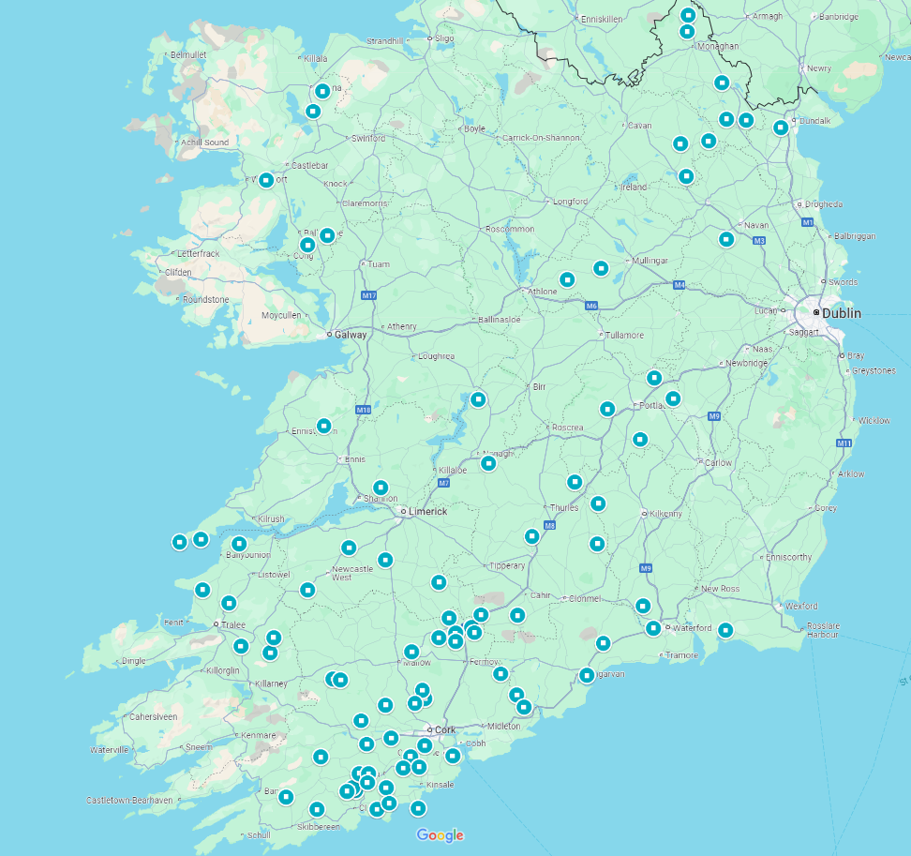

 = Farm location

Figure : Farm locations (Google maps, 2024)

We visited farms between April and May 2024. Farmers were trained to take aseptic quarter milk samples by the researchers and were asked to collect these samples from every CM case they detected throughout the lactation and freeze it immediately after. Frozen milk samples were collected bi-monthly by the researcher and transported back to Teagasc for laboratory analyses.

To analyse the samples, 10 µL of milk were plated on blood agar and evaluated based on colony morphology and haemolytic activity. Samples showing fewer than three distinct colony types, with each type containing more than five colonies, were further tested on a panel of 10 agars to identify presumptive pathogens (Laboratory Handbook on Bovine Mastitis, 2019 and Farre., *et al* 2022). The further tests included, Mannitol Salt Agar, MacConkey Agar, Edward Modified Agar, Baird Parker RPF Agar, RAPID’B. cereus Agar, ALOA Agar, TBX Agar, Pseudomonas CFC Agar, HiChrome Cronobacter Agar, XLD Agar. Descriptive statistical analyses have been undertaken to visualise the preliminary data in R, using the tidyverse package.

**Results**

Seventy-eight farms (97.5%) operated a spring calving system (cows calving between February and April and are dried-off between November and December), with 1 farm (1.25%) operating a split calving system (where a portion of the cows are calved in autumn and spring) and 1 farm (1.25%) operating a year round calving system.

Preliminary results to date are based on 281 frozen CM milk samples from 55 farms. Fifty one (18.15%) samples identified as *Escherichia coli*, thirty five (12.45%) presented as *Streptococci species* and 23 (8.2%) were identified as *Staphylococcus Aureus*.

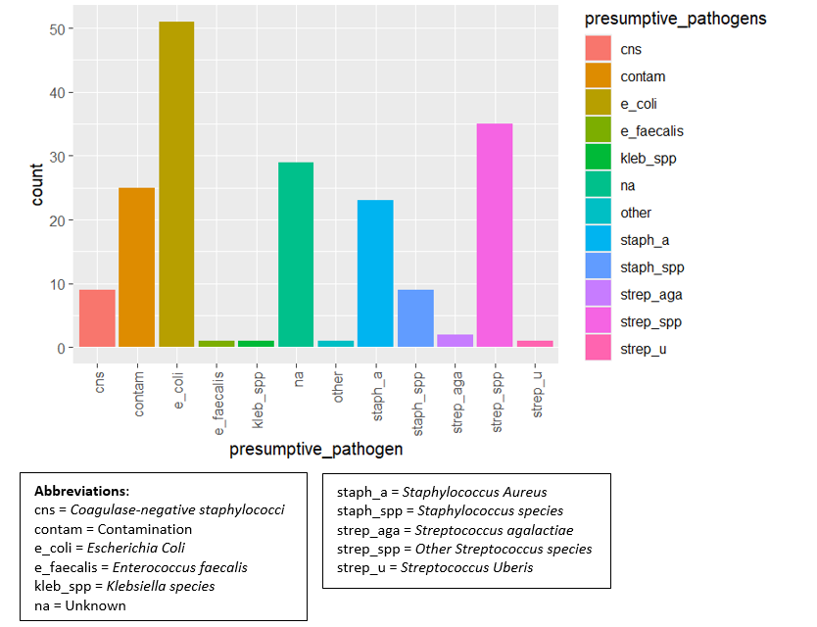

Figure : Count of presumptive clinical mastitis pathogens

**Conclusion**

This study offers valuable insights into the aetiology of clinical mastitis in Irish dairy farms. We found E. coli as the most prevalent bacteria causing clinical mastitis. It is important that further bacteriology testing is carried out along with blood agar to ensure accurate identification of mastitis pathogens and patterns. Further research will explore current incidence rate in Irish dairy farms and factors associated with clinical mastitis to help inform prevention and control measures specific to the Irish context.

**Acknowledgements**

The authors acknowledge funding from Teagasc and the University of Nottingham.

**References**

FARRE, M., ZECCOMI, A. & KELTON, D. 2022. Bulletin of the International Dairy Federation, 515

HARMON, R. 1994. Physiology of mastitis and factors affecting somatic cell counts. *Journal of dairy science,* 77**,** 2103-2112.

KEANE, O. M., BUDD, K. E., FLYNN, J. & MCCOY, F. 2013. Pathogen profile of clinical mastitis in Irish milk-recording herds reveals a complex aetiology. *Veterinary Record,* 173**,** 17-17.

LABORATORY HANDBOOK ON BOVINE MASTITIS. 2019

UÍ CHEARBHAILL, A., BOLOÑA, P. S., RYAN, E. G., MCALOON, C. I., BURRELL, A., MCALOON, C. G. & UPTON, J. 2024. *Irish Veterinary Journal,* 77**,** 8.