Application
This work attempts to understand the nature of a poor gut health phenotype present in a pedigree broiler chicken line and test the association of intestinal dysbiosis with gut permeability and systemic bacterial infection.
Introduction
Poor gut health poses a serious welfare consideration for broiler chickens. Intestinal dysbiosis (or dysbacteriosis) (Teirlynck et al., 2011) describes an ill-defined syndrome that is generally characterized by disruption of the gut microbiome, and typically occurs around the first 20-30 days of life. Intestinal dysbiosis has been associated with gut leakage and increased bacterial colonization of the liver (Tellez et al., 2014; Di Vincenzo et al., 2023). This project aims to study naturally occurring intestinal dysbiosis in broiler chickens reared under farm conditions, using the natural phenotypical variation observed within a pedigree chicken line.
Materials and Methods
A group of 210 one-day-old male pedigree broiler chickens were housed in a single pen under controlled commercial conditions. They were allowed to grow with ad-libitum access to a standard broiler diet for a period of five weeks, including starter, grower and finisher phases. Blood samples were collected from every chicken on days 15 and 28 via the brachial vein, and on days 35 or 36 from the heart immediately after euthanasia. The occurrence of dysbiosis was evaluated at the time of post-mortem with the use of a macroscopic evaluation scoring system (Teirlynck et al., 2011). Liver tissue was collected immediately post-mortem for assessment of bacterial translocation. Whole blood and homogenised liver tissue sample dilutions were cultured under aerobic conditions using MacConkey and 7% sheep blood agar for 20h at 37ºC. Blood and liver bacterial colony forming units (CFU) were counted and compared between chickens with high and low dysbiosis scores using the non-parametric Mann-Whitney test. Selected colonies from liver and blood samples were identified with the use of MALDI-TOF (Matrix-Assisted Laser Desorption/Ionization – Time-of-Flight Mass Spectrometry)(Tsuchida et al., 2020). A subgroup of 20 randomly selected chickens were also subjected to an in-vivo gut permeability assessment using fluorescein isothiocyanate - dextran (FITC-d) on days 15, 22, 28 and 36 of the study. FITC-d blood concentration levels were compared between single score dysbiosis groups (scores 1-9) using two-way ANOVA paired with Fischer’s LSD multiple comparisons test.
Results
The results showed the presence of bacteria in the blood and liver of chickens with high and low dysbiosis scores (Figure 1A). The total number of culturable bacteria in the blood, cultured with the use of blood agar, differed between the chickens with low and high dysbiosis on days 22 and 35-36, but not on day 28. However, there was no significant difference in the number of coliforms, which was assessed with the use of MacConkey agar. No significant difference was detected in bacterial numbers identified in the liver. The colonies isolated for identification were chosen as representatives of commonly encountered morphotypes. In total, 17 species of bacteria were identified, of which five were found in both biological samples, five were only found in blood and seven only in liver samples (Figure 1B). FITC-d gut permeability assessment showed variable outcomes between low and high dysbiosis chickens (Figure 2).
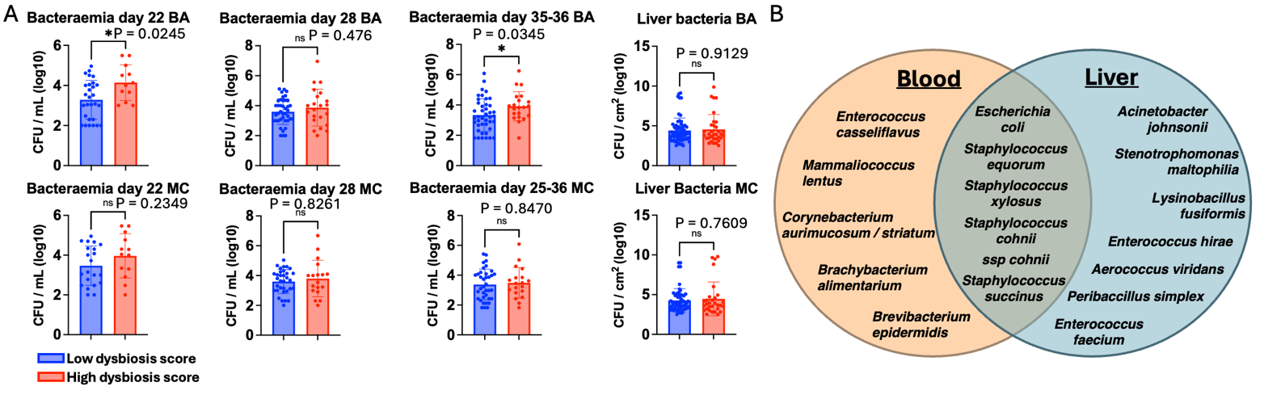
Figure 1: A: the number of CFUs in the blood and liver of chickens with low and high dysbiosis scores at different timepoints cultured at 37 ºC using blood agar (BA) and MacConkey agar (MC) under aerobic conditions. B: Bacterial species identified in the blood and liver cultures.
Figure 2:FITC-d concentration in the serum of chickens grouped by score (A), and by low and high dysbiosis score groups (B).

Conclusions
Macroscopic dysbiosis scores assigned during post-mortem were not directly reflected by total bacterial or specific coliform counts in the blood and liver, or FITC-d concentration in the blood, suggesting that intestinal dysbiosis is not always directly associated with gut leakage. The detection of non-gut-associated bacteria, such as Staphylococcus xylosus, in the blood and liver of these chickens suggests multiple sites of infection within this pedigree broiler line. This study underscores the complexity and multifactorial nature of the intestinal dysbiosis and provides a foundation for investigating the mechanisms underlying this syndrome, including the roles of microbial diversity, host genetics and extraintestinal infections.

References
Teirlynck E., Gussem M. D. E., Dewulf J., Haesebrouck F., Ducatelle R., Van Immerseel F. 2011, Avian Pathology, 40:2, 139-144
Tellez Guillermo , Latorre J. D. , Kuttappan V. A. , Kogut M. H. , Wolfenden A. , Hernandez-Velasco X. , Hargis B. M. , Bottje W. G. , Bielke L. R. , Faulkner O. B. 2014, Frontiers in Genetics, 5, 1664-8021
Tsuchida S., Umemura H., Nakayama T., 2020, Molecules 25(20), 4775.
Di Vincenzo, F., A. Del Gaudio, V. Petito, L. R. Lopetuso, and F. Scaldaferri. 2023, Internal and Emergency Medicine 19(2), 275–293

