**Application**

Cell grazing and undrained pasture plots had greater total soil carbon concentration and stock than continuous stocking after five years, which could enhance overall total soil health.

**Introduction**

Grasslands are vital for supplying food, goods, and services that support the livelihoods and economies of people globally. They are a key resource for livestock, offering grazing opportunities and conserved feeds. There are distinct benefits and drawbacks associated with livestock grazing systems. Therefore, developing effective grazing management strategies that prioritize the benefits is essential. Grazing management that benefits the soil's physical and chemical properties should be encouraged. Effective management of grassland ecosystems involves carefully balancing priorities like food production, economic sustainability, and the preservation of ecosystem services (Boval and Dixon, 2012). Drainage is believed to cause a significant decrease in total carbon (TC) storage in soil (Harris et al., 2018). The relationship between grazing method (GM) and drainage system (DS) is crucial for managing soil moisture and enhancing pasture productivity, adding complexity to soil chemistry. This study aimed to measure the impact of two GM (cell grazed, CG; and continuous stocking, CS) and DS (drained and undrained) on the TC concentration and stock in intensively managed grassland soils.

**Materials and Methods**

The study was carried out at Rowden Moor near North Wyke, Rothamsted Research, southwest England. The soil is derived from the underlying Carboniferous Crackington Formation. There were 12 experimental plots of 1-ha each. The plots consist of a series of hydrologically isolated fields (lysimeters). Six plots have surface drainage only (undrained) and six plots have surface drainage plus 85-cm-depth subsurface drainage (drained). Half of the plots of each drainage type were managed under CG (in 20-day rotation cycles) and the other 6 under CS. The CG plots were divided into two lanes of 0.5 ha and each lane was subdivided into 30 cells of 167 m2 using bespoke electric fencing and water supply equipment (KiwiTech Int). All plots were grazed with 10 - 15 ewes and 20-25 lambs from 2018 to 2022 during the grazing season (April to October). Ten soil cores were sampled from each of the 1-ha plots evenly distanced along a ‘**W**’ shape to capture field heterogeneity to a depth of 30 cm in August 2022. At each sampling point, the core was sub-divided into two cores (0-10 cm and 10-30 cm), making 240 soil samples in total. The soil samples were processed and analysed for TC concentration and stock. *Lolium perenne*, *Agrostis stolonifera* and *Holcus lanatus* were the dominant grass species. Data analysis was performed using the linear mixed model of JMP statistical software with GM, DS, and their interaction as fixed effects while plot, and cores were used as random effects.

**Results**

Significant effects of GM and DS on soil TC were found at 0 – 10 cm soil depth. CG had 0.66 greater percentage points (pp- difference between percentages) carbon concentration than CS (Figure 1a). Undrained plots were 0.71 pp greater than the drained plots. However, the main effects and their interaction were not significant at 0 – 30 cm (p = 0.6158, 0.6349, and 0.3097 for GM, DS, and GM x DS, respectively). Significant interaction existed between GM x DS on TC stock (*F* = 8.1890, *p* = 0.0050) at 0 – 10 cm depth with the highest stocks observed in the undrained CG plots (Figure 1b). At 10 – 30 cm, there were no significant effects from the main factors or their interaction effect (*p* = 0.7123, 0.3178, and 0.8149, for GM, DS, and GM x DS, respectively). CG pastures are typically reported to have more plant litter and standing herbage that reduces evaporation losses by moderating extremes in soil surface temperatures, protecting the soil from drying winds, and conserving moisture better than CS pastures (Teutscherova et al., 2021), which could promote organic matter turnover compared to CS systems.

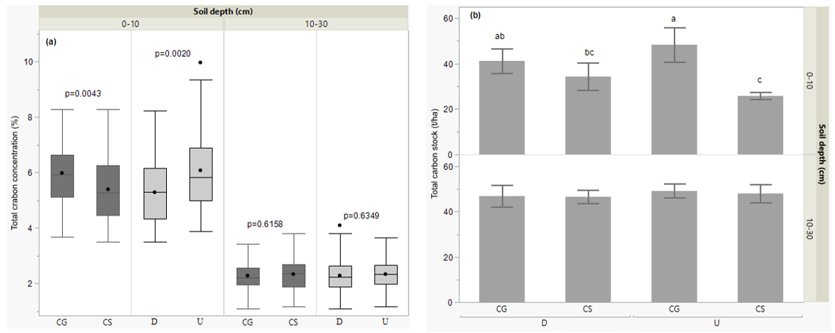

Figure 1: Box plots showing the main effect grazing method (GM; cell grazed, CG; and continuous stocking, CS) and drainage system (DS; drained, D; and undrained, U) for total carbon concentration (a) and the bar graph with GM x DS (b) at 0 -10 cm and 10 – 30 cm soil depth. Error bars are constructed from a 95% confidence interval.

**Conclusions**

Greater TC concentrations and stocks occurred in the upper soil layer (0-10cm) in CG plots compared to CS plots after five years of different management.

**References**

Boval, M., & Dixon, R.M. (2012). Animal 65,748–762.

Harris, P., Bol, R., Evans, J.,Hawkins, J.M.B., Dixona, E.R., Wolf, K., Dungait, J.A.J., Griffith, B., Herbst, M., Dhanoa, M.S., Beaumont, D.B., Dunna, R.M., Wiesenberg, & G.L.B. (2018). European Journal of Soil Science 69, 48–68.

Teutscherova, N., Vazquez, E., Sotelo, N., Villegas, D., Velasquez, N., Baquero, D., Pulleman, M., & Arango, J. (2021). Applied soil ecology, 159:103835.