**Application**

Estimates of residual metabolizable protein (MP) intake (MPI) were highly correlated with dietary N use efficiency (NUE) and feed efficiency (FE), and largely determined by N intake (NI) and milk protein yield, suggesting genetic selection for feed efficiency and milk protein yield will have positive effects on NUE in dairy cattle.

**Introduction**

Dietary NUE (milk N/NI) in lactating dairy cattle is relatively low, partly because of protein degradation in the rumen, with typically 75% or more of NI excreted in faeces and urine of lactating dairy cows. These manure N losses contribute to inventories of nitrate, nitrous oxide, and ammonia associated with milk production. As NUE is inversely related to NI, decreases in diet crude protein (CP) concentration are invariably associated with increased NUE. In previous studies (Reynolds et al., 2016) we observed considerable variation in NUE between individual animals, and the range in NUE between animals was similar for diets differing in CP concentration. This variation in NUE between animals suggests there is a genetic component to NUE as has been demonstrated for feed efficiency (milk energy yield/kg feed dry matter intake [DMI]) (Liu and VandeHaar, 2020).

Residual feed intake (DMI minus predicted DMI based on estimated metabolizable energy [ME] or net energy requirement) is used to compare FE between individual animals. We hypothesized that calculation of residual MPI might provide a more appropriate estimate of animal variation in protein use efficiency than NUE, as animals do not have a CP requirement per se. Therefore, our objective was to compare estimates of residual MPI with NUE and FE and use multivariate regression to evaluate their primary determinants.

**Materials and Methods**

A total of 42 Holstein cows (mean parity and days in milk 3.6 and 131, respectively) were individually fed using Calan gates for 12 weeks to provide measurements of daily DMI and milk yield and weekly milk composition and body weight. Cows were offered a 16% CP diet during a 3-wk covariate period and then changed to one of 2 diets (n=21 each) formulated to provide 90% (14% CP) or 105% (18% CP) of MP requirements (Reynolds et al., 2016) for a further 9 weeks. Residual MPI was calculated as measured MPI minus MP requirements (milk protein production, maintenance, body weight change, and gestation) using weekly averages and Feed into Milk (FiM; Thomas, 2004). Residual ME intake (MEI) as a measure of FE was also calculated using MEI and FiM estimates of ME requirement. Pearson correlations of efficiency estimates and production parameters were determined using SAS. Weekly averages were analysed using Mixed Models procedures testing fixed effects of diet CP, week, and their interaction and random effects of cow, with week as a repeated effect. The mixed model also included average protein intake, milk yield, milk fat, protein, lactose, urea, and somatic cell concentrations, body weight (BWT), and parity as covariates.

**Results**

Within treatment diets, relative variation for residual MPI between cows was similar to variation for NUE and residual MEI. Pearson correlation analysis showed significant correlations between residual MPI and NUE (-0.710; P < 0.001; Figure 1) and residual MEI (0.836; P < 0.001). Residual MPI was greater (P < 0.012) for the 18% CP diet than the 14% CP diet (266 vs 35 g/d, respectively; SEM = 48), reflecting greater MPI relative to requirement for the higher CP diet, with covariate effects (P < 0.007) of protein intake, milk yield, milk protein, fat, and urea concentration, and BWT. Residual MEI was lower (P < 0.001) for the 18% CP treatment (-29.9 and 33.5 MJ/d for 18 and 14% CP diets, respectively), reflecting the increase in milk solids yield with higher diet CP. Using means for the last 3 weeks of measurements, the overall relationship between residual MPI and residual MEI had a relatively low R2 (0.367), but within diet CP treatments there were positive relationships with higher R2 values (0.874 and 0.691 for 14 and 18% CP, respectively). This is similar to the findings of Lui and VandeHaar (2020), who also observed a higher correlation between residual DMI and NUE within diet CP treatment groups.

**Conclusion**

The correlation between residual MPI, residual MEI, and NUE efficiency indicates that milk yield and protein concentration relative to DM and protein intake are shared primary determinants. Although residual MPI is a better reflection of the biological basis of differences in NUE between cows, these results suggest that it can be reliably estimated using measurable parameters (N intake and milk N yield). The correlation between NUE and milk yield, milk protein concentration, and feed efficiency suggests that continued genetic selection for these traits will contribute to improved breeding value for NUE.

.

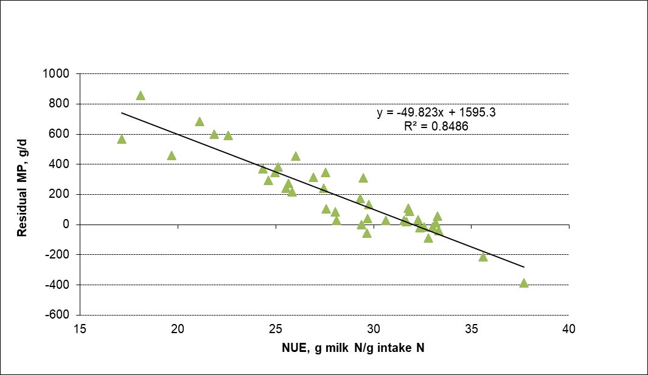

**Figure 1:** Relationship between residual metabolizable protein (MP) intake and N use efficiency (NUE) in lactating Holstein cows. Data are averages for the last 3 weeks of treatments.

**Acknowledgments**

Funding from Defra (SCF0232) and the contributions of A. K. Jones and technical staff at the Centre for Dairy Research are gratefully acknowledged.

**References**

Liu, E., VandeHaar, M.J. 2020. Journal of Dairy Science, 103, 3177–3190.

Reynolds, C. K., Crompton, L. A., Humphries, D. A., Jones, A. K. 2016. Proceedings of the 5th International Symposium on Energy and Protein Metabolism (Skomial, J. and Lapierre, H.), EAAP Publ. No. 137, Wageningen Academic Publishers, The Netherlands, 263-264.

Thomas, C. 2004. Feed into Milk: A New Applied Feeding System for Dairy Cows. University of Nottingham Press, Nottingham, UK.