**Application**

Understanding the dynamics of respiratory microbiota across various sites in the respiratory tract during viral challenge with BoHV-1 offers significant insights into the pathogenesis of bovine respiratory disease (BRD).

**Introduction**

BRD is multifactorial and causes morbidity and mortality in cattle of all ages. Viral and bacterial infectious agents, in addition to psychological stress caused by management and environmental factors contribute to disease onset. The composition of the bovine respiratory tract microbiome has been shown to play a role in respiratory health. Studies have utilized 16S rRNA gene sequencing to characterize the cattle respiratory microbiome (Johnston et al., 2017; McDaneld et al., 2018; Centeno-Martinez et al., 2022). Despite current research, there is a lack of data concerning the perturbations to the respiratory microbiota as a result of viral infection. Bovine herpesvirus 1 (BoHV-1), a double stranded DNA virus, is a key pathogen associated with BRD. Therefore, the objective of this study was to characterise the bacterial microbiota of the nasal cavity and pharyngeal tonsil of dairy calves following experimental infection with a specific BRD-associated virus, BoHV-1.

**Materials and Methods**

Holstein-Friesian bull calves (mean age (SD) = 149.2 (23.8) days; mean weight (SD) = 174.6 (21.3) kg) were either administered BoHV-1 inoculate (1 × 107/mL × 8.5 mL) (n = 12) (challenged) or were mock challenged with sterile phosphate buffered saline (control) (n = 6). Clinical signs were monitored and scored daily, and nasal swabs were collected from each animal until euthanasia at day (d) 6 post-challenge. Pharyngeal tonsil tissue (PGT) samples were collected from all animals at post-mortem. Based on clinical scores and quantification of BoHV-1 virus by qPCR, nasal samples collected on d0, d4 and d6 post-challenge were selected for bacterial 16S gene amplicon analysis. Total DNA was extracted from nasal and pharyngeal tonsil samples and full-length bacterial 16S gene amplicon sequencing was conducted on the Oxford Nanopore Technologies MinION Mk1C sequencing device. Fastq files were generated during the sequencing run using GUPPY base-caller algorithm within the Minknow software that was installed on the device. Clinical score data were analysed using SAS (9.4). Clinical score data were tested for normality using PROC REG and analysed using the PROC MIXED procedure of SAS (9.4), with time-point as the replicate measures. Fastq files were uploaded to the EPI2ME platform and analysed using the Fastq 16s workflow (v.2022.01.07). Results from the EPI2ME analysis were input into R and alpha diversity analysis was performed using the phyloseq (v1.40.0) package.

**Results**

There was a significant treatment by time interaction (P < 0.0001) for clinical score and rectal temperature between BoHV-1 challenged and control calves. Clinical scores were greater for BoHV-1 challenged calves on d 3, 4, 5, and 6 compared to d -1 (P < 0.001), and were greater for BoHV-1 challenged than control calves on d 4, 5, and 6 (P < 0.05) (Figure 1). No significant difference (P > 0.05) was detected in the relative abundance or diversity of bacterial genera between the control and challenged nasal swab samples. A total of 470, 571, and 569 bacterial genera were detected in the nasal swab samples collected on d 0, d 4, and d 6 respectively. The most prevalent genera identified in challenged calves across these days were *Moraxella* (mean (SD)) (25.1 (10.0) %), *Pasteurella* (51.6 (17.0) %), and *Pasteurella* spp. (64.7 (18.4) %), respectively. In controls the most prevalent bacterial genera were *Moraxella* (37.2 (10.2) %), Pasteurella (38.1 (16.0) %), and *Pasteurella* spp. (30.4 (12.5) %), respectively. In the PGT, 1479 genera were identified across all samples. No significant difference (P > 0.05) was detected in the relative abundance of bacterial genera between challenge and control PGT samples. The most common bacterial genera identified in challenged animals were *Streptococcus* (12.4 (4.5) %), *Mycoplasmopsis* (11.8 (5.3) %), *Mesomycoplasma* (7.9 (5.1) %), and *Pasteurella* spp. (7.3 (2.4) %). In control samples, the most prevalent genera identified were *Pasteurella* (30.3 (15.5%)), *Chitinophaga* (16.5 (14.8%)), *Moraxella* (11.4 (10.3%)), *Streptococcus* (7.2 (3.9%)) and *Escherichia* spp (6.6 (5.4%)).

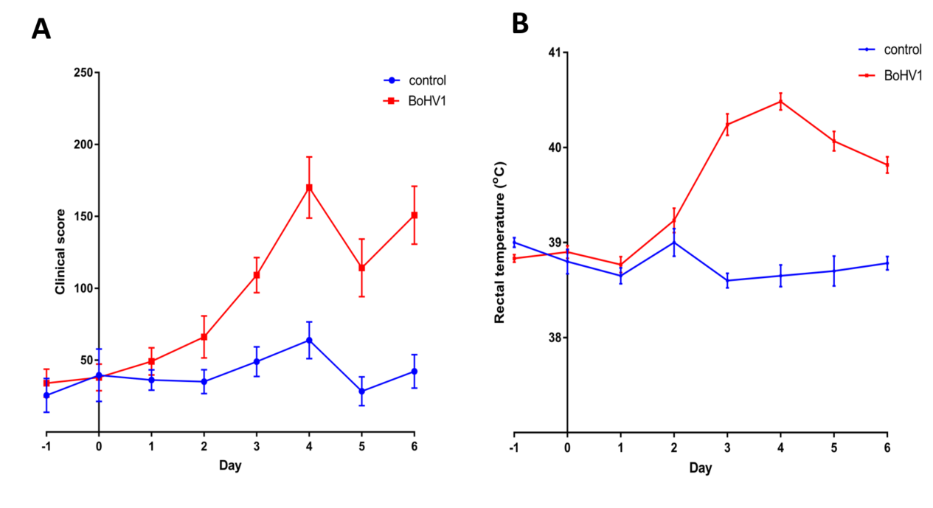

**Figure 1.** Clinical scores (**A**) and rectal temperatures (**B**) from the BoHV-1 challenged (n = 12) and the control (n = 6) calves during the BoHV-1 challenge study (means and their standard errors are presented). The day on which the challenge as administered is represented as day 0.

**Conclusions**

BoHV-1 induced clinical signs of BRD and allowed for the characterization of the composition of the bacterial microbiome across upper and lower respiratory tract sites. Furthermore, the use of replicate nasal swab samples across multiple time-points allowed for the examination of these bacterial populations over the course of an active viral infection.

**Acknowledgements**

This project was funded through the US-Ireland R&D partnership call (RMIS_0033 Project 16/RD/US-ROI/11) and (2018US-IRL200), and the EU Horizons 2020 ‘HoloRuminant’ project (grant agreement number: 101000213). SOD is a Teagasc Walsh Scholarship recipient (WS 2020033).

**References**

Centeno-Martinez, R.E., Glidden, N., Mohan, S., Davidson, J.L., Fernández-Juricic, E., Boerman, J.P., Schoonmaker, J., Pillai, D., Koziol, J., Ault, A. and Verma, M.S., 2022. Identification of bovine respiratory disease through the nasal microbiome. Animal microbiome, 4(1), p.15.

Johnston, D., Earley, B., Cormican, P., Murray, G., Kenny, D.A., Waters, S.M., McGee, M., Kelly, A.K. and McCabe, M.S., 2017. Illumina MiSeq 16S amplicon sequence analysis of bovine respiratory disease associated bacteria in lung and mediastinal lymph node tissue. BMC veterinary research, 13, pp.1-18.

McDaneld, T.G., Kuehn, L.A. and Keele, J.W., 2018. Evaluating the microbiome of two sampling locations in the nasal cavity of cattle with bovine respiratory disease complex (BRDC). Journal of animal science, 96(4), pp.1281-1287.