Application
A circulating microRNA, miR-127, was associated with dairy cow performance and affected bovine stem cell function in vitro. miR-127 may be a potential biomarker for performance, providing information to support selection, thus improve herd health, fertility, and profitability.
Introduction
Dairy cattle performance mainly comprises early growth, fertility, disease resistance, milk production, and lifespan. These traits are intercorrelated and cow performance could be improved by utilising biomarkers for these traits (Guinan et al., 2023). Circulating microRNAs are ideal biomarkers because they affect many cellular processes, where they repress mRNA translation (Friedman et al., 2009), are relatively stable, and easily measured in biofluid samples (Ioannidis et al., 2018). The present work investigated associations between plasma microRNAs and cow age and performance traits, using longitudinal sampling, and potential microRNA function. The potential roles of one microRNA identified, miR-127, in bovine tissue development was investigated by determining the effects of manipulating miR-127 levels in bovine mesenchymal stem cells (MSCs) on proliferation, differentiation, and putative gene targets.
Materials and Methods
Levels of 378 miRNAs were quantified by PCR array in plasma from 12 calves that were previously identified as having extremely different early performance. Four calves had infections and died, four had poor growth and fertility, and four had good growth/fertility with no health issues. Growth and fertility in the latter two groups differed in mean average daily gain before weaning (0.5 vs 0.9), one year bodyweight (332kg vs 385kg), age at first service (505d vs 429d), and number of services to conception (2.25 vs 1.25). Eighty-five microRNAs were differentially expressed between groups or were associated with a performance trait. Nine of these were validated by RT-qPCR using longitudinal samples at calf (<1 month old), heifer (14-23 months), and cow (29-35 months) stages from 91 animals. Spearman pairwise correlations were applied to microRNA levels. General(ised) linear mixed models (GLMM) tested associations between individual microRNA levels or microRNA ratios and age or performance, including growth, health, survival, fertility, and milk production in the first two lactations. Fixed factors included miRNA expression and factors that influence the trait, as chosen by backwards selection, including breed, year of birth or calving, month of birth or calving, and length of lactation as applicable. The random term was animal ID with associated pedigree. microRNA levels were also quantified in 19 body tissues from three 5-month-old male calves. Then, microRNA level was analysed by GLMM in R (fixed term: tissue type; random: ID). miRPath, TargetScan, and miRTarBase were used to identify putative genes and pathways targeted by miR-127.
Bovine MSCs were extracted from subcutaneous adipose tissue or skeletal muscle from four 5-month-old male Holstein-Friesian calves. Cells were transfected with miR-127 mimic, miR-127 inhibitor, or scramble nucleotide sequence control using HiPerFect transfection reagent (Qiagen), using the manufacturer’s fast-forward protocol. To quantify cell proliferation, MTT assay was performed and absorbance read at 550nm. For adipogenesis, induction media was applied for 14 days containing DMEM, 10% foetal bovine serum (FBS), 100 IU/ml penicillin, 100μg/ml streptomycin, 1μM dexamethasone, 10μg/ml insulin, 0.5mM 3-isobutyl-1-methylxanthine, and 100μM indomethacin. Lipids were stained using oil red O and quantified as the proportion of the image stained. For myogenesis, induction media containing DMEM, 2% FBS, 100 IU/ml penicillin, and 100μg/ml streptomycin was applied for four days. Cells were stained for nuclei (DAPI) and myosin heavy chain. Fusion index was calculated as the proportion of nuclei located within myotubes. Levels of miR-127, its predicted targets, and lineage-specific markers were quantified by RT-qPCR. MTT absorbance, immunostaining, and qPCR data were analysed using GLMM (fixed terms: treatment and time; random term: ID).
Results
Figure 1 shows a graphical representation of results for miR-127. Additionally, among nine studied miRNAs, eight were associated with age, longitudinal miR-126-3p levels were associated with first lactation somatic cell count (mastitis indicator) and second lactation milk yield, and cow miR-142-5p levels were associated with calving interval. Seven ratios in total were associated with a performance trait. miR-127 was widely expressed across calf tissues, with no significant associations between tissue type and miR-127 expression. In addition to the microRNAs shown in Figure 1, miR-127 was significantly (P<0.05) negatively correlated with miR-126-3p and miR-34a. In MSCs, adipogenesis and MAPK4 expression were not affected by miR-127 mimic or inhibitor.
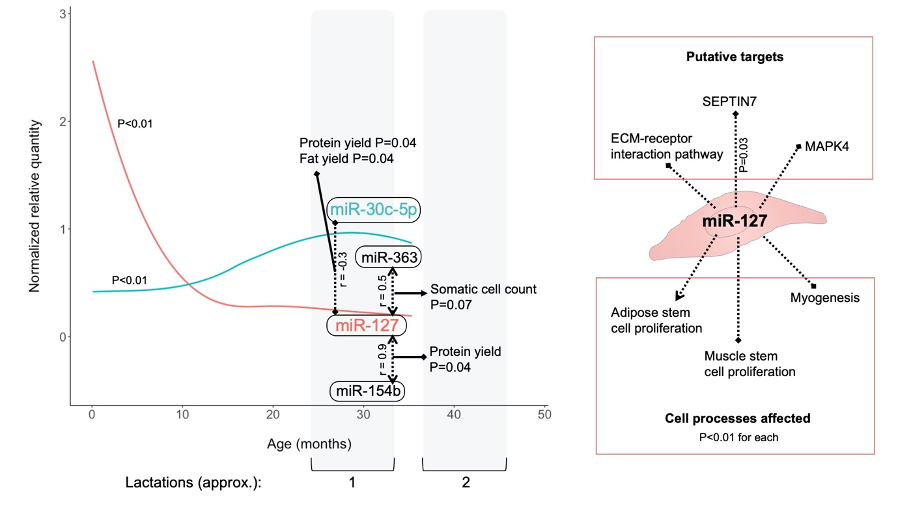
Figure 1: Graphical summary of miR-127 results. Lines with arrows indicate positive associations and lines with clubs indicate negative associations. Left: plasma miRNA quantity plotted against age. Loess curves show that on average, miR-127 decreased with age (red) and miR-30c-5p increased (blue). Correlations with some miRNAs are denoted by dotted lines with Spearman’s rho. Loess curves of miR-154b and miR-363 closely resemble miR-127 (not shown). Solid lines indicate associations between the ratio of those two miRNAs, quantified in first lactation, with a trait. Right: potential targets and functions of miR-127 in bovine MSCs. Altering miR-127 levels during myogenesis significantly reduced fusion index and SEPTIN7 expression.
Conclusions
miR-127 was expressed widely in calves, decreased with age, and ratios involving miR-127 were associated with milk production or somatic cell count, suggesting potential as a biomarker. Together with results from bovine MSCs, this supports a role for miR-127 in stem cell function and warrants further investigation.
References
Friedman, R. C., Farh, K. K. H., Burge, C. B. & Bartel, D. P. (2009). Most mammalian mRNAs are conserved targets of microRNAs. Genome Research, 19, 92–105.
Guinan FL, Wiggans GR, Norman HD, Dürr JW, Cole JB, Van Tassell CP, et al. (2023). Changes in genetic trends in US dairy cattle since the implementation of genomic selection. Journal of Dairy Science, 106, 1110–1129.
Ioannidis, J., Sánchez-Molano, E., Psifidi, A., Donadeu, F. X. & Banos, G. (2018). Association of plasma microRNA expression with age, genetic background and functional traits in dairy cattle. Scientific Reports, 8, 12955.

