Application
Multispecies swards containing grasses, legumes, and herbs provide farmers with a more drought-resilient, sustainable, and bio-diverse pasture requiring less N fertilizer compared to perennial ryegrass monocultures.

Introduction
The use of multispecies swards has many purported ecological and agronomic benefits, particularly in sustainable livestock systems. By integrating legumes, these swards reduce reliance on nitrogen fertilizers, while the complementary traits among mixed species enhance forage yield (Lüscher et al., 2014). Additionally, the inclusion of herbs has shown potential in lowering greenhouse gas emissions from ruminants (Khan et al., 2023).

However, despite these benefits, the impact of climate change on pasture systems—an essential component of sustainable livestock—is less well understood. This knowledge gap underscores the importance of investigating adaptive strategies for climate resilience. Finn et al. (2018) reported that multispecies swards in intensively managed grasslands can mitigate climate stressors, such as drought, by promoting yield resilience and aiding grassland recovery post-drought. In this context, our objective was to assess the impact of drought stress on forage yield of multispecies swards compared to a perennial ryegrass monoculture.

Materials and Methods
A two-year field experiment was established at the University of Reading with sowing in April 2023 followed by a clearing cut in Autumn. The study employed a 2 x 2 factorial design to investigate the effects of species richness and water availability on forage yield across 20 plots (2 m x 12.5 m each), each with polytunnels (3 m x 12 m, height 2.5 m) to simulate drought conditions erected in April 2024. Treatments included two species richness levels (10 plots each): monoculture perennial ryegrass (PRG; Lolium perenne) control and a six-species mixture (2 grasses: L. perenne, Phleum pratense; 2 legumes: Trifolium repens, T. pratense; and 2 herbs: Cichorium intybus, Plantago lanceolata) and two levels of moisture, with five plots for each species richness level irrigated with tap water (11 mm applied once per week) and five plots without additional water. Moisture treatments were maintained from May 1 to September 19, 2024, for a total of 142 days. Nitrogen fertilization was applied at 200 kg N/ha in monoculture plots and 100 kg N/ha in six-species mixture plots. Between March and July 2024, PRG control plots received three applications (75 kg N with 40 kg SO₃ per hectare on March 22, 75 kg N on May 21, and 50 kg N on July 12), while six-species mixture plots received two applications (50 kg N with 40 kg SO₃ per hectare on March 22, and 50 kg N on May 21).

Above-ground biomass was harvested three times throughout the duration of the moisture treatment using three randomly placed quadrats (50 × 50 cm) per plot, cut to a residual height of 4 cm with shears. Harvests were conducted approximately two weeks, ten weeks, and twenty weeks after the initiation of the moisture treatment, following the removal of the polytunnels. Fresh forage mass from quadrat cuts was recorded, and a 1 kg subsample was oven-dried at 60°C to determine dry matter (DM) yield. The cumulative yield from the three harvests for each plot was analysed using Mixed models to determine the fixed effects of mixture, moisture, and their interaction and random effects of the plot. Least squares means were compared using Tukey’s adjustment at P < 0.05.
Results
The six-species mixture had a higher (P < 0.0001) total DM yield (12,742 ± 437 kg/ha) compared to the PRG control (8,896 ± 437 kg/ha).

Drought had a negative impact on forage production (P < 0.0001), with well-watered plots yielding 12,976 ± 437 kg DM/ha compared to drought conditions (8,662 ± 437 kg/ha). The interaction between species richness and moisture availability was not significant (P = 0.9278; Figure 1), indicating the six-species mixture and PRG monoculture responded similarly to the drought stress. However, due to the yield benefit of species richness, the yield of the drought-stressed six-species mixture receiving 100 kg N/ha (10,557 ± 618 kg/ha) was not significantly different from the yield of well-watered PRG monoculture receiving 200 kg N/ha (11,025 ± 618 kg/ha). These results highlight the resilience of diverse mixtures, providing a yield advantage over PRG monoculture despite similar impacts from drought.

Conclusion
Overall, the findings demonstrate that species richness, including grasses, legumes, and herbs, enhances yield compared to a PRG monoculture receiving greater N fertilizer. Whilst the response to drought was similar in magnitude for two levels of species richness, the drought-affected six-species mixture achieved yields comparable to well-watered PRG monoculture. These results underscore the advantages provided by species richness by counteracting drought effects and reducing reliance on N fertilizer.
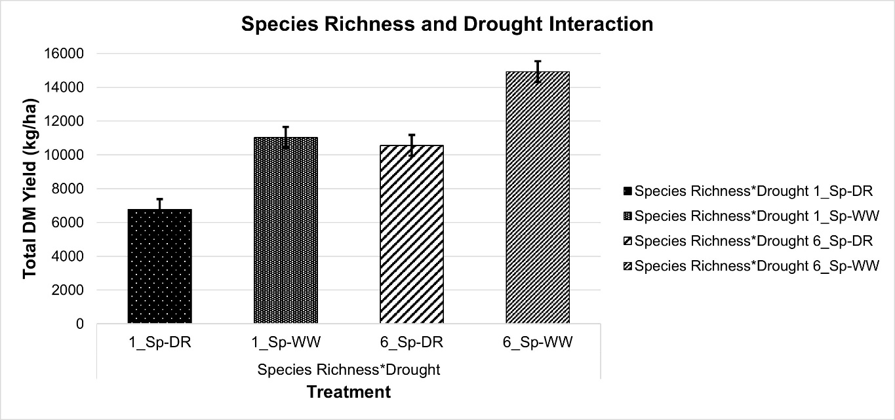
Figure 1: Interaction effects of species richness (perennial ryegrass, 1_Sp; 6 species mixture, 6_Sp) and moisture treatment (DR: drought; WW: well-watered) on total forage dry matter (DM) yield. Data are presented as mean values and SEM per treatment combination (n=5.
Acknowledgments
This project has received funding from the European Union’s Horizon 2021 doctoral network program [Marie Skłodowska-Curie grant agreement No. 101072579] and UK Research and Innovation (UKRI) [UK government’s Horizon Europe funding guarantee (grant number EP/X028003/1)]. The technical contributions of the Crops Research Unit and Centre for Dairy Research are gratefully acknowledged.

References
Finn, J. A., et al. (2018) Agric Ecosyst Environ 258, 149–153.
Khan, A. S., et al. (2023) Animal - Open Space 2, 100052.
Lüscher, A., et al. (2014) Grass and Forage Science 69, 206–228.

