**Potential use of sheep wool as a soil amendment to mitigate drought effects on red clover (*Trifolium pratense*) within a circular economy approach for grazing livestock**

**Application:** Pelleted sheep wool, mixed with compost, may help mitigate drought impacts in red-clover swards. The study was a proof of principle experiment as part of a circular economy approach for livestock grazing systems.

**Introduction:** The potential for using sheep wool as a fertiliser to support growth has previously been recognised in other plant species (Zheljazkov 2005). Previous studies demonstrated that using wool as a soil amendment can also increase the moisture content of the potting media (MacKintosh *et al*. 2023). This study investigated the potential of sheep wool to mitigate the effects of drought using red clover grown in pots in a controlled environment.

**Methods:** Red clover seedlings (n=30) were transplanted (1 seedling/pot) into 15cm pots, containing different mixtures of raw kemp sheep wool pellets and commercial compost: compost alone (0% wool), 10% wool:90% compost, or 20% wool:80% compost, mixed on DM basis. After a 29-day establishment period, a 14-day experimental phase was conducted where half the plants were maintained well-watered and the remainder were droughted, giving six treatments (5 replicates/treatment) in a randomised complete block design. Plants were maintained in controlled environment (20°C day/12°C night, and daylength to 10 hours) facilities at IBERS. At the end of the 14- day drought period, all plants were harvested and assessed for indicators of drought effects. Relative leaf water content as a measure of turgidity, and herbage yield were assessed as the main indicators of drought mitigation, alongside pot moisture, salinity and leaf area. Data were statistically analysed using Genstat (v.22) [Baird *et al,* 2022] using ANOVA and Bonferroni *post hoc* where wool content and water exposure were the treatment factors and block number was the blocking factor. Statistical significance was attributed where *P* < 0.05.

**Results:** The relative leaf water content was significantly reduced for droughted plants grown in 100% compost, confirming that plants were drought-stressed (P < 0.05, Fig. 1). The addition of wool to compost increased the relative leaf water content of droughted plants to an extent that was not significantly lower than the well-watered plants that were also grown in 10% or 20% wool (P < 0.05, Fig. 1). Pot moisture content confirmed that the droughting treatment was successfully implemented, with droughted plants in 100% compost having a lower pot moisture content compared to well – watered plants (P < 0.05). Droughted plants grown in the presence of wool had similar pot moisture content to that of the well-watered plants (P > 0.05). However, wool also increased the salinity of the potting media of both droughted and watered plants (P < 0.05). There was no significant effect of wool content or drought treatment on herbage dry matter yield or leaf area.

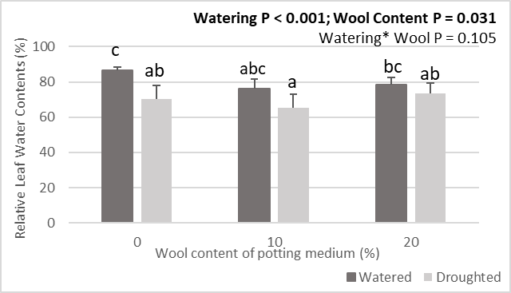

**Figure 1**. Relative leaf water contents (%) at the end of the drought period.

**Conclusion:** The data indicate that wool can mitigate the impacts of drought in the time frame studied by allowing the plant to maintain its leaf turgidity, through its effect on maintaining soil moisture content. Due to increased salinity in the potting media where wool was used, further study is required to ensure that wool used as a soil amendment does not have any potential deleterious effects when used over longer time periods. However, given the challenges associated with climate change, it is important to consider methods to combat the effects of drought, and wool used as a soil amendment may provide benefits to forage production, through re-purposing low-grade shorn wool and reducing waste on-farm.

**Acknowledgements:** This work was completed as part of the GrOw Wales Green project, led by IBERS, Aberystwyth University in partnership with Hybu Cig Cymru, British Wool, Birch Plastics, Farming Connect, Volac, Wool Testing Authority, and AHDB. This project has received funding through the Welsh Government Rural Communities - Rural Development Programme 2014-2020, which is funded by the European Agricultural Fund for Rural Development and the Welsh Government.

**References:** Baird *et al.,* 2022,GenStat® (Release 22)

MacKintosh, S. B., R. Fychan, J. Davies, H. Powell, M. Scott and C. L. Marley (2023). Regenerative Agriculture – Understanding the opportunities and challenges conference proceedings, York, UK, Assocaition of Applied Biologists.

Zheljazkov, V. D. (2005). Journal of Environmental Quality **34**(6): 2310-2317.