**Available former foods, co-products and by-products with potential for incorporation into monogastric livestock diets within the UK**

**C.C. Mulvenna1, I. Kyriazakis2, F. Short3, F. Khattak4 and R. Muns1**

**1**AFBI, Hillsborough, United Kingdom

**2**Queen’s University Belfast, United Kingdom

**3**Centre for Innovation Excellence in Livestock, United Kingdom

**4** Scotland’s Rural College (SRUC), United Kingdom

***Application:*** Increasing reliance on sustainable feed resources achieved through the valorisation of former food products (FFPs), as well as co- and by-products resulting from UK’s different manufacturing processes, can mitigate the environmental burdens and economic costs associated with the production of livestock feed.

***Introduction:*** Feed production is the largest contributor to the environmental and economic impacts associated with most livestock production systems. Rising global demand for animal products is predicted to double livestock production by 2050, intensifying competition between humans and animals for crops, land, and water use. Global livestock production systems rely heavily on unsustainable plant-based protein to fulfill dietary protein requirements, with pigs and poultry as key, competitors for human-edible crops. Using FFPs, co- or by-products has the potential to benefit local producers and the wider economy by reducing the pressures on land required for feed-crop cultivation/ landfill, environmental and water footprint of livestock feed production, and by avoiding costs associated with conventional crop production, while simultaneously valorising and recognising the value of readily available products which otherwise would be lost or incur disposal costs.. An estimated 650,000t of FFPs are processed annually in the UK for animal feed, along with 800,000t of surplus food that could be suitable for use in animal feed (WRAP, 2016). To optimise these sustainable sources, we must identify what is available and in what quantities and evaluate its suitability as a feed ingredient.

***Methods:*** A multistep approach was adopted to build an inventory of potential alternative feed ingredients from FFPs, co-, and by-products (Figure 1).

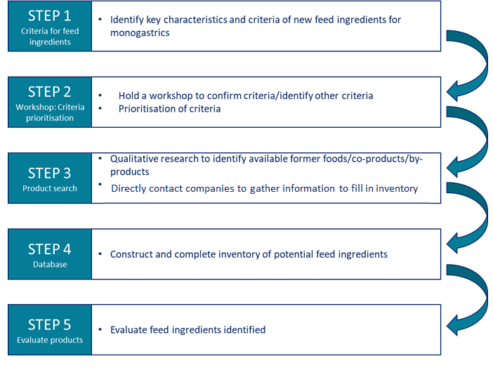

Figure 1. Overview of methodology used to construct and populate the alternative ingredient inventory.

The initial phases of this research project encompassed a systematic approach to identify and prioritise the key characteristics or criteria when considering a potential feed ingredient for the diets of non-ruminant livestock. These preliminary steps (Steps 1 and 2) involved a meticulous process of identifying and prioritizing the critical characteristics and criteria through consultations with stakeholders in the animal feed industry and researchers specialising in this field. Step 3 entailed extensive desk-based qualitative research aimed at sourcing and collating information on available products. This phase was characterised by direct engagement with various sectors of the industry, including animal feed companies, feed mills, supermarkets, large-scale and local food producers/processors, nutritionists, waste management companies, etc. This was complemented by a thorough review of both published scientific and grey literature (news articles, industry websites, and published government reports). This multi-pronged approach not only facilitated the identification of areas of focus and sources of information but also broadened the scope of the search for potential feed ingredients. To foster broader communication and acquire additional insights, questionnaires were prepared and distributed within industry working groups. With the amalgamation of information from these various sources, an extensive inventory of potential feed ingredients was meticulously constructed and populated with a wide array of data, including details on product generation, availability, stability, safety, regulatory implications, acceptability, environmental impact (assessed using Life Cycle inventory sourced from suppliers or assigned based on the GFLI database), functionality, incorporation, and cost related attributes.

***Results:*** Over 60 companies across the UK livestock feed industry and the food and drinks production industry were directly contacted to identify FFPs, co- or by-products. Responses and data from four major feed suppliers and one algae-based company, the survey generated an inventory of 17 FFPs and 21 co-products. Among these, 17 FFPs and 21 co-products showed potential for pig diets, and seven FFPs and one co-product were found suitable for poultry diets. Most of the ingredients identified came from the brewery/distillery (17) and baking (10) industries. The inventory registers 14 products with crude protein (CP) over 20%, the highest being Brewers yeast (CP 35-40%, lysine 2.7%). Nineteen ingredients were liquid or moist, which limits their widespread use across pig systems in their current form. Information on availability, location, further processing requirements, and cost of the products was limited or unavailable, especially for Wales and Northern Ireland. Ingredients in the inventory have a lower environmental impact (ranging 5.2- 406.2 kg CO eq / tonne product) than imported South American soyabean meal (3050 kg CO eq / tonne product, Tallentire et al. 2017).

***Conclusions:*** In conclusion, collation of information presented in this report has identified significant gaps in the information available in the public domain pertaining to FFPs, co-/by-products within the UK feed industry. To progress the utilisation of these products as sustainable dietary ingredients for non-ruminant animals, it is imperative to establish a co-ordinated UK-wide strategy aimed at systematically identifying and categorising FFPs, co- and by-products. Such an approach will facilitate the advancement of processing and development techniques, ultimately promoting the utilisation of these underutilised resources.

***Acknowledgements:*** Funding was provided by the CIEL.

***References:*** WRAP UK, 2016. Quantification of food surplus, waste and related materials in the grocery supply chain, Final Report.

Tallentire CW, Mackenzie SG and Kyriazakis I, 2017. Agricultural Systems, 154, 145-156.