Application
This is the first Life Cycle Assessment (LCA) that directly quantifies the environmental impact of beef-on-dairy (BxD) production in the UK and evaluates differences due to genetics. This novel method provides a framework for quantifying the environmental footprint resulting from genetic improvement, enabling the impact of a targeted breeding programme to be measured in terms of environmental outcomes.
Introduction
Amidst the rapid development of new sustainability interventions for livestock, genetic improvement remains the most impactful approach to permanently increase production efficiency. To fully realise efficiency gains, traits that impact animal performance from birth to slaughter must be considered for genetic selection, which is rarely accomplished in beef breeding programmes due to the segmented nature of the industry. BxD systems provide an opportunity to collect full lifecycle data, including traits related to growth, efficiency, and carcass characteristics, and comprise 35% of prime cattle slaughtered in Great Britain. Although genetic improvement is not a new technology, targeted index selection for BxD production is uncommon, and the effect of targeted breeding programmes on the environmental impact of livestock production remains largely unknown.
LCA is the gold standard for determining the environmental impact of livestock production. Several notable LCAs have assessed the environmental footprint of suckler beef (e.g., Putman et al., 2023), and one LCA has accounted for genetic merit in swine (Thoma et al., 2024); however, at present, no LCAs analysing BxD systems have been published.
The study objectives were to (1) provide a novel framework to include genetic merit in an LCA to quantify the environmental benefits achieved from genetic improvement, and (2) present the first environmental footprint for BxD production.
Materials and Methods
Attributional LCA models were developed for two UK BxD populations, each with distinct breeding goals: one targeted for commodity beef programmes emphasising age at slaughter, feed efficiency and carcass yield (HY), and the other for high-value Angus programmes emphasising growth and carcass quality (HQ).
Within each population, two genetic levels were assessed, where levels were based on the programme-specific selection index of the sire: average and elite (³1.8 SD above the mean) genetic merit. The system boundary included the dairy where the animal was conceived, the growing phases to reach slaughter weight – weaning, rearing, grazing (HQ only) and finishing – feed production and manure management from the growing phases, and the abattoir.
LCA inputs comprised animal performance and feed data (N=10,214 HQ and N=3,132 HY). Data was aggregated from individual records in each growing phase for BxD animals in commercial settings. Traits included average daily gain, days in growing phase, and individual dry matter intake from feed intake trials (HY only). To account for genetic merit in the LCA, animal performance traits were averaged across genetic levels within each growing phase and population and used as inputs into the LCA.
Impact assessment was performed according to the Product Environmental Footprint method 3.1 (European Commission, 2021). Each environmental impact category was reported per one kg carcass weight (CW), the functional unit.
Results
The emission intensity for animals of average and elite genetic merit was 18.05 and 17.21 kg CO₂e/kg CW, respectively, for HQ (-4.66% reduction from average to elite) and 8.77 and 7.99 kg CO₂e/kg CW, respectively for HY (-8.82% reduction from average to elite). Manure management, feed production, and enteric fermentation were the primary contributors to emission intensity for both populations (Figure 1).

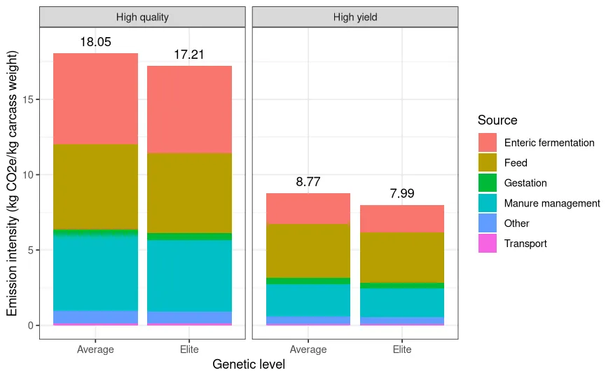
.
Figure 1. Emission intensity of each genetic level (average vs. elite) within each population (high quality vs. high yield), by emission source. Total emission intensity for each genetic level is above each bar.
Total emission intensity and enteric fermentation values from both average and elite genetic levels were lower than those previously reported for Northern European beef production (20.41 kg CO2e/kg CW from FAO, 2022), indicating an overall potential environmental advantage for BxD.
Environmental impact of the elite genetic level was lower than that of the average genetic level in both populations. The larger impact in the HQ population compared to the HY population across all categories was driven by higher slaughter ages due to the required 180-day grazing period. Feed efficiency and days in the finishing phase were the primary drivers of impact.
Conclusions
The environmental impact of targeted breeding programmes can be assessed using LCAs that incorporate genetic improvement. Genetic selection aimed at the BxD value chain results in more efficient resource use and lower environmental impact of beef production.
LCAs developed for animal protein production should account for differences in genetic merit to capture the added environmental benefits that genetic improvement confers to the entire system. The environmental benefits achieved through genetic improvement, while incremental per generation, are permanent and cumulative over multiple generations. Consequently, continued genetic improvement will further reduce the environmental impact of BxD production relative to average BxD genetics, emphasising that designed genetic programmes are an integral part of developing protein production systems with lower environmental impact.
References
European Commission. (2021). Commission Recommendation (EU) 2021/2279 of 15 December 2021 on the use of the Environmental Footprint methods to measure and communicate the life cycle environmental performance of products and organisations
FAO. (2022). GLEAM 3 Dashboard. In: Shiny Apps. Cited [2024-01-14]. https://foodandagricultureorganization.shinyapps.io/GLEAMV3_Public/
Putman, B., Rotz, C. A., & Thoma, G. (2023). Journal of Cleaner Production, 402, 136766.
Thoma, G.J.; Baker, B.; Knap, P.W. (2024). Animals, 14(2435).

