Title: Predicting, validating and applying mixed parasite infection models for sheep under current and future climate scenarios
Application: Assessment and adaptive management of mixed parasite infections on grazing pasture to modify treatment interventions and limit chemical inputs.
Introduction: Livestock are often infected with multiple parasites and pathogens, yet control efforts in the host are generally focused on one agent at a time. Furthermore, the importance of the mixed population of infective parasite stages residing on pasture, and therefore risk of future co-infections in the host, are often neglected. This is further complicated by the fact that parasite population dynamics on grazing pastures are not static, but fluctuate spatiotemporally, driven by external factors such as environmental conditions and farm management (Eysker et al., 1998; O’Connor et al., 2006). This complicates day-to-day livestock management and anthelmintic treatment decisions, as strategies must consider current and future infection risk for multiple parasite species.
Climate change is shifting the traditional seasonal patterns of parasite infections and is projected to continue doing so, altering the occurrence of co-infections (van Dijk et al., 2008; Rose et al., 2016) and presenting farmers with additional uncertainty when timing anthelmintic interventions. Improving parasite management strategies to attenuate parasite transmission relies on adequate knowledge of the complex spatiotemporal patterns of multiple parasite species. Our aim was to apply a suite of mathematical models capable of predicting gastrointestinal nematode (GIN) population dynamics for multiple species at the regional, farm and individual field scale, under current and future climate scenarios. These predictions can be used to guide targeted parasite management strategies.
Materials and methods: To assess overlapping parasite seasonality and likelihood of co-infections at the regional and farm level in the UK, an egg hatch prediction model for Nematodirus battus (Gethings et al., 2015), was used alongside the Q0 spatial predictor and GLOWORM-FL model frameworks for Haemonchus contortus and Teladorsagia circumcincta (Rose et al., 2015; 2016). Q0 values ≥1 signify that environmental conditions are conducive to population growth in the absence of host immunity with resultant increased infection pressure. To assess recent predicted seasonality of these parasites in the UK, temperature and precipitation data between 2012-2022 were extracted from the E-OBS gridded datasets (Cornes et al., 2018) at 0.1° resolution. Meanwhile, to predict the likelihood of future alterations in species transmission windows, climate data from the UK Climate Projections 2018 (UKCP18) project were assessed.
To predict GIN risk on a field-by-field basis, the model reported by McFarland et al., (2022) was adapted to predict H. contortus and T. cirumcincta L3 on pasture. Model inputs were collected on a commercial sheep farm in Northern Ireland (NI), during the 2023 grazing season. Pooled faecal samples were collected from batches of ewes and lambs on eight occasions during the 2023 grazing season. A combination of traditional and molecular diagnostics were applied to collected parasite lifestages to examine species composition and relative abundance. These data were used to validate the models and permit scenario based modelling for individual species. To further validate model predictions under current climatic conditions, longitudinal pasture larvae counts were carried out on six selected fields to monitor observed L3 pasture contamination relative to model predictions. Final model inputs consisted of daily total precipitation (mm), daily mean temperature (°C) and predicted total number of GIN eggs deposited on each ﬁeld per hectare, per day. Model outputs were adjusted to predict daily L3/kg of DM herbage for each of the respective ﬁelds.
Results: Assessment of model predictions at the regional and farm level suggested parasite species seasonality varied based on geographic location and climatic conditions. Figure 1 illustrates the differences in predicted H. contortus seasonality and the model predicted number of infective L3 larvae on pasture for two farm locations in the UK during the 2020 grazing season. Model predictions using the Q0 and GLOWORM-FL models illustrated that environmental conditions were conducive for the maintenance of H. contortus populations in NI (Fig. 1A) and the South-East of England (Fig.1B). However, increased population growth and number of infective L3 on pasture was predicted for the NI farm between June-August 2020 compared to the farm in South-East England. This was likely due to increased precipitation during the summer months in NI, a requirement for H. contortus development, motility and survival. Changing shifts in transmission windows were also predicted for the modelled parasite species under climate change scenarios.
Model predictions of GIN risk on a field-by-field basis suggested that parasite species composition varied on fields throughout the grazing season relative to timing and length of the grazing period. Pasture larvae counts often showed agreement with model predictions, however on occasion predicted and observed levels of field L3 contamination did not align. GIN faecal egg counts varied throughout the grazing season relative to sample collection date and application of anthelmintic treatments. Parasite species, including T. circumcincta, Trichostrongylus colubriformis, Oesophagostomum venulosum and N. battus were isolated from faecal and pasture samples and confirmed the occurrence of mixed parasite infections both within the host and on grazing pastures.
Conclusions: Simulation models are important tools to predict general GIN population dynamics, and alongside improved, affordable, species-level diagnostics could provide a valuable resource for predicting pasture infectivity with multiple parasite species. The current study demonstrated how these models can be applied to predict GIN population dynamics at multiple scales including regional, farm and the individual field level. Predictions using current and future climate projections highlighted the variability in seasonality between species at different geographic locations and the likelihood of host co-infection risk. These predictions can be used to develop and assess targeted parasite management strategies that are flexible enough to respond to rapidly changing parasite phenology and farm management.
Acknowledgements: The authors acknowledge funding from BBSRC grant number BB/X017567/1.
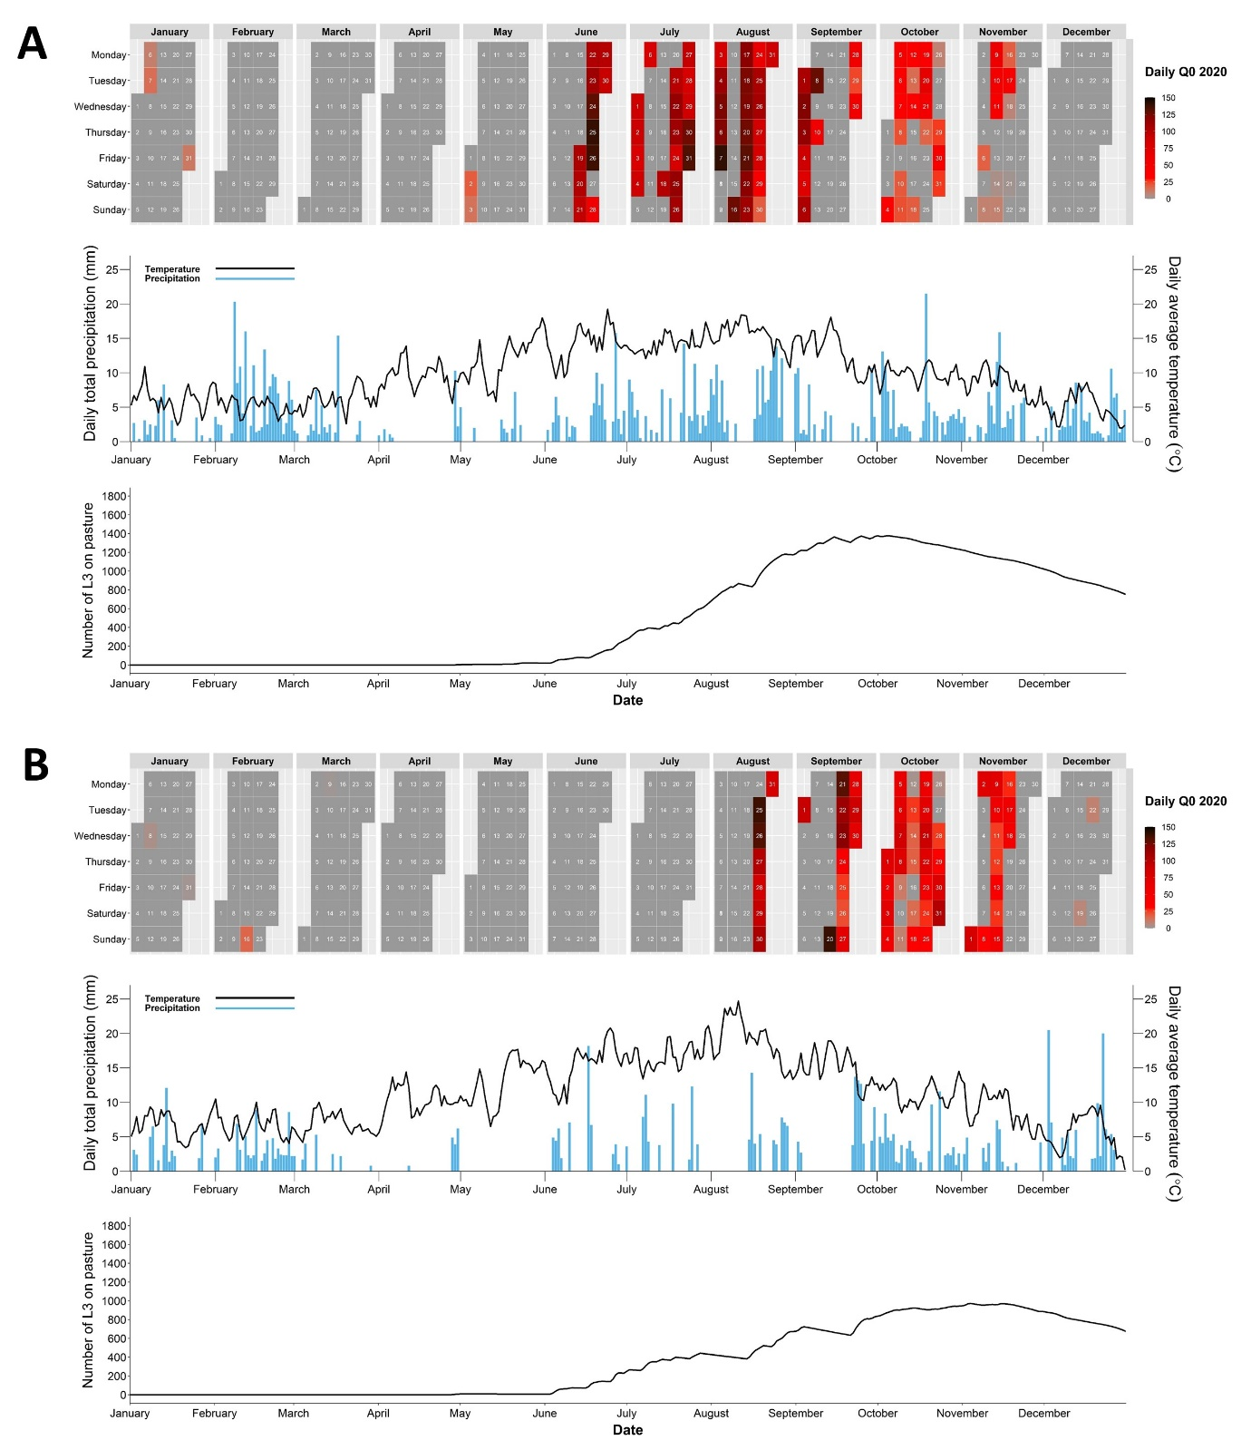
Figure 1. Q0 and GLOWORM-FL model predicted population growth and number of infective L3 on pasture for Haemonchus contortus for a farm in Northern Ireland (A), and South-East England (B). The top panel in (A) and (B) shows daily predicted Q0 values for each location between January and December 2020. The middle panel in (A) and (B) illustrates the daily average temperature (°C) and daily total precipitation (mm) for each farm location. The bottom panel in (A) and (B) illustrates the GLOWORM-FL model predicted number of L3 on pasture for each farm location when model inputs consisted of 100 parasite eggs per day for the duration of the simulation.

References:
Cornes, R. C., van der Schrier, G., van den Besselaar, E. J., & Jones, P. D. (2018). Journal of Geophysical Research: Atmospheres, 123(17), 9391-9409.
Eysker, M., Van Der Aar, W. M., Boersema, J. H., Githiori, J. B., & Kooyman, F. N. J. (1998). Veterinary Parasitology, 76(1-2), 81-94.
Gethings, O. J., Rose, H., Mitchell, S., Van Dijk, J., & Morgan, E. R. (2015). Parasitology, 142(10), 1306-1317.
McFarland, C., Vineer, H. R., Chesney, L., Henry, N., Brown, C., Airs, P., Nicholson, C., Scollan, N., Lively, F., Kyriazakis, I., & Morgan, E. R. (2022). International Journal for Parasitology, 52(10), 691-703.
O’Connor, L. J., Walkden-Brown, S. W., & Kahn, L. P. (2006). Veterinary Parasitology, 142(1-2), 1-15.
Rose, H., Wang, T., van Dijk, J., & Morgan, E.R., (2015). Ecological Modelling, 297, 232–245.
Rose, H., Caminade, C., Bolajoko, M. B., Phelan, P., van Dijk, J., Baylis, M., Williams, D., & Morgan, E. R. (2016). Global Change Biology, 22(3), 1271-1285.
van Dijk, J., David, G. P., Baird, G., & Morgan, E. R. (2008). Veterinary Parasitology, 158(1-2), 73-84.

