Title: (Use Normal style (Times New Roman 12). Only capitalise the first letter of the first word. No full stop at the end of the title)
Construction of the mRNA-miRNA regulatory network identifies candidate genes and pathways associated with Johne's disease in dairy cattle.
Summary: (Your summary (Times New Roman 10) must use Body text style and must not be longer than this box)
Application This comparative transcriptome profiling analysis allows for the identification of associated mRNAs/genes and miRNAs, their functions, and important pathways in Johne's disease and healthy samples.

Introduction Johne's disease (JD) is a chronic and incurable disease in ruminants that severely affects animal welfare and causes great economic losses for worldwide livestock production, especially in dairy cattle (Ariel et al., 2020). The causative agent, Mycobacterium avium ssp. paratuberculosis (MAP), causes chronic enteritis in ruminants, eventually leading to weight loss, diarrhea, gradual decrease in milk production, and death of infected animals. As the usual diagnostic methods to control this disease are ineffective, alternative diagnostics are urgently needed for disease control. During infection, MAP bacilli undergo phagocytosis by host macrophages, causing subclinical infections that can lead to immunopathology and disease dissemination (Casey et al., 2015). Therefore, analysis of the host macrophage transcriptome during infection is expected to elucidate molecular mechanisms and host-pathogen interactions associated with Johne's disease. In addition, although non-coding RNAs (ncRNAs; e.g., miRNAs) have an important role in regulating immune system function and may provide valuable information about the disease, their role in paratuberculosis infection in cattle has not yet been fully investigated (Marete et al., 2021).

Materials and Methods Microarray and RNA-Seq datasets from peripheral blood mononuclear cells (PBMCs) of Johne's disease and healthy Holstein dairy cattle were retrieved from the National Center for Biotechnology Information (NCBI) Gene Expression Omnibus (GEO) public database. Gene set annotation and functional enrichment analysis were applied to explore hub mRNAs/genes and miRNAs related to Johne's disease using DAVID, g:Profiler, GeneCards, and STRING database to determine potential functions, metabolic, and signaling pathways. Interactions between types of RNAs (i.e. mRNAs/genes and miRNAs) identified were predicted, and a mRNA-miRNA regulatory network was constructed by integrating the protein-protein interaction (PPI) network and gene regulatory network (GRN). Genes were assigned to functional categories using the Gene Ontology (GO) database under biological process (BP), molecular function (MF), and cellular component (CC).

Results Comparative transcriptomics-related analyses identified 4536 and 783 differentially expressed genes (DEGs) between Johne's disease and healthy groups for RNA-Seq and microarray datasets respectively, based on the fold change (≥1 and ≤−1) and false discovery rate (FDR <0.05). Among these, 23 genes were common between RNA-Seq and microarray datasets. In addition to DEGs, 19 miRNAs were also simultaneously identified in the RNA-Seq datasets. Furthermore, we identified 10 hub genes (CCL20, CCL4, IL10, NOS2, NR4A1, PTGS2, SERPINE1, TFPI2, TNFAIP6, and TNFSF13B) involved in dairy cattle Johne's disease. Identified biological and regulatory networks were mainly associated with immune system signature pathways. Gene ontology annotation and enrichment analysis, based on the mRNA-miRNA regulatory network (Figure 1) revealed 20, 1, and 1 GO terms related to Johne's disease in the biological process, molecular function, and cellular component categories, respectively. In addition, KEGG enrichment analysis identified cytokine-cytokine receptor interaction, intestinal immune network for IgA production, and signaling pathways for IL-17, TNF, HIF-1, and NF-kappa B. Gene set annotation and functional enrichment of identified DEGs implicated important biological pathways.

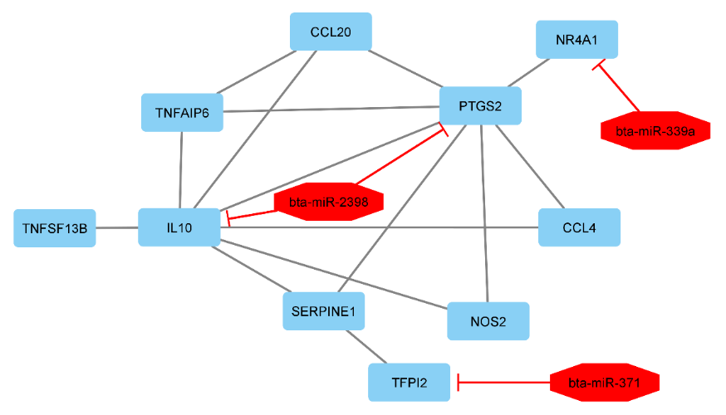
Figure 1. mRNA-miRNA regulatory network on Johne's disease in dairy cattle.

Conclusions These findings provided valuable insights into the molecular evidence for the biological mechanisms of transcriptome profiling of Johne's disease versus healthy Holstein dairy cattle. In addition, they are an impetus to elucidate molecular networks and functions of DEGs associated with peripheral blood mononuclear cells regarding immune system function and a starting point for future studies on bovine Johne's disease.

References
Ariel, O., Gendron, D., Dudemaine, P.L., Gévry, N., Ibeagha-Awemu, E.M. & Bissonnette, N. (2020). Frontiers in Immunology 10, 2874.
Casey, M.E., Meade, K.G., Nalpas, N.C., Taraktsoglou, M., Browne, J.A., Killick, K.E., Park, S.D., Gormley, E., Hokamp, K., Magee, D.A. & MacHugh, D.E. (2015). Frontiers in Immunology 6, 23.
Marete, A., Ariel, O., Ibeagha-Awemu, E. & Bissonnette, N. (2021). Frontiers in Veterinary Science 8, 639053.

