**Potential of genetic selection for feed efficiency, carcass quality and meat quality traits in sheep: A meta-analysis**

**Steffimol Rose Chacko Kaitholil1, Aurelie Aubry2, Faisal Rezwan3, Mark Mooney1, Masoud Shirali1,2**

**Queens University, Belfast, UK1, Agri-food & Biosciences Institute, NI, UK2, Aberystwyth University, Wales, UK3**

**Application*:*** The success of genetic selection programs depends on the heritability of the traits used as indicators in breeding programs. The study revealed that feed efficiency and carcass quality traits in sheep possess moderate to high heritability, while meat quality traits exhibit relatively lower heritability. This information could be valuable for those involved in breeding and selection programs for sheep and could help inform decisions regarding which traits to prioritize in such programs.

**Introduction*:*** Over the years, genetic selection has proved to be an effective tool in enhancing the productivity and performance of livestock. Through this method, specific desirable traits are identified and selected for breeding, leading to the production of offspring with enhanced genetic makeup and improved performance in areas such as growth rate, feed efficiency (FE), carcass quality (CQ), and meat quality (MQ). With continuous improvements in genetic and genomic technologies, farmers and breeders can now use these advanced techniques to further refine their selection criteria, leading to the development of even more robust and high-performing animal breeds. To achieve successful genetic selection, trait heritability (h2) plays a crucial role (Habtegiorgis et al., 2022), with various studies reporting varying estimates of h2 for these traits in sheep. This study aimed to combine the results from these individual studies in a statistical meta-analysis to obtain a deeper insight into the genetic parameters of key efficiency and production-related traits in sheep.

**Materials and methods*:*** The search strategy for the meta-analysis was performed based on the preferred reporting items for the systematic reviews and meta-analyses (PRISMA) framework using databases namely, EBSCO, PubMed, Scopus, and Web of Science. The keyword search included ovine, sheep, lambs, ewes, or rams, and no publication date limits were enforced due to the limited availability of sheep data. Subsequently, only studies on h2 of FE, CQ, and MQ traits were selected with those unrelated, such as wool characteristics and milk production, excluded. Nine published records between 2005 and 2023 were identified which analyzed h2 from a diverse range of sheep breeds, including Merino (n=27,690), Targhee (n=1,047), Romane (n=951), New Zealand maternal sheep (n=986), Canadian crossbred lambs (n=16,565) and composite rams (½ Columbia, ¼ Hampshire, ¼ Suffolk) (n=1,239), with a total of 48,478 sheep included. The R package meta (Borenstein et al., 2021) was utilized to perform a meta-analysis of seven FE, CQ, and MQ traits in sheep including residual feed intake (RFI), feed conversion ratio (FCR), hot carcass weight (HCW), intramuscular fat (IMF), dressing percentage (DP), pH and shear force, with a random-effects model used to account for variability in estimations. Findings were summarized, and forest plots were generated to visualize and interpret observations.

**Results*:*** Performed meta-analysis conducted in this study indicates that RFI presents a moderate h2 estimate of 0.27±0.07 (P<0.05) as an FE trait. Similarly, CQ traits such as HCW, IMF, and DP were found to be moderately to highly heritable, with h2 estimates of 0.26±0.05 (P<0.05), 0.45±0.04 (P>0.05), and 0.23±0.05 (P>0.05) respectively. Conversely, pH and shear force, which are meat quality traits, showed less heritability, with h2 estimates of 0.09±0.02 and 0.20±0.08 respectively (both P>0.05). Notably, RFI, FCR, HCW, and shear force exhibited significant heterogeneity, with I2 index values of 78, 77, 75, and 65, respectively which could be attributed to various factors such as breed, management, and diet.

**Conclusion*:*** The results of the meta-analysis are highly informative on the genetic underpinnings of key traits such as FE and CQ, both of which have been found to have moderate to high heritability. The inclusion of these traits into the selection programs will be of substantial benefit to breeders and farmers in the production of animals with superior performance in these traits. The findings will serve as a foundation for future research on genomics applications such as genome-wide association analysis of FE, CQ and MQ traits in sheep.

**Figure 1**: Forest plot representing moderate to high heritability estimates for a) RFI and b) HCW (P<0.05).

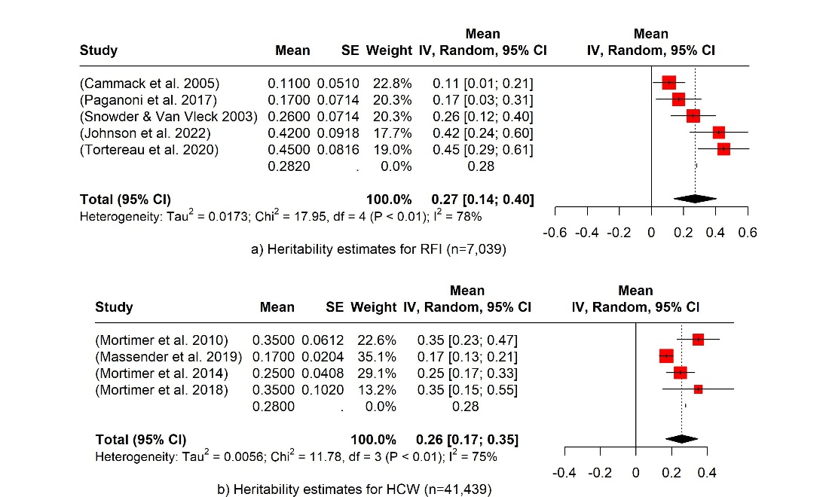

**Acknowledgements*:*** The authors acknowledge funding support from the UKRI doctoral training (Grant no: BB/T008776/1) UKRI Biotechnology and Biological Sciences Research Council (BBSRC) Doctoral Training Partnership (DTP) FoodBioSystems under grant no BB/T008776/1, and CASE studentship funding from Agri-food Bioscience Institute (AFBI) through Northern Ireland Farm Animal Biobank (project no: 21/5/01 funded by DAERA).

**References*:*** BORENSTEIN, M., HEDGES, L. V., HIGGINS, J. P. & ROTHSTEIN, H. R. 2021. *Introduction to meta-analysis*, John Wiley & Sons.

HABTEGIORGIS, K., HAILE, A., GETACHEW, T., KIRMANI, M. A. & GEMIYO, D. 2022. Analysis of genetic parameters and genetic trends for early growth and reproductive traits of Doyogena sheep managed under community-based breeding program. *Heliyon,* 8.