***Application***

The present study is relevant for improving animal welfare protocols and providing better animal management practices in the livestock sector.

***Introduction***

Various climatic variables influence animal welfare aspects (Gauly et al., 2013). Understanding the behavioural dynamics of cattle in response to environmental changes is pivotal for optimizing animal welfare and farm management practices. The Temperature-Humidity Index (THI) is a relevant indicator commonly used to assess the environmental stress in livestock, particularly under extreme environmental conditions (Dunn et al., 2014). Qualitative Behavioural Assessment variables (QBA), first introduced by Wemelsfelder et al. (2000) to assess the welfare of farm animals, incorporate data on animals' body language. The objective of the present study was to analyse the relationship between THI and the QBA descriptors.

***Materials and Methods***

We conducted QBA on beef cattle across three farmlets such as two pasture-based (based on permanent pasture (PP), and based on reseeded grass-clover swards (GWC); cattle housed at weaning and turned out to pasture in spring) and one intensive finishing system (IFS; 40% concentrate, 60% silage; cattle housed at weaning and kept indoor until finishing) from January to December 2023 at the North Wyke Farm Platform (NWFP), Rothamsted Research, UK. We assessed animal welfare through QBA as adapted by Cooke et al. (2023), recorded between weekly and monthly (varying between months) and evaluate the influence of THI on the QBA descriptors, such as activity levels and social behaviours in beef cattle over the three systems. The THI was calculated from the air temperature (Ta) and relative humidity (RH) data recorded automatically every 15 min at the NWFP met station. Pearson correlation coefficients were computed to measure the strength and direction of the relationships between THI [THI= (0.8*Ta + (RH/100) * Ta – 14.4)- 46.4] (Habeeb et al., 2018), and QBA descriptors. Principal Component Analysis (PCA) was employed to reduce the dimensionality of the QBA descriptors and to identify patterns of variation among the behavioural responses. Further, PCA biplots were created to visualize the clustering of farmlets and the contributions of QBA variables to the principal components. In addition, an ANOVA was performed to examine the effects of farmlets, THI, and their interaction on the QBA variables.

***Results***

The mean THI was 62 in the summer and 48 in the winter (Figure 1). The analysis revealed several negative (p<0.05) correlations between THI and QBA variables in the three systems. Notably, ‘Calm’ (-0.52, -0.17, -0.25), ‘Active’ (-0.46, -0.54, -0.44), ‘Lively’ (-0.36, -0.44, -0.30), and ‘Playful’ (-0.37, -0.41, -0.40). Negative correlation between THI and ‘Agitated’ (-0.38, -0.25, -0.26), ‘Apathetic’ (-0.38, -0.45, -0.35) and ‘Distressed’ (-0.38, -0.38, -0.42) (correlation values were indicative to IFS, PP and GWC, respectively) were also found, indicating decreased behavioural expression in animals with higher THI levels. However, ‘Indifferent’ showed a positive correlation with THI in farmlets IFS, PP and GWC (0.13, 0.41, 0.38). Moreover, the absence of a considerable negative correlation of THI with the remaining QBA variables does not indicate that these variables are irrelevant but rather that they may indicate adaptive behavioural responses to THI during the study period. Farmlets-specific effects were not significant, suggesting that treatments across the three farmlets did not influence the QBA variables (p = 0.340). The PCA biplot (Fig 2) provides a comprehensive visual representation of the relationships between QBA descriptors and the grouping of farmlets (IFS, PP and GWC). Dim1 (27.5% of variance explained) and Dim2 (16.4% of variance explained) collectively account for 43.9% of the variability. The overlap of the farmlets within the PCA biplot ellipses indicates that behavioural patterns among the three groups are not distinctly separated. This finding suggests that farmlets conditions may not influence the overall QBA of animals, which is further supported by the results of the ANOVA analysis (p = 0.557). Hence, the study highlights the impact of THI on various aspects of beef cattle behaviour.

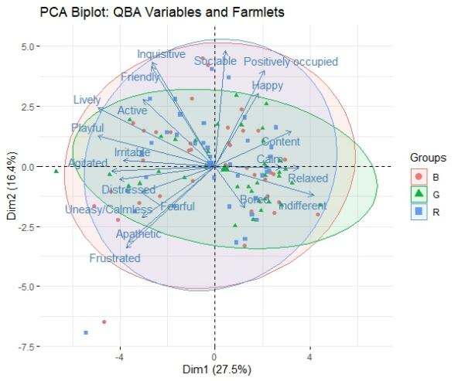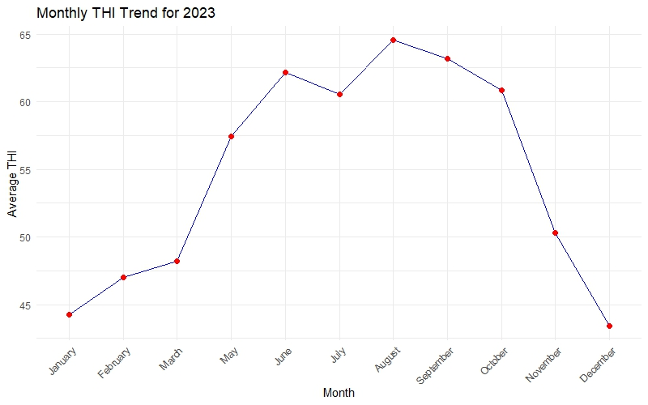

|  |  |
| --- | --- |
| **Fig 1**. Temperature and Humidity Index (THI) during the assessment period | **Fig 2***. Principal Component Analysis Biplot of QBA Variables across three Different Farmlets Systems [IFS (R), PP (G), GWC (B)]. Dim1 (27.5%) and Dim2 (16.4%) Variability Explained.* |

***Conclusion***

It is evident that THI had a relationship with the QBA descriptors reflected in the behaviours across all three farm systems that were investigated. Given that all the farmlets demonstrated a negative correlation across QBA variables, were influenced by changes in THI, and no PCA difference among farming systems, the findings underscore the importance of incorporating environmental considerations into animal welfare strategies in all farming systems.

***References:***

1. Cooke, A. S., Mullan, S., Morten, C., Hockenhull, J., Le-Grice, P., Le Cocq, K., Lee, M. R., Cardenas, L. M., & Rivero, M. J. (2023). *The Journal of Agricultural Science, 161*(3), 450–463.
2. Dunn, R. J., Mead, N. E., Willett, K. M., & Parker, D. E. (2014). *Environmental Research Letters, 9*(6), 064006.
3. Gauly, M., Bollwein, H., Breves, G., Brügemann, K., Dänicke, S., Daş, G., Demeler, J., Hansen, H., Isselstein, J., König, S., & Lohölter, M. (2013). *Animal, 7*(5), 843–859.
4. Habeeb, A. A., Gad, A. E., & Atta, M. A. (2018). *International Journal of Biotechnology and Recent Advances, 1*(1), 35–50.
5. Wemelsfelder, F., Hunter, E. A., Mendl, M. T., & Lawrence, A. B. (2000). *Applied Animal Behaviour Science, 67*(3), 193–215. https://doi.org/10.1016/s0168-1591(99)00093-3