*Exploring Factors Associated with Peripartum Subclinical Hypocalcemia in Dairy Cows Using a Multivariate Approach*

Corresponding author: J.C Ángeles- Hernández

***Key words*** milk, multivariate analysis, hypocalcemia, cattle.

***Application***

In practical terms, identification of high-risk cows based on coat colour, temperature-humidity index (THI) level and parity can optimise herd management strategies and allow early detection and prevention of Subclinical hypocalcemia (SCH). This approach can increase productivity and improve animal welfare in dairy systems.

***Introduction***

Subclinical hypocalcemia (SCH) is an important metabolic disorder in dairy production because calcium plays a critical role in many physiological processes. Prolonged low serum calcium concentrations postpartum can lead to reduced milk yield, immune dysfunction, mastitis, metritis and decreased fertility (Caixeta et al 2017). Factors such as parity, metabolic alkalosis and dietary levels of Ca, Mg and P have been widely associated with disturbances in calcium homeostasis. However, other factors such as temperature-humidity index (THI), number of calves, calving month and cow coat colour have been less studied. The aim of this study was to investigate these non-conventional factors and its potential association with the incidence of SCH in dairy cows using a multivariate approach.

***Material and methods***

A total of 362 multiparous cows from a commercial farm in Jalisco, Mexico, at 21° N 163° W were studied between July 2023 and January 2024. Blood samples were collected from each animal at calving, 24, 48 and 72h postpartum. Ionised calcium levels were measured immediately after sampling using portable equipment (LAQUAtwin Ca-11C, HORIBA, Japan). Cows were classified as having or not having SCH based on their serum ionised calcium concentration, using a cut-off value of 1 mmol/L (Neves et al., 2018). In addition, the following information was recorded: coat colour (predominantly black = 121, predominantly white = 45 and spotted = 187), THI, body condition score at calving (scale 1-5), calving month, parity (1-7), number of calves (1 or 2), ambient humidity, maximum ambient temperature and calf sex. Due to the number of variables involved in the study, a multivariate analysis approach using Factor Analysis of Mixed Data (FADM) was used. This methodology analyses the similarities between individuals when mixed variables are considered; it also allows for the exploration of the association between quantitative and qualitative variables. The ellipse plot facilitates the interpretation of the FADM, which uses projections of clouds of individuals to which concentration ellipses corresponding to given characteristics were added. The FADM was carried out using the FactoMineR package (Le et al., 2008) and FactoExtra (Kassambara and Mundt, 2017) in R (R core team, 2022).

***Results and Discussion***

The FAMD factor map showing clustering based on coat colour, calving month, number of calves, parity and THI scores is shown in Figure 1. Our results indicate that a higher incidence of SCH at all time points was closely associated with spotted and black coat colours, whereas cows with white coats had a lower incidence. To our knowledge, this is the first work reporting these findings. Regarding the effect of THI, our results show that moderate THI levels had a detrimental effect regardless of coat colour. Conversely, lower THI levels were slightly associated with a reduced incidence of SCH across all measurements. The months of October and November showed a stronger association with the presence of SCH at all time points, whereas July and August showed a weaker association with SCH. Older cows were found to be more susceptible to SCH, as shown in Figure 1, with cows with more than five parities having a higher incidence of SCH it is in accordance with Reinhardt et. al., (2011), who found that SCH was more prevalent at higher age. Finally, cows giving birth to twins were found to have a greater predisposition to SCH.

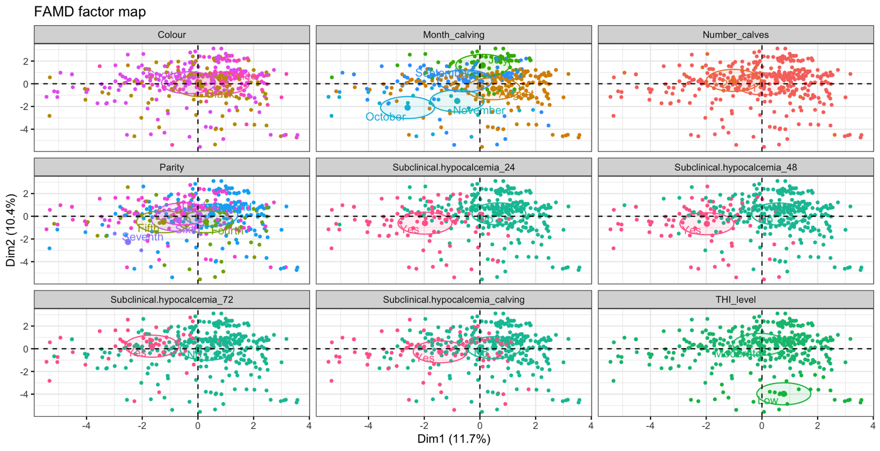 **Figure 1.** Ellipse plots of the factor analysis of mixed data.

***Conclusion***

This study highlights the multifactorial nature of SCH in dairy cows, revealing associations between its incidence and non-conventional factors such as coat colour, THI levels, calving month, parity and calving number/size. Spotted and black coated cows, moderate THI levels and older cows were identified as being at higher risk of SCH. These results suggest that considering these factors in herd management strategies could improve the early detection and prevention of SCH, potentially improving productivity and welfare in dairy systems. Further research is warranted to validate these findings and explore targeted interventions.

***Acknowledgements***

Special thanks to DVM Mario Gutierrez and Refugio Padilla from San Juanico Dairy farm in San Juan de Los Lagos Mexico

***References***

Anzures-Olvera, F., Véliz, F.G., De Santiago, A., García, J.E., Mellado, J., Macías-Cruz, U., Mellado, M., 2019. Journal of Thermal Biology, 81, 82-88.

Caixeta, L.S, Ospina, P.A, Capel, M.B, Nydam, D.V. 2017. Theriogenology. May; 94:1-7.

Kassambara, A., and Mundt, F., 2017. <https://doi.org/10.32614/cran.package.factoextra>.

Le, S., Josse, J., and Husson, F., 2008. Journal of Statistical Software, 25(1), 1-18. <https://doi.org/10.18637/jss.v025.i01>.

Neves, R. C., Stokol T, Bach K.d, McArt J.A. 2018. Journal of Dairy Science. 101:1334–1343 <https://doi.org/10.3168/jds.2017-13779>

R, Core Team, 2022. R. R Foundation for Statistical Computing. <https://www.R-project.org>.

Reinhardt T.A, Lippolis J.D, McCluskey B.J, Goff J.P, Horst R.L. 2011. Vet J. Apr;188(1):122-4.