**Application**

Bridging the gap between agricultural research and practice is becoming increasingly important as new information emerges. This knowledge transfer project provided an opportunity for Welsh farmers to trial a multispecies ley on farm and compare it with a conventional ley of perennial ryegrass, timothy and clover. Preliminary results from one farm indicated the multispecies ley to have a tendency to produce greater volumes of herbage biomass over the grazing season in comparison to the conventional ley, however no differences were observed between the daily liveweight gains of select weaned lambs grazing each ley.

**Introduction**

The inclusion of multispecies swards, often referred to as herbal leys into a farm’s grazing rotation is increasing in popularity, with a wealth of benefits seen to livestock, forage, and soils, when managed appropriately. Existing research has indicated that multispecies leys may result in improved lamb performance and reduced faecal egg counts (FEC) in comparison with perennial ryegrass-clover swards (Cooledge et al., 2024, Grace et al., 2019).

Whilst current studies have largely focused on assessing animal and forage performance from multispecies leys (where there are more than two species included in the ley) in comparison with conventional leys (e.g. perennial ryegrass-based), there are still key research gaps, in particular relating to the success of multispecies leys on various sites on multiple soil types.

The aim of this ongoing project was to compare herbage availability and the performance of lambs grazing either a multispecies ley reseed or a conventional perennial ryegrass, timothy and clover reseed on several commercial farms in Wales. The project also offers an opportunity to investigate the impact of varying site conditions (i.e. differing farms on a range of soil types) on the leys’ success. This project was set up as part of a wider knowledge exchange programme, where knowledge exchange in agriculture is important for transferring scientific knowledge and communicating scientific research to farmers. Due to the project still ongoing, here we present the preliminary findings from one farm.

**Materials and Methods**

The project consisted of a 2-hectare field split into two equal sizes, ploughed and reseeded with either a perennial ryegrass, timothy and clover seed mix or a 15-species multispecies ley (grass = 4, legumes = 6, herbs = 5) at a rate of 34.6kg/hectare. Each treatment was further split into three equal sized paddocks with electric fencing to allow for the rotational grazing of plots by weaned lambs. In August 2024, 100 weaned lambs were selected and allocated into one of two groups balanced for gender and liveweight, to graze each treatment. Ten lambs from each group were further selected, balanced for live weight and gender (32.3 kg ± 0.43 kg) and monitored throughout the grazing season. Lamb numbers were reduced gradually as grass growth decreased, leaving 10 lambs to graze each treatment (a total of the 20 monitor lambs on the field) by December 2024 at which point a final sward height of approximately 4-5 cm was achieved, after which lambs were removed to allow the leys to rest for the subsequent grazing season. Lambs were weighed monthly during the grazing period (August – December) to monitor daily liveweight gain (DLWG) and faecal samples were collected monthly from a representative proportion of the lambs (n = 10) to monitor worm burden by faecal egg count (FEC).

Herbage biomass availability was measured monthly from August - November by placing three 50 m x 50 m exclusion cages in each treatment ley and cutting herbage present within a 50 cm x 50 cm quadrat to a height of 5 cm. Herbage recovered was weighed to determine fresh weight before drying in a microwave until a constant weight was achieved. Results were upscaled to determine the total dry matter herbage biomass over the grazing period. Botanical species composition was assessed on the farm on ungrazed plots before grazing.

Lamb average daily live weight gain data were analysed using a repeated measures analysis of variance and the total herbage biomass over the grazing season were analysed using a two-tailed t-test.

**Results**

The preliminary results from this farm demonstrated that the multispecies ley had a tendency to produce increased herbage biomass over the duration of the grazing season in comparison to the conventional ley (Figure 1).

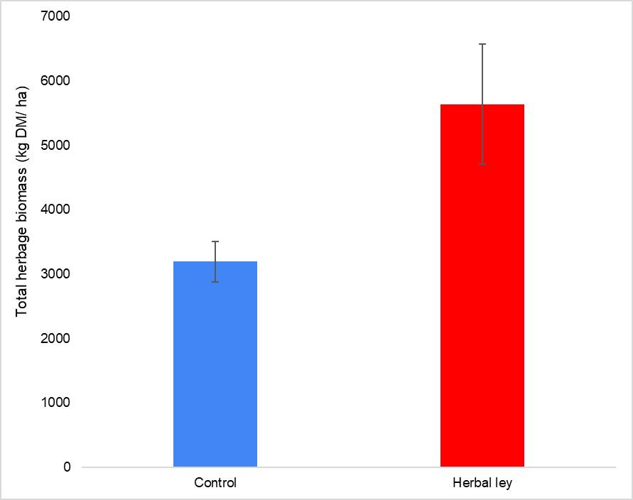

*Figure 1. Total herbage biomass of both treatments over the grazing period (August - November 2024).*

Dry matter content was higher on average in the conventional ley than the multispecies ley throughout the grazing season. There was no significant difference in lamb liveweight gain between the lambs grazing the multispecies ley compared to the conventional ley (p > 0.05).

**Conclusions**

Preliminary results from the project’s establishment year indicate no significant differences in lamb performance or total herbage biomass from either sward during the grazing season. However, as only limited measurements were available for analysis, further measurements taken in 2025 is required to determine the impact of the multispecies leys on these measured parameters.

**Acknowledgments**

The authors are grateful to the Welsh Government for funding this project. They are also thankful to DLF for their contribution of seed mixes and technical support towards the project.

**References**

Cooledge, E.C., Kendall, N.R., Leake, J.R., Chadwick, D.R. and Jones, D.L. (2024). Herbal leys increase forage macro-and micronutrient content, spring lamb nutrition, liveweight gain, and reduce gastrointestinal parasites compared to a grass-clover ley. Agriculture, Ecosystems & Environment, 367, 108991.

Grace, C., Lynch, M.B., Sheridan, H., Lott, S., Fritch, R. and Boland, T.M. (2019). Grazing multispecies swards improves ewe and lamb performance. Animal, 13(8), 1721-1729.