Application
Immediate improvements in cow health can be made by encouraging farmers to fully facilitate lying duration. Optimising lying duration should also be prioritised during the planning and construction of new facilities.
Introduction
Restricted lying times in dairy cows can alter feeding behaviour, as cows deprived of lying time will compensate with substantial reductions in feeding time, which in turn can result in health disorders. Lying times can be influenced by management factors as well as animal specific factors including illness and injury, age and parity, reproductive status and lactation stage of the cow [1]. Length of stay in a close-up pen prepartum (days in close up, DCU), prepartum stocking density, calving density and time from the last pen filling event to calving are management factors considered important in ensuring transition cow health [2]. Failure to optimize these factors may also cause forced reductions in lying duration with negative consequences for animal health. This study therefore explores the associations between management factors considered important for transition cow health and daily lying times and evaluates their association with disease outcomes.
Materials and Methods
Daily lying duration for 21-d prior to calving until 21-d post calving was recorded for 499 cows located in a single UK herd calving over a 12-month period. For each cow, data were recorded on the length of stay in the prepartum pen, prepartum stocking density, calving density and number of days from the last pen filling event to calving. The number of cows in the prepartum pen on each day was counted and used to calculate the average daily stocking density experienced by each cow from 8 d to 2 d prior to calving. Calving density was calculated as the number of cows calving each week during the study period divided by the overall average number of cows calving per week for the same period. The number of days from the last pen filling event to calving was calculated for each cow by subtracting each cow’s calving date from the date of the last additions to the pen. Health events and treatments were recorded by farm staff in accordance with written protocols. Linear regression was used to assess the association between the selected management factors and daily lying times. Logistic regression was then used to model the odds of disease (any single case or combination of ketosis, mastitis, metritis, milk fever, and displaced abomasum) during the first 30 days in milk. We considered 3 ways to include daily lying duration in our models: daily lying duration, 3-d averages, and 7-d averages. Weekly averages, for the 3-wk before calving, were chosen because these smoothed out the variability of daily lying duration and avoided overfitting. Stepwise variable selection based on Akaike’s information criterion was used to select the 7-d average lying duration to include in the final model. The disease model was based on mean pre-calving daily lying durations over the period of 8 d to 2 d prior to calving, days spent in close-up and gestation length (GL). To avoid multicollinearity issues, we used the scores for the first principal component (PC1) of the covariance matrix of DCU and GL as a proxy variable to simultaneously adjust for DCU and GL.
Results
Daily lying duration was 745 ± 115 min\d (mean ± standard deviation). No association was found between prepartum stocking density, PC1, calving density and time from the last pen filling event to calving and daily lying duration in prepartum cows. Both lactation group (P < 0.05) and season of calving (P < 0.05) were associated with daily lying duration, with cows in the 3rd lactation and above lying for 23 min\d longer than those in the 2nd lactation, and those calving in autumn/winter lying for 22 min\d longer than those calving in spring/summer.
Figure 1 shows the daily lying duration prepartum for diseased and non-diseased cows. Daily lying duration was negatively associated with the odds of disease (P = 0.03); however, the positive coefficient for its quadratic term (P = 0.04) indicates that the rate of reduction decreased as lying time increased, meaning that odds of disease had a minimum value at a daily lying time of 860 min.
Conclusions
Lying duration was not associated with the management factors considered important for transition cow health but was associated with parity group, with cows in parity 3 and above lying down for longer than cows in parity 2. Cows lay down for longer in the cooler seasons of autumn/winter than spring/summer. Daily lying duration during the transition period are however associated with health outcomes in multiparous cows. This information can be used to inform farmers during the construction of new facilities, as well as in the daily management of current buildings. For example, in deciding the dimensions and size of cubicles and bedded areas, or the frequency of addition of bedding materials and increased bedding depth.
References
[1] Tucker, C. B., Jensen, M. B., DE Passillé, A. M., Hännen, L. & Rushen, J. 2021. Invited review: Lying time and the welfare of dairy cows. Journal of Dairy Science, 104, 20-46.
[2] Cook, N. B., and Nordlund K. V. 2004. Behavioral needs of the transition cow and considerations for special needs facility design. Veterinary Clinics North America. Food Animal Practice, 20:495–520
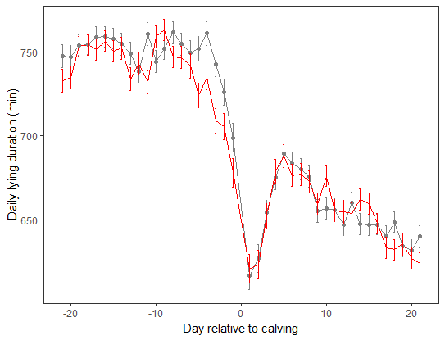
Fig. 1. Daily lying duration around calving for cows with no disease (grey line; error bars show standard error) versus cows with at least one case of disease (red line; any single case or combination of ketosis, mastitis, metritis, milk fever, and displaced abomasum) during the first 30 days in milk.

