Title: (Use Normal style (Times New Roman 12). Only capitalise the first letter of the first word. No full stop at the end of the title)
Candidate genes and pathways associated with bovine tuberculosis identified with an mRNA-miRNA regulatory network.
Summary: (Your summary (Times New Roman 10) must use Body text style and must not be longer than this box)
Application This comparative transcriptome profiling analysis identified associated mRNAs and miRNAs, their regulatory mechanisms, and potential pathways in cows infected with bovine tuberculosis compared to healthy (H) cows.

Introduction Bovine tuberculosis (bTB), a chronic infectious disease primarily affecting domestic dairy and beef cattle, is caused by Mycobacterium bovis (MB), a pathogenic bacterium within the Mycobacterium tuberculosis complex (MTBC) (Hall et al., 2021). The economic impact of bTB on the livestock industry is substantial, with estimated losses > $3 billion annually in global agriculture (Waters et al., 2012). Host immune responses to mycobacterial infection involve a complex interplay between innate and adaptive immune systems. Previous transcriptomic studies demonstrated that mRNA expression was significantly altered in bovine monocyte-derived macrophages (MDM) following MB infection. Thus, analyzing the host macrophage transcriptome in response to MB infection is expected to shed light on molecular mechanisms and host-pathogen interactions associated with bTB. Moreover, although non-coding RNAs (ncRNAs), e.g., microRNAs (miRNAs), have crucial roles in regulating immune system function and may offer valuable insights into the disease, their role in MB infection in cattle has not been thoroughly investigated (McLoughlin et al., 2021).

Materials and Methods RNA-Seq and microarray datasets from blood samples, specifically MDMs of MB-infected and control Holstein dairy cattle, were retrieved from the National Center for Biotechnology Information (NCBI) Gene Expression Omnibus (GEO) public database. Gene set annotation and functional enrichment analysis were conducted to explore hub mRNAs and miRNAs associated with bTB, using the DAVID and STRING databases. This analysis aimed to determine potential functions as well as metabolic and signaling pathways related to the disease. Also, interactions between the RNAs (mRNAs and miRNAs) were predicted and an mRNA-miRNA regulatory network constructed by integrating the protein-protein interaction (PPI) network with the gene regulatory network (GRN). Additionally, genes were assigned to functional categories using the Gene Ontology (GO) database, which includes biological processes (BP), molecular functions (MF) and cellular components (CC).
Table 1. Summary of the GEO accession numbers for RNA-Seq and microarray data sets associated with bTB.
No. | Data Type | GEO a Accession | Platform | Samples (MB:H)
1 | Microarray | GSE33309 | GPL2112 ((Bovine) Affymetrix Bovine Genome Array) | 42 (21:21)
2 | Microarray | GSE41401 | GPL11649 (Agilent-023647 B. taurus (Bovine) Oligo Microarray v2 (Probe Name version)) | 12 (6:6)
3 | RNA-Seq | GSE45439 | GPL15750 (Illumina Genome Analyzer IIx (Bos taurus)) | 14 (7:7)
4 | RNA-Seq | GSE60265 | GPL15750 (Illumina Genome Analyzer IIx (Bos taurus)) | 16 (8:8)
5 | RNA-Seq | GSE62506 | GPL15749 (Illumina HiSeq 2000 (Bos taurus)) | 78 (39:39)
Results Comparative transcriptomics-related analyses identified 3076 and 3229 differentially expressed genes (DEGs) between MB-infected and control Holstein dairy cattle samples for RNA-Seq and microarray datasets respectively, based on a fold change ≥ 1 or ≤ -1, and a false discovery rate < 0.05. Among these, 13 genes were common between transcriptomic profile datasets. In addition to DEGs, 9 and 39 miRNAs were simultaneously identified in the RNA-Seq datasets and literature mining, respectively. Furthermore, we identified 5 hub genes (CCL4, CXCL2, IL12B, IL1A, and RETN) involved in MB infection. Identified biological and regulatory networks were mainly associated with immune system signature pathways. Gene set annotation and functional enrichment of identified DEGs implicated important biological pathways. In this regard, functional enrichment analysis, based on the mRNA-miRNA regulatory network (Figure 1) revealed 6, 4 and 1 GO terms related to bTB in the biological process, molecular function, and cellular component categories, respectively. In addition, KEGG enrichment analysis identified cytokine-cytokine receptor interaction, tuberculosis, and signaling pathways for chemokine, NF-kappa B and Toll-like receptors.
Conclusions These findings offered valuable insights into the molecular evidence surrounding the regulatory mechanisms involved in transcriptome profiling of MB-infected Holstein dairy cattle, compared to noninfected controls. Additionally, they are an impetus to explore molecular networks and functions of DEGs associated with blood samples, particularly focusing on MDMs and their role in immune system function. This research provides a foundational starting point for future studies on bovine tuberculosis disease.
References
Hall, T.J., Mullen, M.P., McHugo, G.P., Killick, K.E., Ring, S.C., Berry, D.P., et al. (2021). Integrative genomics of the mammalian alveolar macrophage response to intracellular mycobacteria. BMC Genomics, 22(1), 343.
Waters, W.R., Palmer, M.V., Buddle, B.M. and Vordermeier, H.M. (2012). Bovine tuberculosis vaccine research: historical perspectives and recent advances. Vaccine, 30(16), 2611-2622.
McLoughlin, K.E., Correia, C.N., Browne, J.A., Magee, D.A., Nalpas, N.C., Rue-Albrecht, K., et al. (2021). RNA-seq transcriptome analysis of peripheral blood from cattle infected with Mycobacterium bovis across an experimental time course. Frontiers in Veterinary Science, 8, 662002.

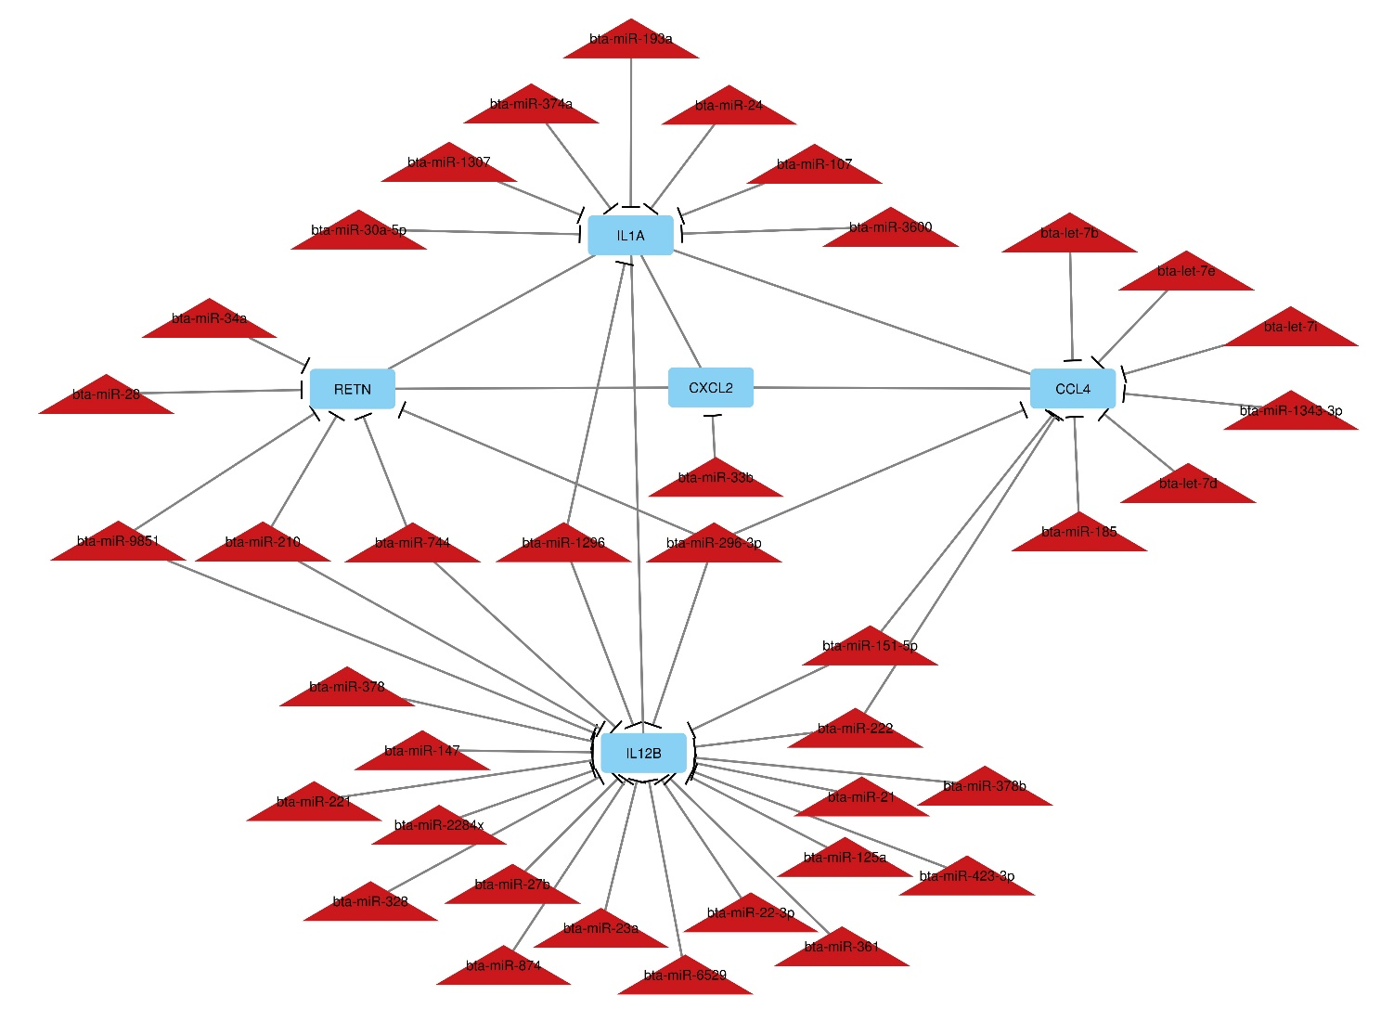
Figure 1: mRNA-miRNA regulatory network on MB infection in dairy cattle.

