***Application:***

This work is vital for addressing gaps in monitoring and understanding ammonia concentration levels and its influencing factors in Irish pig farms.

***Introduction***

Ammonia (NH3) and greenhouse gas emissions, including methane (CH₄), and nitrous oxide (N₂O) are receiving increased attention due to environmental and health concerns (Kriz et al., 2021). NH3 is not only a significant air pollutant due to its strong odour and toxicity at high levels (Roney & Llados, 2004), but in Europe, animal production alone accounts for over 75% of NH3 emissions. In Ireland, the agricultural sector contributes 98% of the total national NH3 emissions, with pigs and poultry responsible for 7% (Kelleghan et al., 2021). Past studies have largely concentrated on NH₃ levels, their spatial distribution, emissions, and seasonal and diurnal variations, particularly in poultry and livestock farms across Europe (Wyer et al., 2022). However, there is limited scientific knowledge regarding ammonia concentration monitoring in pig facilities in Ireland. This research builds on existing work by monitoring NH₃ concentrations within a pig research facility in Ireland. Using Off-axis Integrated Cavity Output Spectroscopy, the study examined NH₃ concentrations levels in a finishing pig building, evaluated NH3 concentrations patterns and its influencing factors.

***Keywords:*** ammonia, pigs, ventilation, temperature

***Materials and methods***

NH₃ concentrations were monitored continuously for 76 days in three finishing pig rooms (Rooms A – 117 pigs, Room B – 112 pigs, and Room C – 102 pigs) measured using a Los Gatos Research (LGR) gas analyser. Indoor temperature and ventilation were continuously monitored using the Big Dutchman system. All measurements were conducted from 9th August – 23rd October 2024. The pigs were fed a 16% crude protein diet. NH₃ concentrations were sampled for one hour at the exhaust fan according to the VERA protocol (Losada et al., 2014). The LGR provided 115 readings per hour at each sampling location, with a 31-32 second set interval. Data manipulation and visualisation was done using MS excel. Daily averages were used.

***Results and discussion:***

The study observed that ammonia concentration levels and other measured parameters followed a consistent pattern across the three rooms during the measurement period, with Room B exhibiting the lowest ventilation requirement, indoor temperature, and highest ammonia concentrations levels **(Figs. 1, 2 and 3)** respectively. During the early phase of the finishing pig period, NH₃ concentration levels increased, gradually declined during the mid-growth phase, and increased again in the final finishing period **(Fig. 3)**. **Figures 1, 2, and 3** illustrated that an increase in NH₃ concentration levels was associated with a decrease in ventilation requirements and indoor temperatures across all rooms, and vice versa. This relationship was particularly evident in Room B, which recorded the highest ammonia concentration levels but the lowest ventilation requirements among the three rooms. These findings suggest a significant interaction between NH₃ concentration levels, ventilation requirements, and indoor temperature, with each factor influencing the other. Also, variation in temperature was greatly influenced by ventilation requirement of the rooms. Moreover, although Room A had the highest stocking density, other environmental factors beyond the number of animals played a more critical role in determining NH₃ concentration levels. For instance, Room B, with fewer animals, exhibited higher NH₃ concentration levels, indicating that factors such as ventilation requirement and manure management had a greater impact on NH₃ accumulation in those rooms.

***Conclusion:***

The NH₃ concentration levels measured in all three rooms stayed within the 10 ppm limit (7.16 mg/m³) proposed in the Best Available Techniques guidelines for indoor pig environments. Also, facilities with higher stocking densities can effectively control ammonia concentration levels through good manure management practices and proper maintenance of indoor environmental conditions. Factors such as ventilation and indoor temperature played a key role in influencing/determining NH3 concentration levels in the rooms. This study suggests that improving air quality in a finishing pig house can be achieved by examining several factors to monitor and reduce ammonia levels.

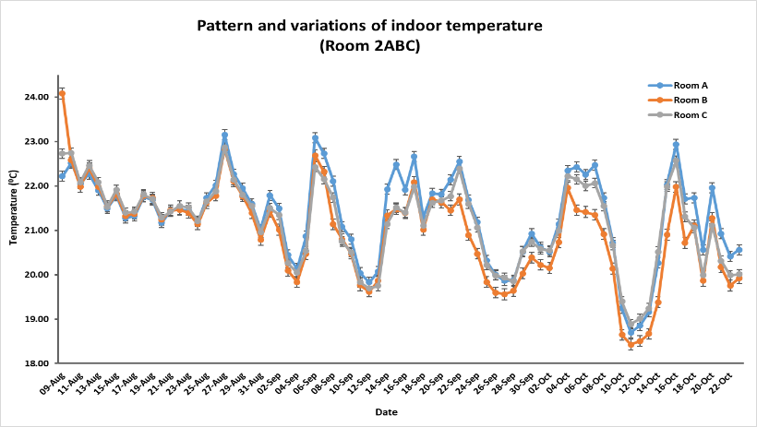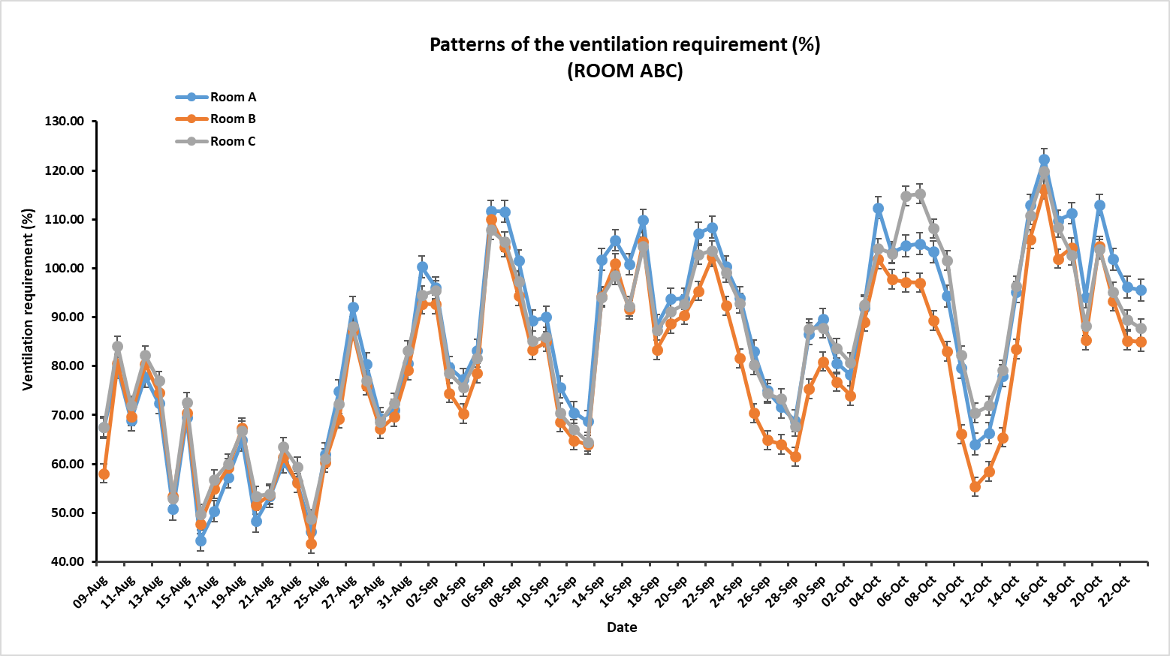

**Figure 2: Patterns and variations of indoor temperature**

**Figure 1: Patterns of ventilation requirement**

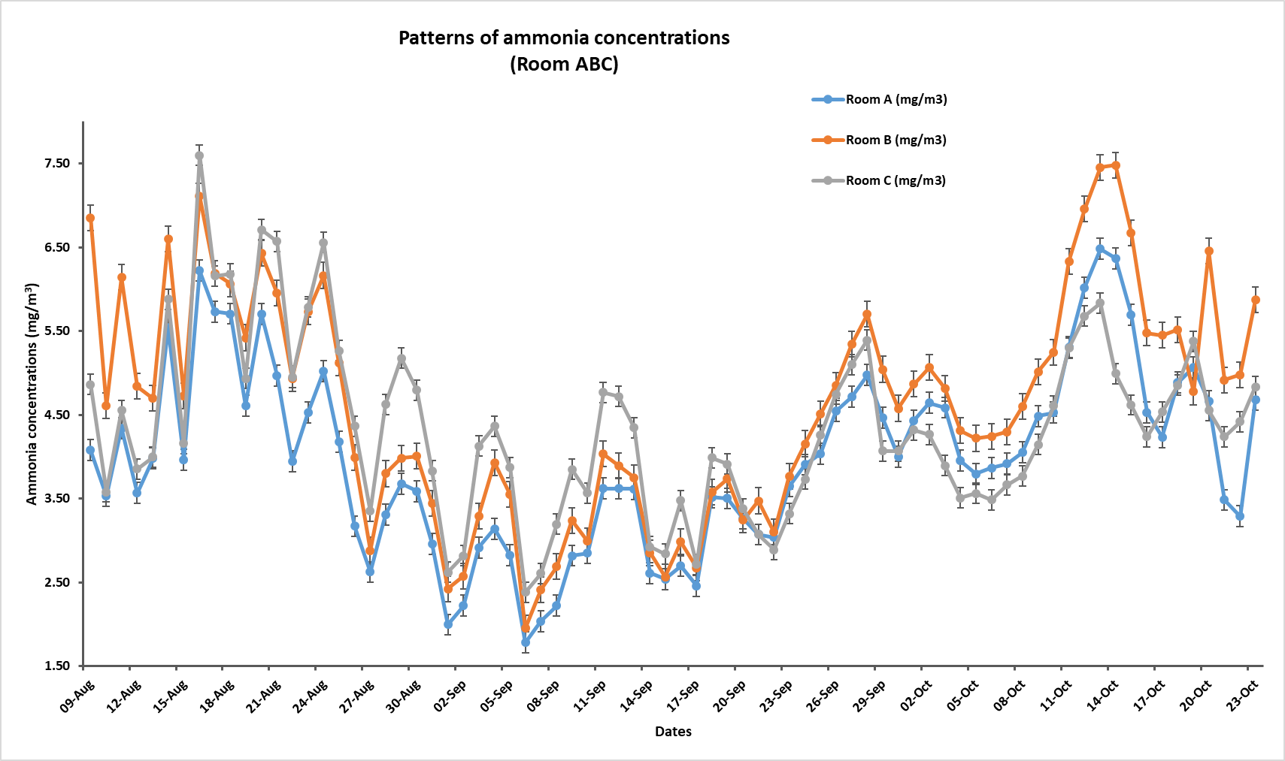

**Figure 3: Patterns of ammonia concentrations**

***Acknowledgements***

The authors acknowledge the funding from Teagasc, the Irish Agricultural and Food Development Authority and to the farm staff for their great support.

***References***

Kelleghan, D. B., Hayes, E. T., Everard, M., & Curran, T. P. (2021). Predicting atmospheric ammonia dispersion and potential ecological effects using monitored emission rates from an intensive laying hen facility in Ireland. *Atmospheric Environment, 247*, 118214.

Kriz, P., Kunes, R., Smutny, L., Cerny, P., Havelka, Z., Olsan, P., Xiao, M., Stehlik, R., Dolan, A., & Bartos, P. (2021). Methodology for measurement of ammonia emissions from intensive pig farming. *Agriculture, 11*(11), 1073.

Losada, J. M., Edouard, N., Guiziou, F., Melse, R., Riis, A., Sommer, S., & Brusselman, E. (2014). *Decision document on the revision of the VERA protocol on air cleaning technologies March* (1570-8616).

Roney, N., & Llados, F. (2004). Toxicological profile for ammonia.

Wyer, K. E., Kelleghan, D. B., Blanes-Vidal, V., Schauberger, G., & Curran, T. P. (2022). Ammonia emissions from agriculture and their contribution to fine particulate matter: A review of implications for human health. *Journal of Environmental Management, 323*, 116285.