**Application**

The study comparing set stocking (SS) and rotational cell grazing (CG) in a UK-based temperate climate offers insights for optimal grazing practices. It informs livestock productivity, soil health impacts, aiding sustainable land management decisions and policy formulation for improved agricultural practices.

**Introduction**

Grasslands are crucial for ruminant feed and various societal benefits such as biodiversity, recreation, and carbon storage, and support millions of cattle and sheep, yielding billions of litres of milk and tons of meat annually in the UK. Grasslands are managed under a variety of stocking methods that exert different impacts on animal, plant, and soil responses. Traditional continuous grazing often leads to overgrazing and uneven pasture use, impacting productivity. Rotational stocking, alternating grazing and rest periods, such as cell grazing, aim for improved productivity and diverse vegetation. Yet, direct comparisons between continuous and rotational grazing in temperate climates are limited. This study aimed to compare set stocking and cell grazing impact on productivity and soil carbon content of a dairy x beef production system.

**Material and methods**

This grazing experiment comparing SS and CG took place in Devon (UK) in a 12-hectare field divided into three sections (blocks) totalising six enclosures. SS paddocks were 1.75 ha, while CG paddocks were 1.0 ha, comprising two 0.5-hectare lanes with 21 fence posts delineating up to 42 cells. The entire field was reseeded with perennial ryegrass and white clover in 2013. Autumn-born dairy x beef steer calves, acquired in 2018 (average weight 255 kg) and 2020 (average weight 219 kg), grazed for two consecutive seasons, distributed randomly across treatment groups balanced for weight and breed. SS enclosures were continuously grazed, while CG were rotationally grazed with animals moving to a new cell every day. The daily allocated grazing area for the CG enclosures varied according to pasture growth rate and animal feed demand in order to maintain pasture quality and optimise grass utilisation. Cattle were winter-housed after the first grazing season. The following April they returned to the same grazing method and were taken through to finish on pasture. Monthly animal weights, weekly pasture covers using a rising plate meter, and annual soil samples (10cm depth) for carbon content analysis were recorded. Liveweight gain, animal production per hectare and soil carbon content were analysed with a MIXED model with repeated measures in time using the GLIMMIX procedure of SAS 9.2 (2010).

**Results**

Overall, the SS steers grew faster (p < .0001) than those on the CG system (0.767vs. 0.600 kg/day) with variation over the years (Figure 1a). Conversely, land productivity, measured as kg liveweight gained per hectare, was greater in the CG enclosures (687 kg/ha) compared to SS (463 kg/ha), and showed variability across time (Figure 1b). Notably, the carrying capacity of the CG enclosures increased over time (p < 0.0001), from 1738 to 3035 kg liveweight per ha, whereas it remained relatively constant for the SS, ca. 1300 kg liveweight per ha (Figure 1c). In 2018, before the first grazing season started, the enclosures allocated to each stocking method had similar (p>0.05) soil carbon content, averaging 3.35%. There was a general trend to increase carbon content until the third year; however, the SS displayed a decline in soil carbon content, whereas the CG enclosure maintained the carbon levels accumulated in the earlier years (Figure 1d). This difference in soil carbon content in 2022 could be due to the divergence in botanical composition (*Lulium perenne* L. increased in the CG method over time and decreased in the SS method, data not shown).

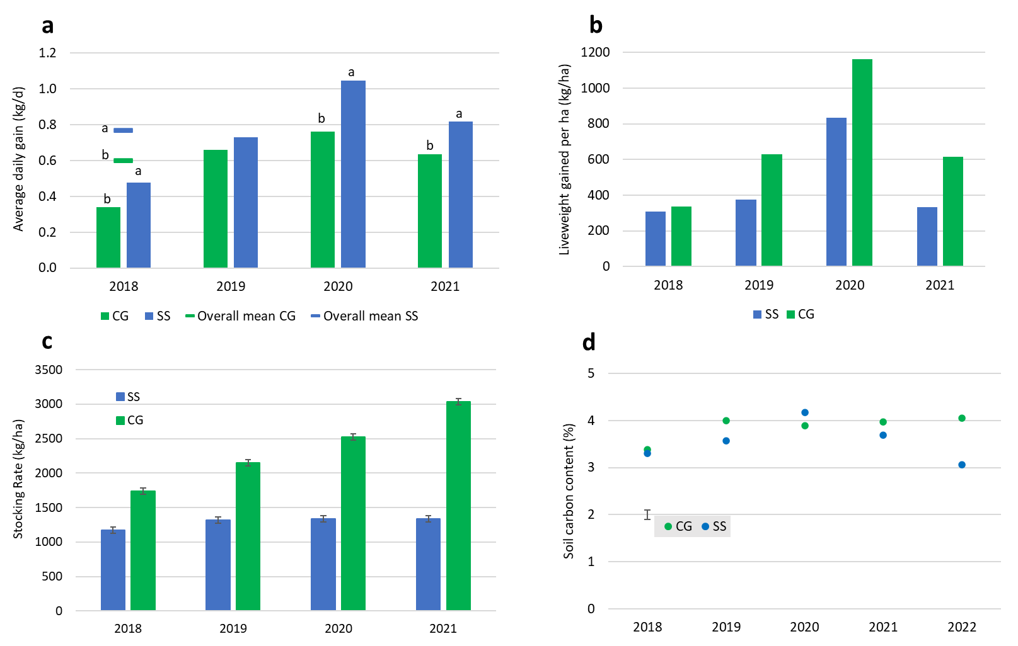

**Figure 1.** Average daily gain (a), liveweight gained per ha (b), stocking rate (c) and soil carbon content (d) of enclosures grazed by dairy x beef steers under set-stocking or cell grazing methods over a four-year experiment.

**Conclusions**

The study concluded that rotational CG demonstrated higher liveweight production per hectare and carrying capacity, while SS exhibited higher individual animal performance. Additionally, CG increased soil carbon levels, highlighting its potential for sustainable grazing practices compared to SS in a temperate climate. Vertical bars are the standard error of the mean.

**Acknowledgement**

This research was supported by BBSRC through the grants “Soils to Nutrition” BBS/E/C/000I0320. The setting up and execution of the three first years of the TechnoGrazing experiment (2018-2020) was funded by the European Regional Development Fund (ERDF). We thank James Daniel (Precision Grazing Ltd.) for his support in setting up the experimental enclosures. The contributions by MJR were also supported by “Growing Health” (BB/X010953/1) funded by BBSRC, and by “AgZero+: Towards sustainable, climate-neutral farming” (NE/W005050/1) funded by NERC and BBSRC.