**Application**

Evaluating the impact of different dry cow treatments will contribute to design guidelines and policy to reduce antibiotic use in Irish dairy farms and to reduce the risk of antibiotic residues in milk.

**Introduction**

There is a need in Ireland for farmers to transition to non-antibiotic dry cow therapy (European Parliament and the Council of the European Union, 2019; Clabby et al., 2022). The common alternative is the use of internal teat sealants (ITS) to prevent infections during the dry period (Bradley and Green, 2004). Additionally, using short acting antibiotics could reduce the risk of antibiotic residues in the bulk tank due to cows calving earlier than expected for example.

The objectives of this study were to: 1- assess the impact of using ITS alone, antibiotic alone (AB), or antibiotic plus ITS (AB+ITS) at dry-off in low somatic cell count cows (SCC, <200,000 cells/mL) on somatic cell count in the following lactation; and 2- assess the impact of using a short versus a long acting antibiotic at dry-off in cows with high SCC (>200,000 cells/mL).

**Materials and Methods**

This study was approved by Teagasc’s Animal Ethics Committee (License No. 1542017), and procedures were carried out in accordance with the Health Products Regulatory Authority (HPRA) of Ireland. The study was conducted from November 2017 (dry-off season) to the end of lactation of 2018 in three research herds. Herds were spring calving pasture-based systems. For the study related to objective 1 (**Study 1**), cows with every test day SCC below 200,000 cells/mL were blocked according to lactation, average SCC and expected week of calving in the spring 2018. Cows within blocks were sequentially assigned to receive ITS, AB or AB+ITS at dry-off. For cows in the study related to objective 2 (**Study 2**) cows which ≥1 test day SCC above 200,000 cells/mL were blocked using the same criteria as above and then were sequentially assigned to receive a short acting Cloxacillin based antibiotic + ITS (Clox+ITS) or long acting Cephalonium based antibiotic (Cep+ITS) at dry-off.

Herds undertook weekly cow SCC recordings during 2018. Cow SCC was log 10-transformed (LogSCC) for analysis. The effect of dry-off treatment on LogSCC was analysed using mixed models with cow within farm as a random effect and parity (2, 3, 4 and >5), DIM and milk yield as covariates. The data was also analysed using raw SCC values to provide untransformed estimates, however p-values correspond to the analysis done on LogSCC.

**Results**

**Study 1**

Across all herds 69, 76 and 73 cows were treated with AB, ITS and AB+ITS at dry-off, respectively. In total 30 (43.4%), 22 (28.9%) and 32 (43.9%) cows had 0 high SCC (>200,000 cells/mL) in the following lactation in the AB, ITS and AB+ITS groups, respectively. Eight (11.6%), 13 (17.1%) and 19 (26.0%) cows had 1 high SCC in the following lactation in the AB, ITS and AB+ITS groups, respectively. The AB, ITS and AB+ITS groups had 31 (45.0%), 41 (53.9%) and 22 (30.1%) cows, respectively with ≥2 high SCC in the following lactation.

Dry-off treatment had a significant impact on LogSCC. Cows treated with ITS had 0.21 and 0.23 higher LogSCC compared to AB+ITS and AB cows, respectively (*P* < 0.001). The AB+ITS and AB treatments were not significantly different (P = 0.7).

**Figure 1**. Raw SCC estimates for dry-off treatments applied to low SCC cows (<200,000 cells/mL).

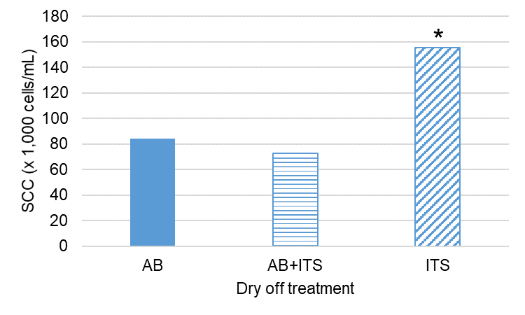

* indicates a significant difference (p < 0.05). Dry-off treatment: AB, antibiotic alone; AB+ITS, antibiotic plus internal teat sealant; ITS, internal teat sealant alone.

**Study 2**

144 and 146 cows were enrolled in the Clox+ITS and Cep+ITS treatment groups, respectively. In total, 46 (31.9%) and 44 (30.1%) cows had 0 high SCC in the following lactation for the Clox+ITS and Cep+ITS treatments, respectively. Seventeen (11.8%) and 22 (15.1%) cows had only 1 high SCC in the lactation for the Clox+ITS and Cep+ITS treatments, respectively. For the Clox+ITS and Cep+ITS treatments, 56 (38.8%) and 58 (39.7%) cows, respectively had ≥2 high SCC in the lactation.

There were no significant differences in LogSCC between these two dry-off treatments.

**Figure 2**. Raw SCC estimates for dry-off treatments applied to high SCC cows (>200,000 cells/mL).

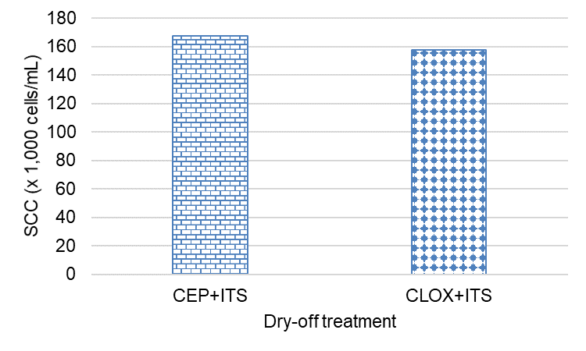

Dry-off treatment: CEP+ITS, Cephalonium based antibiotic plus internal teat sealant; CLOX+ITS, Cloxacillin based antibiotic plus internal teat sealant.

**Conclusions**

Using ITS alone increased SCC in the following lactation compared to antibiotic alone or combined with internal teat sealant. This is consistent with other Irish studies but different to international studies. This could be due to lack of cure of infections not detected by using a 200,000 cells/mL SCC cut-point or new infections over the dry period. In previous Irish studies, there is evidence of a high level of new infections when treating cows with ITS alone, which would suggest that more focus needs to be placed on the dry-off procedure and the dry cow management. We found no differences on SCC by treating cows with a short acting or long acting antibiotic at dry-off in high SCC cows, even if they had different active principles. This suggests that adequate capacity to cure existing infections at the end of lactation was achieved by both products and that no additional new infections occurred during the dry period as a result of using a short acting antibiotic.

**References**

Clabby, C., McParland, S., Dillon, P., Arkins, S., Flynn, J., Murphy, J., and Silva Boloña, P. 2022. Internal teat sealants alone or in combination with antibiotics at dry-off–the effect on udder health in dairy cows in five commercial herds. *Animal*, *16*(2), 100449.

European Parliament and the Council of the European Union. 2019. Regulation 2019/6 of the European Parliament and of the Council of 11 December 2018 on veterinary medicinal products and repealing Directive 2001/82/EC. Off. J. Eur. Union L 4:43–167.

Bradley, A. J., and M. J. Green. 2004. The importance of the nonlactating period in the epidemiology of intramammary infection and strategies for prevention. Vet. Clin. North Am. Food Anim. Pract. 20:547–568. <https://doi.org/10.1016/j.cvfa.2004.06.010>.