Enhancing Solid-State Fermentation of Sunflower Meal: Optimizing Duration of Fermentation with Synergistic Probiotic Strains
Application
Solid-state fermentation with Bacillus subtilis enhances the nutritional value of sunflower meal for use in poultry feeds by lowering fibre content, providing a cost-effective protein alternative to soyabean meal. This approach reduces production costs and supports environmental sustainability.
Introduction:
Feed expenses represent about 60-70% of the total costs in poultry farming (Adesehinwa, 2007), with soybean meal (SBM) traditionally used as the main protein source. However, reliance on SBM has become problematic due to environmental issues, including deforestation and substantial water usage (Ferreira et al., 2016), making it essential to explore other options. Sunflower meal (SFM) is emerging as a more affordable alternative (Ciurescu et al., 2019), but its high fiber content poses challenges in poultry diets by reducing nutrient absorption and potentially affecting bird growth and health (Villamide & San Juan, 1998). A promising solution to improve the nutritional profile of SFM involves fermenting it with microorganisms such as bacteria and yeast. A study we carried out in our lab found that fermenting SFM with a Bacillus subtilis preparation reduced the total fibre content and increased levels of certain essential amino acids, compared to samples without added microorganisms This experiment aimed to optimize the duration of SSF for sunflower meal using various probiotic strains both individually and in combination. Neutral detergent fiber (NDF) used as an indicator, and amino acid content was also measured as part of the evaluation.
Materials and methods
This experiment aimed to compare two probiotic strains, Bacillus subtilis (treatment A) and Saccharomyces cerevisiae strain K5-5A (B); both obtained from the National Centre for Biotechnology Education, University of Reading, with two commercial strains, 11CFT (C) and 11GFT (D); purchased from Corteva Agriscience). Individual cultures (A and B) were inoculated at 5% (v/w) per 5 g sample, whereas commercial probiotics (C and D) were inoculated as per manufacturers’ recommendations (2.4% v/w). For treatment combinations the equivalent doses were used (e.g., for ABCD 5+5+2.4+2.4%). Sunflower meal was adjusted to 80% moisture and autoclaved. Treatments and combinations (including controls of just SFM) were incubated at 30°C in duplicate, with sampling every two days, over a 14-day period. Samples were then freeze-dried and stored at -20°C until analysis. NDF was determined following a protocol using Ankom 200 Fiber Analyzer. Amino acids were analysed after hydrolysis in 6M HCl in an atmosphere of nitrogen, with separation based on mass-to-charge ratio (m/z) using a Shimadzu LCMS-8050 triple quadrupole mass spectrometer with Nexera UPLC, without derivatization. Data were analyzed using one-way ANOVA within the GLM procedure in Minitab version 22.1, with Tukey's test for post hoc comparisons. The independent variable was treated as a fixed factor. Differences were considered significant if p< .05.

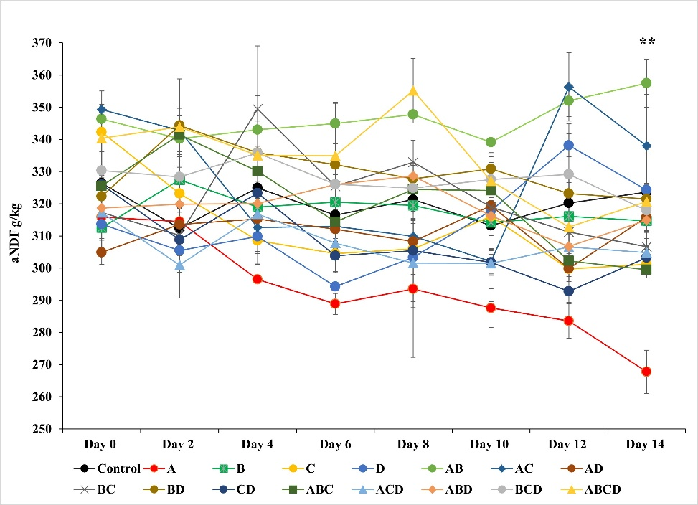
Fig. 1. Impact of 14-day fermentation and microbial inoculum on the aNDF content in Sunflower Meal. A: Bacillus subtillis, B: Saccharomyces cerevisiae Strain K5-5A, C: 11CFT (Lactobacillus buchneri ATCC PTA-6138, and Lactobacillus plantarum ATCC 55944), D: 11GFT (Lactobacillus buchneri ATCC PTA-6138, Lactobacillus plantarum ATCC PTA-6139, and Lactobacillus plantarum ATCC 55944). aNDF: neutral detergent fibre corrected for ash. ** significant differences at p < .001.

Table 1
Effect of microbial inoculum (alone and in combination) on the amino acid and aNDF contents (g/kg DM) of sunflower meal following a two-week period of solid-state fermentation.
Treatments | Control | A | B | C | D | AB | AC | AD | BC | BD | CD | ABC | ACD | ABD | BCD | ABCD | SEM | p-values
aNDF | 324^{abc} | 268^{d} | 315^{bc} | 301^{bcd} | 324^{abc} | 358ª | 338^{ab} | 316^{bc} | 307^{bc} | 322^{abc} | 303^{bcd} | 300^{cd} | 305^{bcd} | 315^{bc} | 318^{bc} | 321^{abc} | 6.64 | <0.001
Lysine | 14.9^{bcd} | 13.3e | 13.90de | 13.5e | 11.3^{f} | 13.1e | 12.9e | 15.2^{bc} | 15.9^{ab} | 16.7ª | 15.6^{ab} | 14.2^{cde} | 15.2^{bc} | 15.5^{abc} | 15.0^{bcd} | 13.7de | 0.26 | <0.001
Arginine | 35.9ª | 16.3^{g} | 31.8^{bc} | 30.1^{cd} | 24.3^{ef} | 31.4^{bc} | 23.0^{f} | 31.2^{bc} | 33.6^{ab} | 33.4^{ab} | 32.2^{bc} | 32.9^{abc} | 29.9^{cd} | 31.6^{bc} | 32.1^{bc} | 27.2de | 0.58 | <0.001
Threonine | 15.7^{abc} | 11.6^{g} | 15.6^{abc} | 14.2^{cdef} | 15.3^{bcd} | 15.1^{bcde} | 11.8^{g} | 13.2^{efg} | 16.7^{ab} | 17.4ª | 16.0^{abc} | 14.6^{cdef} | 15.9^{abc} | 15.8^{abc} | 13.0^{fg} | 13.5^{defg} | 0.38 | <0.001
Valine | 18.2^{efg} | 16.2^{h} | 18.5^{def} | 18.1^{efg} | 16.3^{h} | 18.8^{bcde} | 16.5^{h} | 18.7^{cde} | 19.2^{bcd} | 19.6^{b} | 19.4^{bc} | 17.5^{g} | 18.2^{efg} | 19.7^{b} | 21.3ª | 17.8^{fg} | 0.17 | <0.001
Leucine | 18.2^{d} | 15.0^{g} | 18.4^{d} | 18.5^{cd} | 16.6^{ef} | 17.1e | 14.4^{g} | 16.0^{f} | 20.5^{b} | 20.5^{b} | 20.6^{b} | 17.9^{d} | 19.1^{c} | 20.6^{b} | 24.0ª | 20.7^{b} | 0.13 | <0.001
Isoleucine | 18.0de | 14.9^{i} | 18.2de | 18.5^{cd} | 16.6^{gh} | 17.0^{fg} | 14.6^{i} | 16.0^{h} | 20.4^{b} | 20.6^{b} | 20.4^{b} | 17.6^{ef} | 19.2^{c} | 20.7^{b} | 24.0ª | 20.6^{b} | 0.13 | <0.001
Histidine | 9.7^{ab} | 5.4^{f} | 8.7^{cd} | 9.0^{cd} | 8.4^{d} | 9.3^{bc} | 6.6e | 8.8^{cd} | 10.0^{ab} | 10.3ª | 10.3ª | 8.9^{cd} | 9.8^{ab} | 10.2ª | 9.7^{ab} | 8.4^{d} | 0.13 | <0.001
Phenylalanine | 16.4^{d} | 13.4^{f} | 16.9^{c} | 17.2^{bc} | 15.2e | 13.7^{f} | 12.0^{g} | 13.3^{f} | 17.3^{bc} | 17.4^{b} | 17.4^{b} | 16.1^{d} | 16.1^{d} | 17.3^{bc} | 20.6ª | 17.6^{b} | 0.08 | <0.001
Data were analysed using one-way ANOVA within the GLM procedure in Minitab version 22.1. Different letters within the same row indicate significant differences at p<.05. Tukey's test was used for post hoc comparisons.

Results
During the first 12 days of fermentation, there was no difference between treatments for NDF content (Fig. 1). However, by day 14, Bacillus subtilis fermentation resulted in lower (P<0.05) NDF content compared with the control (Table 1). After 14 days fermentation lower (P<0.05) lysine concentrations were observed for treatments A, B, C, D, AB, AC, ABC, and ABCD, relative to the control. Arginine concentrations were also lower (p < .05) across most treatments, particularly in groups A, D, AC, and ABCD. Similarly, SFM threonine and histidine content was lower (P<0.05) with treatments A and AC, compared with control. Conversely, the combination fermentation of S. cerevisiae and the two commercial strains (treatment BCD) improved (P<0.05) the concentration of valine, leucine, isoleucine, and phenylalanine.
Conclusion
After 14 days of fermentation, B. subtilis (A) decreased the NDF content of sunflower meal, and there was no effect of other treatments either alone or in combination. However, essential amino acids were also lower in several treatment groups (including B. subtilis fermentation). Although B. subtilis shows promise as an effective microbial candidate to improve the nutritional quality of SFM for poultry diets, changes in essential amino acid content must be considered.
References
Adesehinwa, A.O.K., 2007. Bulgarian Journal of Agricultural Science, 13, 593-600.
Ferreira, M.E., Ferreira, L.G., Latrubesse, E.M., Miziara, F., 2016. Journal of Land Use Science, 11, 33-47.
Ciurescu, G., Vasilachi, A., Grigore, D., Grosu, H., 2019. South African Journal of Animal Science, 49, 735-735.
Villamide, M.J., San Juan, L.D., 1998. Poultry Science, 77, 1884-1892.

