**Application** Low protein diets can reduce ammonia emissions from slurry of dairy cows.

**Introduction** Cattle production is a considerable source of nitrogen (N) polution. Dietary manipulation of protein levels is an effective measure to reduce N excretion and slurry ammonia emissions in livestock production. The objective of the current study was to examine the impact of crude protein (CP) level in the diet on ammonia emissions from slurry of dairy cows.

**Materials and Methods** Slurry ammonia emission data used were obtained from a 28-day slurry incubation experiment conducted at the Agri-Food and Biosciences Institute. Slurry samples were collected during a digestibility trial involving 12 lactating dairy cows which were offered TMR diets comprising grass silage and concentrates in a 0.5/0.5 ratio (DM basis). Three diets differing in CP content (14.0, 15.5 or 17.0% CP, DM basis) were offered (4 cows/diet, for details please see Craig et al., 2024). Faeces and urine (no acid added) from a single sample day were collected separately from each cow and samples stored at 4°C for 6 days. A15 kg slurry sample was then created for each cow by mixing faeces and urine (in a 30 l bucket) in the same proportion (by weight) that they were excreted in on the designed sampling day. Buckets were then stored in a controlled temperature chamber at 14 °C, with a lid covering approximately ¾ of the surface of the bucket. Ammonia emission measurements were carried out at 0, 3, 6, 24, 48, 72 and 96 hours following mixing, and subsequently at weeks 1, 2, 3 and 4. Prior to each measurement time the lid was placed on each bucket for 1 h before the measurement of air ammonia concentration in the head space using a photoacoustic gas monitor. The data were analysed using GenStat (21st ed., VSNI Ltd).

**Results** Ammonia production increased rapidly following mixing of manure and urine, peaking at 24 h with the low CP diet and at 72 h with the medium and high CP diets, before decreasing gradually until the end of the measurement period (Figure 1). Each increase in dietary CP level increased ammonia emissions during the experiment period (Figure 1), except for the measurements in week 3 between the 2 high CP diets. Reducing dietary CP levels from 17.0% to 15.5% and from 17% to 14.0% reduced ammonia emissions by an average of 41% (range from 36 – 44%) and 64% (range from 61 – 68%), respectively. Similarly, reducing diet CP from 15.5% to 14.0% reduced ammonia emissions by 38% (range from 33 – 40%).

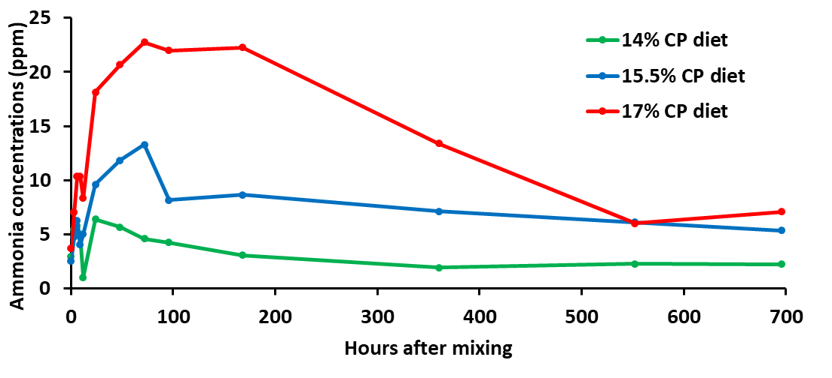

**Figure 1** Ammonia emission patterns from slurry of dairy cows offered diets containing different CP levels

**Conclusions** Reducing dietary CP levels is an effective mitigation strategy to reduce ammonia emissions from dairy production systems. The impacts of lower protein diets on dairy cow performance and welfare/health are currently being examined within this project.

**Acknowledgments** This project was funded by Department of Agriculture, Environment and Rural Affairs, Trouw Nutrition, and John Thompsons and Sons Ltd.

**References**

Craig A, A. Gordon & C. Ferris. 2024. Effect of offering rapeseed-based diets differing in crude protein content on dairy cow performance. Presented in this conference.