Application – The IceQube motion detection system provides an extremely good correlation between actual and recorded steps of dairy cows at pasture, but consistently underestimates the number of steps taken. A simple correction algorithm can be applied to improve the agreement between actual and recorded steps.
Introduction – The IceQube motion detection system is used extensively both on-farm and in research settings to make inferences about dairy cow behaviour and, by extension, their welfare. The original IceTag system has been validated in housed dairy systems (Nielsen et al., 2018; Shepley et al., 2017) and the more recent IceQube system has been validated in a pasture setting (Charlton et al., 2022). All previous studies have shown a good correlation with observed data but with the devices consistently underestimating the number of steps. The consistency of this underestimation presents the opportunity for a correction algorithm to be designed to provide greater agreement between actual and reported step-counts. In the context of a wider project investigating behavioral differences between two different sward types, ryegrass and ryegrass/plantain, the objective of this study was to validate the number of steps recorded by the IceQube against the observed number of steps for the same period and to design an algorithm to improve the agreement between the two data sets.
Materials and Methods - Dairy cows grazing on swards of ryegrass (n=22) and ryegrass/plantain mix (n=22) were each individually observed once for 15 min, and a step count recorded. Steps were recorded only from the leg that had the sensor attached (rear right) and a step was defined as the hoof fully leaving contact with the ground and being replaced in a different position (forward, backward or sideways). Manually recorded data were than modelled against the IceQube output for the same time-points. An Interclass Correlation (ICC2) and a Bland Altman test of agreement were performed on these data. A linear model was used to examine the relationship between the two data sets, and the intercept and slope from this model used to derive a correction algorithm (corrected steps = intercept + (slope x IceQube steps)). The ICC2 and Bland Altman test were run again, this time comparing the observed data with the corrected IceQube data. Acceptable agreement was specified a priori as a bias of ±5% and the 95% CI encompassing zero (Lenoir et al., 2017).
Results - The correlation (ICC2) between the manual observation and the IceQube step count was excellent (0.97), however, the IceQube significantly under-estimated (34 ± 6.5 SE vs 44 ± 4.6 SE, p<0.001) the actual number of steps for each 15 min period (Figure 1) and gave poor agreement (bias = 10.02, 95% CI 7.35 to 12.69). Applying a correction algorithm based on the intercept (5.21) and slope (1.13) from the linear model generated corrected IceQube data that had the same ICC2 and an acceptable agreement with number of steps visually observed (bias = 0.02, 95% CI -2.43 to 2.47) (Figure 2). There was no effect of age/parity of cow, ground conditions or time of day on the accuracy of the IceQube.
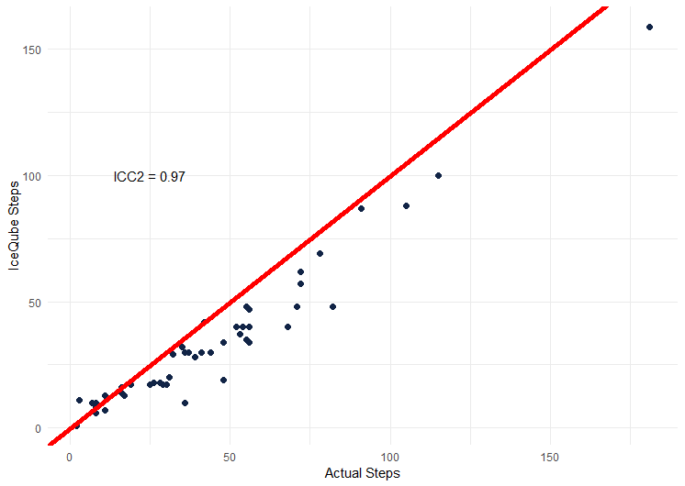
Figure 1 – Actual (observed) step-count verses IceQube reported step-count showing a correlation of 0.97 but a consistent and significant (p=0.12) underestimation shown by the deviation from perfect agreement (red line – intercept = 0, slope = 1)
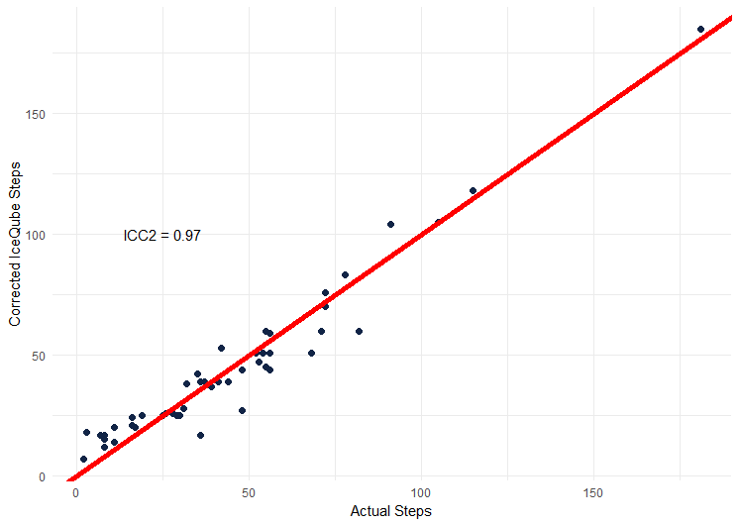
Figure 2 - Actual (observed) step-count verses corrected IceQube reported step-count showing a correlation of 0.97 and now an acceptable agreement between observed and reported data (red line – intercept = 0, slope = 1)

Conclusions - In pasture grazing conditions, the IceQube provides an excellent correlation with the actual step count, allowing the magnitude of any differences between treatment groups to be reliably reported. Using the correction algorithm presented here, the number of steps reported by the IceQube for a 15 min period can be corrected to give an acceptable agreement with the actual number of steps taken.
Acknowledgements - This study was supported by DAERA Evidence & Innovation funding, as part of the project “Investigation of the role of plantain to improve nitrogen use efficiency and reduce emissions in dairy cow grazing systems”.
References
Charlton, G., Gauld, C., Veronesi, F., Rutter, S. M., & Bleach, E. (2022). Assessing the accuracy of leg mounted sensors for recording dairy cow behavioural activity at pasture, in cubicle housing and a straw yard. Animals, 12(5), 638.
Lenoir, A., Trachsel, D. S., Younes, M., Barrey, E., & Robert, C. (2017). Agreement between electrocardiogram and heart rate meter is low for the measurement of heart rate variability during exercise in young endurance horses. Front Vet Sci, 4, 170.
Nielsen, P. P., Fontana, I., Sloth, K. H., Guarino, M., & Blokhuis, H. (2018). Validation and comparison of 2 commercially available activity loggers. Journal of dairy science, 101(6), 5449-5453.
Shepley, E., Berthelot, M., & Vasseur, E. (2017). Validation of the ability of a 3D pedometer to accurately determine the number of steps taken by dairy cows when housed in tie-stalls. Agriculture, 7(7), 53.

