Application Increasing preweaning nutritional levels can shape feed behaviours of Holstein cattle, particularly in their first lactation.
Introduction Early life is a critical time in a calf's life in terms of health and long-term performance. Adequate nutrition in early life is vital to ensure a calf is primed to reach its growth potential and appropriate milestones at the most beneficial time for the animal and the farmer. Currently, the industry standard is to feed calves 10% of their birth body weight (~4 L milk replacer/day). However, increasing evidence indicates that increasing this to 20% of the calf's birth body weight (~8 L milk replacer/day) can increase the animal's performance (Leal et al., 2021). There is a lack of longitudinal studies investigating the behavioural impact of early-life nutritional quantity during the animal's later life. This study aims to investigate if the preweaning nutritional level affects the feed behaviour of Holstein cattle during their first and second lactation. The hypothesis is that the level of nutrition in early life will influence later life feed behaviour.

Materials and Methods At birth, 86 Holstein heifer calves were individually housed and blocked into pairs; each pair received identical colostrum. Within a block, each calf was assigned one of two treatments: the conventional level of milk replacer (4 L/day) or an elevated level of milk replacer (8 L/day). All calves were weaned at week 8 after one week of being stepped down. Calves were housed in pens of 4-6 animals from week 10 onwards and managed similarly regardless of treatment. The animals were followed through their first (n = 77) and second lactations (n = 61). During both lactations, cows were housed in a free-stall barn and fed ad libitum partial mixed ration (PMR) via electronic feed bunks (RIC; Hokofarm Group B.V. Emmeloord, the Netherlands). They also received two types of lactation concentrate from out-of-parlour feeders (Fullwood Packo). A high-protein concentrate was limited to 2.3 kg/day for all cows, and a high-energy concentrate was adjusted depending on the individual's milk output. Feed intake data was collected using the automatic feeders. Every visit to an automatic feeder recorded information including the animal's ID, feed type, date, start and end time of visit, the cow's parity, the days in milk (DIM), and the amount of feed consumed during the visit for both first and second lactation.
Response variables, including feed intake, number of visits to the feeders and the time (secs) spent at the feeders, were analysed using the GLIMMIX procedure of SAS v9.4 (SAS Institute., Cary, NC) with fixed effects of week, treatment and the interaction of week and treatment, and the random effects of block and cow within block. Repeated measures were modelled using a first-order autoregressive covariance structure. The SLICE option of the LSMEANS statement was used to test for treatment differences at specific weeks of lactation. These models were run for concentrate and PMR in both first and second lactation, with each lactation being limited to 44 weeks.

Results The week of lactation was significant for the average concentrate intake in both lactation 1 (F = 45.74, p <0.001) and lactation 2 (F = 29.77, p < 0.001). The average PMR intake revealed that the week of lactation was significant in the first lactation (F = 1.51, p = 0.016). Cattle fed the elevated treatment in preweaning, had a higher number of concentrate eating bouts in the first lactation compared to cattle fed the conventional treatment in early life (F = 8.11, p = 0.005). Within the first lactation, the average number of concentrate and PMR eating bouts revealed that the week of lactation was significant (concentrate: F = 5.31, p <0.001; PMR: F = 1.82, p = 0.001). Week of lactation was also significant for the average number of concentrate and PMR eating bouts in the second lactation (concentrate F = 1.80, p = 0.001; PMR F = 1.57, p = 0.009). In first lactation, cattle fed the conventional treatment spent significantly more time (seconds) at the feeder than cattle fed the elevated treatment (Elevated = 175.90 secs vs Conventional = 208.62 secs, p = 0.020). Examination of the post hoc least square means tests showed there were significant treatment effects from weeks 24 – 43, as seen in Figure 1, with the conventional treatment spending longer time eating than the elevated treatment. This pattern did not cross into the second lactation; only the week of lactation was significant for the average time spent eating concentrate in the second lactation (F = 4.18, p < 0.001). The week of lactation for average time spent eating PMR was significant in both the first lactation (F = 3.00, p <0.001) and the second lactation (F = 2.72, p < 0.001).
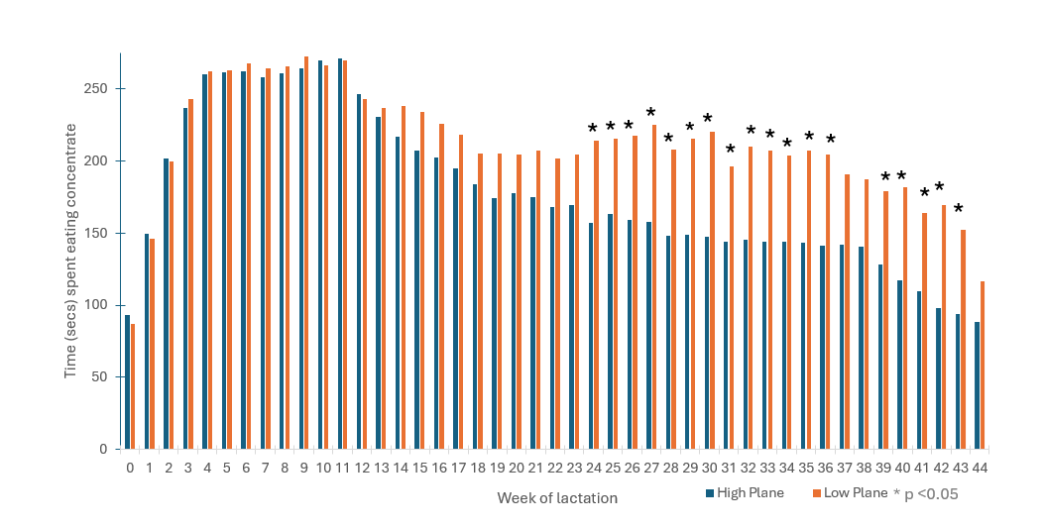
Fig. 1 Average time (seconds) spent eating concentrate in the first concentrate

Conclusions As expected, the cows' feeding patterns were significantly influenced by the week of lactation, for both concentrate and PMR across both lactations. The treatment differences were primarily seen in the first lactation, affecting the number of concentrate eating bouts and the time spent eating concentrate, especially between weeks 24 and 43 (Fig. 1). The time spent eating during the second lactation was only influenced by the week of lactation, showing that both treatment groups had a more consistent intake pattern at this stage. This study's results indicate that preweaning nutritional level can shape feed intake behaviour, particularly in the first lactation.
Acknowledgements: This study was funded by Trouw Nutrition.

References Leal L.N., Doelman J., Keppler B.R., Steele M.A., Martín-Tereso J. 2021. Preweaning nutrient supply alters serum metabolomics profiles related to protein and energy metabolism and hepatic function in Holstein heifer calves. Journal of Dairy Science., 04(7),7711-24.

