Application
Welfare pens are used within Norwegian automatic milking system dairies. These pens are designed to provide prioritised access to resources for certain ‘high-risk’ cow groups (e.g., lame), and may positively influence animal welfare. This study describes welfare pens, their typical usage, benefits, challenges, and costs, and our results can be applied to automatic milking systems worldwide.
Introduction
Automation of the milking process by automatic milking systems increases the autonomy of the cow, with potential welfare and productivity benefits. However, these benefits are diminished if the cows fail to visit the milking robot frequently and regularly enough to maintain production (Jacobs and Siegford, 2012). Certain ‘high-risk’ cow groups (e.g., lame, low-ranking, primiparous), have a reduced ability to compete for access to resources, and typically have lower voluntary visit frequencies and prolonged milking intervals. Thus, they may produce less milk, have poorer udder health, and may experience compromised welfare. Systems which improve access to resources may help mitigate these issues.
In Norway, a system called a welfare pen is commonly used within automatic milking system herds. These systems create two pens, one for the ‘main’ group and a smaller pen for ‘high-risk’ cows. Theoretically, the smaller pen houses fewer cows, resulting in less competition for resources. Despite their popularity in Norway, little empirical evidence exists regarding the structure, usage, benefits, challenges, and economic implications of welfare pens. The aim of this descriptive study was to 1) describe welfare pens and their integration into Norwegian automatic milking system barns, 2) outline how welfare pens are used by Norwegian dairy farmers, 3) report the perceived benefits and challenges of welfare pens, and 4) outline the economic implications of including a welfare pen in an automatic milking system barn.
Material and methods
The study consisted of three components: an online questionnaire, on-farm data collection, and semi-structured interviews. The questionnaire was distributed to Norwegian farmers with automatic milking systems and gathered information pertaining to farm and welfare pen management, benefits and challenges of welfare pens, and opinions on welfare pens. The questionnaire was available online for approximately seven weeks during October-November 2023 and 132 responses were collected. The on-farm portion of the study took place on five farms with welfare pens in southeast Norway. The farms were issued a logbook where they recorded events of cows being moved into the welfare pen, when and why they were moved, and when and why they were removed from the welfare pen. A total of 137 logbook events were registered over a three-month period from October 2023 to January2024. Semi-structured interviews were conducted with three Norwegian agricultural building advisors in August 2024. The interviews explored the advisors’ perception of, and experience with, welfare pens, particularly relating to economic considerations and practical implementation.
Descriptive data analysis was conducted, and open-ended question responses were thematically analysed.
Results
Figure 1A illustrates the typical structure of a welfare pen and its integration into a Norwegian automatic milking system barn. The welfare pen was reported by a majority of questionnaire respondents to accommodate 10-15% of their productive herd. Pregnant cows and heifers approaching calving and freshly calved cows were reported both in the questionnaire and in the logbook data to be the most common reasons for moving cows to the welfare pen, with management of sick and lame cows ranking second. The decision to remove cows from the welfare pen depended on the reason for being placed into the welfare pen, with a combination of predetermined criteria and direct observation being used to decide when to remove cows from the pen.
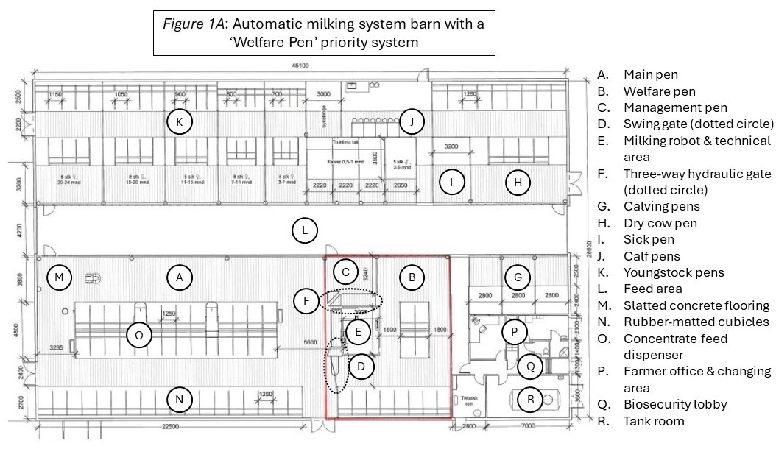
Figure
Figure 1. Automatic milking system barn with a welfare pen priority system

Most survey respondents (71%) felt that the welfare pen had reduced their labour requirements, and overall, respondents felt that animal welfare on the farm was improved. Of respondents without a welfare pen, 65% reported that they would consider installing one. Concerns regarding welfare pens were linked to practical design and management issues, and cost. The building advisors were largely positive towards welfare pens and regularly recommended them. However, they highlighted challenges regarding costliness, particularly when retrofitting existing buildings to accommodate welfare pens. Furthermore, they emphasised that the benefits of installing a welfare pen can be challenging to quantify, as there is no counterfactual for comparison.
Conclusion
Welfare pens are a potentially beneficial addition to automatic milking systems and are generally perceived by users to reduce labour and increase welfare. They are a flexible solution which can be tailored to an individual management system. Though most often used for managing cows in the periods before and after calving, they can be used for several other cow groups and practical applications. The system is particularly applicable when building a new barn for a single robot in systems with limited access to pasture. Further research is necessary to fully understand the benefits, or lack thereof, of welfare pens.

Acknowledgements
The authors thank all study participants, Tine SA, Geno SA, and the WelCow project. Further thanks to BSAS and Innovate UK Business Connect for funding and support.
References
Jacobs, J.A., & Siegford, J.M., 2012. Invited review: The impact of automatic milking systems on dairy cow management, behavior, health, and welfare. J Dairy Sci 95, 2227-2247. doi:10.3168/jds.2011-4943.

