Application
Our results show that breeding animals with higher genetic merit for resistance to digital dermatitis (DD) can lead to reductions in DD incidence. Our in vitro model allows us to study host-pathogen interactions and can lead to a better understanding of disease pathogenesis; this in turn could lead to the development of novel preventive and treatment strategies.

Introduction
Bovine digital dermatitis (DD) is a poly-bacterial disease associated with strawberry-like granulomatous foot skin lesions and lameness, which is endemic to most UK dairy farms. Spirochetes from the genus Treponema have been considered the main causative agent in the disease. Thickening of the epidermis, hyperkeratosis, and infiltration of inflammatory cells are found in the bovine digital skin affected by DD (Pirkkalainen et al., 2024). Among the cells of the immune system, the polymorphonuclear Neutrophil (PMN) are the most abundant cell type and provide a vital early response in host defence by migrating to sites of infection. Research indicates that resistance to DD is heritable, and selective breeding could reduce disease incidence. The UK Agriculture and Horticulture Development Board has recently launched a digital dermatitis genetic evaluation (AHDB, 2020). Here, we aimed to study the association between the DD genetic evaluations and actual DD incidence in a population of dairy heifers. Additionally, we assessed the impact of different genetic merits by developing an in vitro granulocyte migration assay to potentially link genotype to phenotype.

Materials and Methods
This study was conducted under the ethical approval of the University of Liverpool Research Ethics Committee (VREC1372) and ASPA-regulated procedures were operated under a Home Office License (PP8351537). A total of 361 maiden heifers were monitored over a four-month period and their hind feet were examined for presence of DD in a foot trimming crush using the M-stage scoring system. Genomic breeding value (GEBV) estimates for these heifers for DD resistance were made available from the official UK national evaluation. Our phenotypic data were not included in GEBV calculation. Associations between the GEBVs and DD incidence were investigated using logistic regression models. Animals were grouped into terciles based on their GEBVs (high, medium, or low genetic merit). An in vitro model of bovine foot fibroblasts to assess the impact of Treponema phagedenis infection was created. Fibroblasts cells were isolated and cultured from foot skin biopsies taken from 15 heifers, following the protocol by Evans et al. (2014). The heifers were divided into three groups based on their genetic merit and health status. 5 heifers with high genetic merit that were healthy (HGH), 5 heifers with low genetic merit that were infected with DD and then healed (LGH), and 5 heifers with low genetic merit that were chronically infected (LGC). Fibroblast cultures were maintained with media refreshed every 48 hours, and cell morphology and growth were monitored daily. Once cultures reached approximately 80% confluence, fibroblasts were passaged to ensure optimal growth conditions. For migration assays, blood samples were collected from the three heifers per group (HGH, LGH, and LGC). Granulocytes were then isolated from these samples using density centrifugation of EDTA-treated blood, and co-cultured with homologues primary fibroblasts cells in a transwell migration assay using the following stimulatory conditions: (1) Fibroblasts alone, (2) Fibroblasts infected with T. phagedenis, (3) T. phagedenis alone, (4) Interleukine 8 (IL-8) as positive control, and (5) medium alone as negative control. Each condition was tested in triplicate. After 16 hours, the number of granulocytes that had migrated under each condition was counted (Tombácz et al.,2019).

Results
For every 1 SD increase in the GEBVs the OR for any, active, chronic and M2 DD lesion presence were 0.66 (95%CI 0.53-0.82), 0.58 (95%CI 0.45-0.73), 0.63 (95%CI 0.51-0.79) and 0.6 (95%CI 0.42-0.84) respectively. Initially, fibroblasts from each group were seeded at a cell density varying between 200,000 and 800,000 cells per milliliter (ml). After the first passage, cell counts increased to between 2 million and 5 million cells/ml across all groups. Notably, fibroblasts from the HGH group reached 80% confluence within 8 to 10 days, while those from the LGH and LGC groups required 12 to 15 days to reach similar levels of monolayer confluence. Lower numbers of granulocytes migrated when derived from HGH heifers compared to those generated from LGH and LGC (Figure 1).
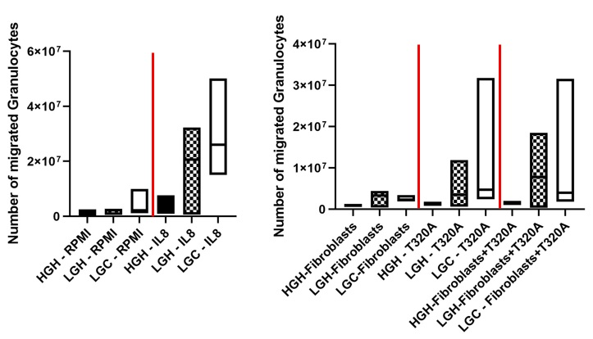
Figure 1: Number of granulocytes migration in maiden heifers with differing genetic merit for Digital Dermatitis resistance. HGH: High genetic merit healthy heifers, LGH: Low genetic merit healed heifers, LGC: Low genetic merit chronic heifers. N = 3 biological replicates, line at mean value.
Conclusions
Our preliminary results suggest that genetic merit for DD resistance is associated with DD incidence and with distinct cellular responses, as fibroblasts from heifers with high genetic merit displayed faster proliferation rates compared to those from low genetic merit. Additionally, granulocyte migration assays indicated that HGH heifers exhibited lower granulocyte migration than LGH and LGC heifers suggesting that genetic factors associated with high merit (DD resistance) may influence immune cell function, potentially leading to a more balanced immune response or altered regulation of cell migration during the inflammatory response. In contrast, the increased granulocyte migration observed in LGH and LGC heifers may reflect a less-regulated inflammatory response, which could potentially contribute to higher susceptibility to DD and related conditions. These preliminary findings provide insight into the immune mechanisms associated with the host genetics of resistance to DD. This model may prove valuable for further studies on genotype-phenotype links in DD resistance.

Acknowledgements
This study was funded by UK Biotechnology and Biological Sciences Research Council (BBSRC; Swindon, UK; Council Reference: BB/X008762/1).

References
AHDB (Agriculture and Horticulture Development Board) AHDB Breeding briefs. 2020. https://ahdb.org.uk/knowledge-library/breeding-briefs
Evans, N. J., Brown, J. M., Scholey, R., Murray, R. D., Birtles, R. J., Hart, C. A., & Carter, S. D. (2014). Differential inflammatory responses of bovine foot skin fibroblasts and keratinocytes to digital dermatitis treponemes. Veterinary Immunology and Immunopathology, 161(1-2), 12-20. https://doi.org/10.1016/j.vetimm.2014.05.005
Tombácz, K., Peters, L. M., Chang, Y. M., Steele, M., Werling, D., & Gibson, A. J. (2019) Pegbovigrastim treatment in vivo does not affect granulocyte ability to migrate to endometrial cells and kill bacteria in vitro in healthy cows. Journal of dairy science, 102(10), 9389–9395. https://doi.org/10.3168/jds.2019-16563
Pirkkalainen, H., Riihimäki, A., Lienemann, T., Anttila, M., Kujala-Wirth, M., Rajala-Schultz, P., Simojoki, H., Soveri, T., & Orro, T. (2024). Local and Systemic Inflammation in Finnish Dairy Cows with Digital Dermatitis. Animals, 14(3), 1-16. https://doi.org/10.3390/ani14030461

