**Preliminary investigation of the mineral and fatty acid composition of grass-fed Dexter beef**

**Application:** Beef from Dexter breed cattle is well renowned for its notably high marbling content, yet this breed has received very little scientific investigation in term of meat quality. This preliminary study offers insight into the mineral and fatty acid (FA) composition of commercially produced, grass-fed Dexter beef in the context of nutrient provision to humans.

**Introduction:** Beef contributes an array of important and highly bio-available nutrients to the human diet, amongst which certain minerals and FAs have particular importance such as iron (Fe), zinc (Zn), selenium (Se) and omega-3 FAs. Dexter cattle are a rare dual-purpose breed of miniature cattle originating from Ireland with mature weights of up to 350kg for cows and 450kg for bulls (McMahon, 2016), and are predominantly reared in extensive, pasture-based systems on small-scale holdings. There has been very little scientific research carried out on the Dexter breed, particularly with regard to meat quality despite the notable high marbling content of beef produced from Dexter breed cattle. Thus, the aim of this preliminary study was to determine and characterise the mineral and FA profile of extensive grass-fed Dexter beef.

**Materials and methods:** Seven commercially-reared Dexter breed cattle were slaughtered in September-October 2018, with an average slaughter age of 30 months and carcass weight of approximately 130kg. Cattle received a grass only diet with a high magnesium salt lick at grazing, and a grass haylage diet during winter housing. Cattle were slaughtered locally to the farm at Long Compton abattoir located in Warwickshire, UK. Carcasses were aged for three weeks prior to cutting, at which point samples of *longissimus dorsi* muscle were collected. Subcutaneous fat, intermuscular fat and connective tissue were removed and the remaining muscle tissue freeze-dried and ground for laboratory analysis. Minerals were extracted using a nitric-perchloric acid digestion with concentrations of Fe, potassium (K), magnesium (Mg) and phosphorus (P) determined by ICP-OES and copper (Cu), manganese (Mn), Se and Zn by ICP-MS. FA methylation and quantification was carried out as per Lee *et al* (2012).

**Results:** Grass-fed Dexter beef contained ‘nutritionally significant’ concentrations (i.e. >15% of the nutrient reference value (NRV) per 100g) of K, P, Fe and Zn (Figure 1). Concentrations of Mg, Cu, Mn and Se were not ‘nutritionally significant’, although Se was very close to the threshold of 15% of NRV. Mean (±SD) total FA content of the Dexter beef analysed was 5.26% (±1.25); comprising 42.0% (±2.77) saturated FAs, 49.3% (±2.88) monounsaturated FAs, 7.15% (±0.948) polyunsaturated FAs. Mean concentration of α-linolenic acid (ALA) was 54.2mg per 100g (±7.19) and below the minimum of 300mg of ALA per 100g required for labelling as a ‘source of’ omega-3 FAs. Mean summative concentration of eicosapentaenoic acid (EPA) and docosahexaenoic acid (DHA) was 19.1mg per 100g (±1.66), again below the minimum of 40mg of long-chain omega-3 FAs (EPA+DHA) per 100g for labelling as a ‘source of’ omega-3 FAs. However, if docosapentaenoic acid (DPA) were included in the sum of ‘long-chain omega-3 FAs’ then the ‘source of’ threshold is exceeded, with the mean summative concentration of EPA, DHA and DPA being 44.8mg per 100g (±3.45) (Figure 2).

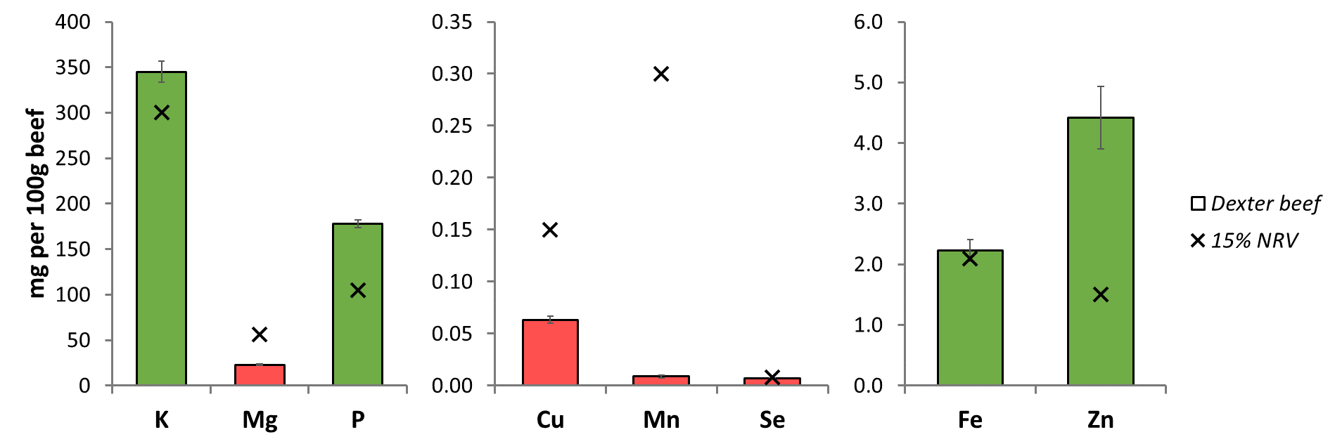

**Figure 1.** Mean mineral concentrations (solid bars ± SD) in commercially produced, grass-fed Dexter beef compared to 15% of the nutrient reference value (NRV) for each mineral (×).

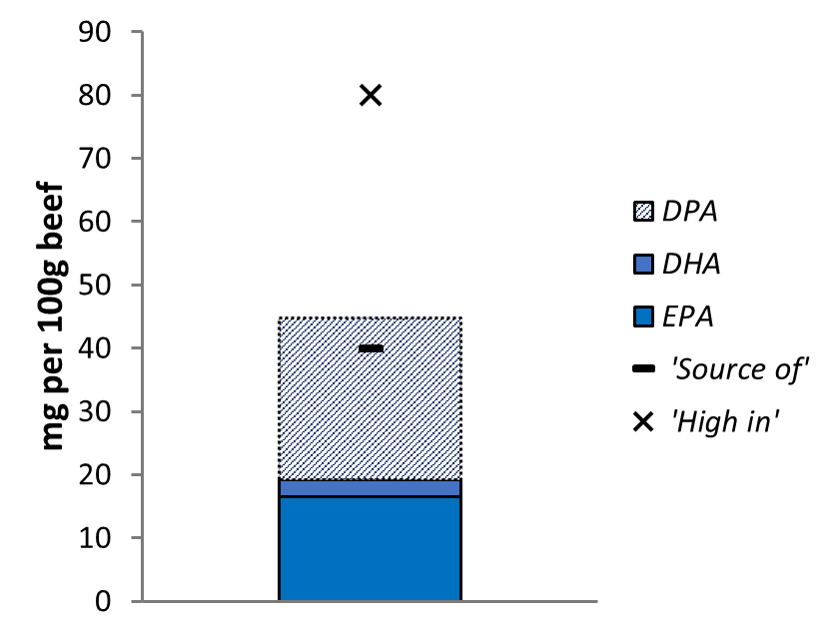

**Figure 2.** Mean summative concentrations of eicosapentaenoic acid (EPA), docosahexaenoic acid (DHA) and docosapentaenoic acid (DPA) in commercially produced, grass-fed Dexter beef compared to concentrations required per 100g of product to be labelled as a ‘source of’ or ‘high in’ omega-3 fatty acids.

**Conclusions:** Grass-fed Dexter beef provides nutritionally significant amounts of K, P, Fe and Zn and can be labelled as a source of these minerals. However, it does not meet current nutritional claims rules in the UK/EU for labelling as a ‘source of’ omega-3 FAs based on EPA and DHA alone. Labelling grass-fed Dexter beef as a ‘source of’ omega-3 FAs would require a rule change so that DPA is included in the definition of ‘long-chain omega-3’ FAs alongside EPA and DHA. Further work is required to determine the extent to which small-scale, locally-grown and extensively-reared meat, such as grass-fed Dexter beef, can contribute to healthier, more sustainable and more equitable human diets.

**References:**

Lee MRF, Tweed JKS, Kim EJ and Scollan ND 2012. Meat Science 92, 863–866.

McMahon S 2016. University of Veterinary Medicine Budapest, Budapest, Hungary.