**Application** There is current interest in the human health benefits of the milk fat globule (MFG) and its membrane. It has been suggested that MFG size and composition could be influenced by dairy cow diet. This pilot study reported a relationship between globule size and certain membrane fatty acids (FA), the availability of which could be changed by altering the cow diet.

**Introduction** Fat in milk is present in the form of a MFG, which comprises a triglyceride core surrounded by a phospholipid-rich membrane (MFGM). Some of these phospholipids have been reported to have a wide range of beneficial effects on human health (Anto et al., 2020). Milk is a good dietary source of these phospholipids, and certain cow diets have been found to increase milk phospholipid content (Argov-Argaman et al., 2014), possibly by decreasing MFG size. In addition, recent research has reported that smaller MFG from unhomogenised milk can have a direct beneficial effect on the gut microbiome, through provision of metabolic support for bacterial growth via metabolites in the MFGM (Raz et al., 2025). It has been hypothesised that the presence of certain MFGM FA, such as *cis*-9 18:1, may drive the mechanism that increases the size of the globule (Cohen et al., 2015), but this has not been fully elucidated. This pilot study aimed to determine whether there was a relationship between MFG size and FA profile of the MFGM phospholipids (in particular *cis*-9 18:1), in milk from cows fed two different diets.

**Materials and Methods** Milk was sampled during afternoon milking from 20 cows at the Centre for Dairy Research, University of Reading. The cows were consuming one of two diets; fresh grass only (n=10; mean ± s.e.m. 309 ± 22.2 days in milk), or a total mixed ration (TMR, 50:50 forage:concentrate) diet (n=10; 82 ± 10.4 days in milk). Within 24 h of collection milk was analysed for MFG size using laser diffraction. The remaining milk was analysed for phospholipid FA profile, with initial extraction using diethyl ether/hexane (Kliem et al., 2013), solid phase extraction to isolate the phospholipids and then methylation of extracted FA (Burdge et al., 2000). Methylated phospholipid FA were separated and identified using gas chromatography (Kliem et al., 2013). The effect of diet on MFG size and phospholipid FA profile was assessed using a one-way ANOVA , and the relationship between MFG size and phospholipid FA profile across all samples was determined using Pearson’s correlation coefficient. Results were reported as significant when *P* < 0.05.

**Results** There was no effect (*P* > 0.05) of diet on MFG size or total milk fat (Table 1). Diet did however affect phospholipid FA profile, with milk from grass-fed cows containing a greater (*P* < 0.05) proportion of 18:3 n-3 and n-3 polyunsaturated FA, and TMR-derived milk containing a greater (*P* < 0.05) proportion of 20:3 n-6 and 20:4 n-6 (Table 1). There was also a tendency (*P* = 0.088) for TMR milk to have a higher proportion of 18:2 n-6 in the phospholipids (probably due to presence of maize silage and fat supplement in the TMR), and for grass milk to have a higher (*P* = 0.087) proportion of conjugated linoleic acids. There were correlations between some of the FA proportions and MFG size. Higher proportions of 16:0 in milk phospholipids were associated with larger MFG sizes (Pearson r = 0.601; Figure 1a) whereas higher proportions of *cis*-9 18:1 were associated with smaller MFG sizes (Pearson r = -0.649; Figure 1b).

**Conclusions** In this pilot study, there was no effect of the two diet types on MFG size. However there were correlations between FA profile and MFG size which were not consistent with hypotheses from previous studies; this could be due to the presence of other FA in mammary epithelial cells which contribute to the synthesis of MFGM. Future research into optimising MFG size and phospholipids needs to include an assessment of the phospholipid families present in MFG, particularly in milk from cows fed diets high in different unsaturated fatty acids.

**Acknowledgements** This study was supported by the University of Reading. Sophie Bellamy was supported by the University’s Undergraduate Research Opportunities Programme. We would like to acknowledge staff at CEDAR, and at the University’s Department of Food and Nutritional Sciences Food Processing Centre, for their assistance.

**Table 1**. Effect of dairy cow diet on milk fat globule size, milk fat content and milk fat phospholipid fatty acid (FA) profile.

|  |  |  |  |  |
| --- | --- | --- | --- | --- |
|  | Diet1 | |  |  |
|  | Grass | TMR | SEM | *P*2 Treatment |
| Milk fat globule size (uM) | 4.4 | 4.4 | 0.25 | 0.984 |
| Milk fat (mg/g milk) | 46.4 | 43.9 | 2.18 | 0.507 |
| *Phospholipid FA profile (g/100 g FA):* | |  |  |  |
| 12:0 | 2.1 | 2.2 | 0.18 | 0.893 |
| 14:0 | 10.6 | 10.9 | 0.30 | 0.680 |
| 16:0 | 37 | 39 | 0.7 | 0.194 |
| 18:0 | 8.8 | 8.4 | 0.26 | 0.494 |
| 18:1 *cis*-9 | 21 | 19 | 0.8 | 0.258 |
| 18:2 n-6 | 2.7 | 3.0 | 0.09 | 0.088 |
| 18:3 n-3 | 0.56 | 0.45 | 0.023 | 0.021 |
| 20:3 n-6 | 0.13 | 0.17 | 0.006 | 0.011 |
| 20:4 n-6 | 0.19 | 0.21 | 0.008 | 0.026 |
| 20:5 n-3 | 0.11 | 0.08 | 0.013 | 0.229 |
| 22:5 n-3 | 0.10 | 0.11 | 0.010 | 0.537 |
| Σ CLA3 | 0.39 | 0.34 | 0.015 | 0.087 |
| Σ n-3 PUFA3 | 0.88 | 0.71 | 0.032 | 0.015 |
| Σ n-6 PUFA | 3.4 | 3.7 | 0.09 | 0.113 |

1Cows consumed either fresh grass only, or TMR – total mixed ration.

2Significance of the effect of diet treatment for n=10 cows.

3CLA – conjugated linoleic acids; PUFA – polyunsaturated fatty acids.

**Figure 1**. Correlation between milk fat globule size and milk phospholipid proportion (g/100 fatty acids) of (a) 16:0, and (b) *cis*-9 18:1, in milk from 20 dairy cows.

1. (b)

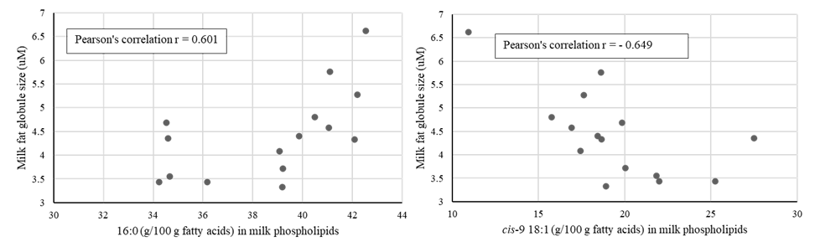

**References**

Anto, L., Wen Warykas, S., Torres-Gonzalex, M., Blesso, C. N. 2020. Nutrients, 12, doi: 10.3390/nu12041001.

Argov-Argaman, N., Mesilati-Stahy, R., Magen, Y., Moallem, U. 2014. Journal of Dairy Science 97:6286-6295.

Burdge, G. C., Wright, P., Jones, A. E., Wootton, S. A. 2000. British Journal of Nutrition, 84, 781-787.

Cohen, B. C., Shamay, A., Argov-Argaman, N., 2015. PLoS One, 10, DOI: 10.1371/journal.pone.0121645.

Kliem, K. E., Shingfield, K. J., Livingstone, K. M., Givens, D. I, 2013. Food Chemistry, 141, 274-281.

Raz, C., Tzirkel-Hancock, N., Shemesh, M., Argov-Argaman, N. 2025. Food Chemistry, 467, https://doi.org/10.1016/j.foodchem.2024.142244