Introduction
Low frequency (LF)-RFID chips are widely used in animal tracking for ear tags in bull studs, where their inability to identify multiple animals simultaneously reduces the risk of erroneous reads (Pinna et al., 2023). However, LF-RFID chips are less suited for high throughput environments such as tracking semen straws in goblets for efficient counting, storage, and distribution. High Frequency (HF)-RFID offers better performance due to their smaller size, making them more suitable for insertion into semen straws (Hoshino et al., 2011).
Application
The aims of the current study were to evaluate the effect of using LF-RFID chips for liquid semen traceability from the barn to the semen processing laboratory and to evaluate the effect of exposure of semen to HF-RFID chips within semen straws on sperm quality parameters post-thaw and field fertility (non-return rates) following Artificial Insemination (AI) for a fully integrated and complete RFID package from semen collection to AI.
Materials and Methods
Semen was collected from Holstein Friesian (HO) bulls 1-3 days/week using an artificial vagina and partially diluted in aliquots of 10ml of egg-yolk based extender (Bullxcell, IMV technologies, Laigle, France) for transport to the laboratory and further dilution into semen straws (0.25ml) at 60 x 10⁶ sperm/ml frozen. Inseminations were performed by AI technicians into HO (91%) or HO cross cows. Fresh semen assessment was performed on partially diluted semen. Sperm concentration assessment was performed on the raw semen sample using a coulter counter (Z Series Beckman Coulter, Beckman, Clare, Ireland). Total motility and progressive motility score were assessed routinely by a trained andrologist prior to freezing and immediately post-thaw using a phase contrast microscope at 20X (BX41, Olympus) and heated stage. Sperm kinematic parameters were measured after semen was diluted in easy buffer B (IMV Technologies®, France) and placed on a pre-warmed glass chamber (4-well, 20-mm depth; Leja, IMV) maintained at 37°C and 1000 sperm were analysed using a computer assisted sperm analyser (CASA system, v.14; IVOSII, IMV Technologies).
Experimental Design
In Experiment 1, Semen ejaculates (n=2/bull) from 5 bulls travelled to the laboratory either in the presence (Treatment A) or absence (controls; Treatment B) of a large LF-RFID chip. Following semen assessments Treatment A was also subjected to the presence of a HF-RFID chip (Treatment A1) or no HF-RFID chip (Treatment A2) while Treatment B was subjected to presence of a HF-RFID chip in the straw (Treatment B1) or no chip (Control; Treatment B2). All treatments were assessed in vitro. In Experiment 2, semen ejaculates from bulls (n=6) were subjected to presence of HF-RFID chips in the straws or controls with no chips. Straws were cryopreserved and used for AI in cows (n=625 and n=631 for control and HF treatment groups, respectively).
Statistical Analysis
Statistical significance was analysed by linear mixed-effect model followed by PostHoc Tukey Games-Howell test or ANOVA with PostHoc Dunnet’s test. Data were considered to differ significantly, if p<0.05.
Results and Discussion
No adverse effects of LF-RFID or HF-RFID were observed on semen quality parameters in vitro or on fertility in vivo, as measured by the 56-day non-return rate in conventional programs (p > 0.05). These findings are in contrast with Pacchierotti et al. (2021), where they suggested that exposure of semen to LF waves could cause decreases in sperm motility and cell viability. The biggest limitations were the capacity for consistent multiple readings with HF-RFID chip straw groups following cryopreservation (and immersion in liquid nitrogen) and Bluetooth connectivity with AI technician handheld devices in field situations.
Conclusion and Implications
RFID technology in bovine semen is a promising technology for more accurate sample labelling as it can improve on errors encountered with barcode traceability systems. New advances in reading RFID under liquid nitrogen could change the landscape in this field of work.
References:
Pinna, D., G. Sara, G. Todde, A. S. Atzori, V. Artizzu, L. D. Spano, and M. Caria. 2023. Advancements in combining electronic animal identification and augmented reality technologies in digital livestock farming. Sci. Rep. 13(1):18282.
Hoshino, Y., K. Mukojima, N. Minami, and H. Imai. 2011. 10 traceability system for an individual frozen semen straw by a tiny radio frequency identification chip. Reprod. Fert. Develop. 24(1):116-116.
Pacchierotti, F., L. Ardoino, B. Benassi, C. Consales, E. Cordelli, P. Eleuteri, C. Marino, M. Sciortino, M. H. Brinkworth, and G. Chen. 2021. Effects of Radiofrequency Electromagnetic Field (RF-EMF) exposure on male fertility and pregnancy and birth outcomes: Protocols for a systematic review of experimental studies in non-human mammals and in human sperm exposed in vitro. Environ. Int. 157:106806.

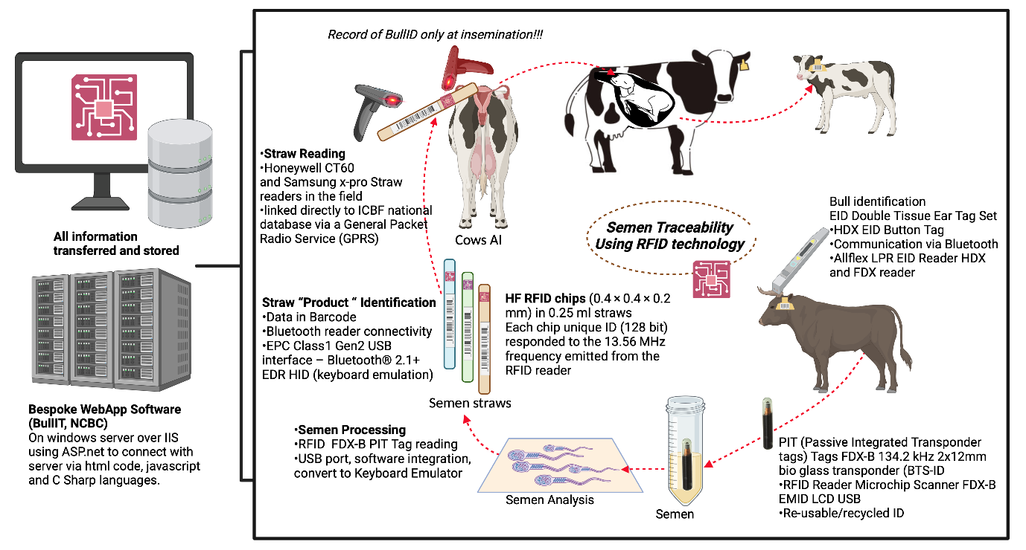
Fig. 1 Technological hardware and software considerations for using Low Frequency (LF)-RFID chips to label the liquid semen and for using High Frequency (HF)-RFID chips for labelling straws for freezing and dispatch for field fertility

