### Application:

The investigation of how molecular alterations in bovine muscle, under a stress challenge,  are conserved or variable according to metabolic and structural properties, has the potential to enhance our understanding of the general stress response and its relationship with *post-mortem* muscle physiology to inform meat management systems.

### Introduction:

Previous studies have demonstrated a relationship between elevated pre-slaughter stress levels and reduced meat quality in farm animals (Xing et al., 2019). Currently, a comprehensive understanding of the biological mechanisms underlying the effects of stress on meat quality is lacking. However, minimising pre-slaughter stress would be beneficial for improving animal welfare and meat quality (Terlouw et al., 2021). The proteome is dynamic and responsive to *in vivo* and *post-mortem* environmental influences, making it a useful biological source for a better understanding of the biological mechanisms at interplay (Gagaoua et al., 2024; Wu et al., 2014). It can be further used to address the knowledge gap on the link between stress and meat quality (Sierra et al., 2021). This study sought to leverage a shotgun proteomic approach to examine the effects of pre-slaughter stress on the *post-mortem* physiological response in two bovine muscles with contrasting physiological properties.

### Material and Methods:

Thirty-two Normand cull cows (mean live weight 642 kg) at 54 ± 8.5  months of age were used in a 3×2 factorial design with three “feeding regimes” (FR) and two “pre-slaughter stress conditions” (PSC). During the finishing period, the cows received three different FR treatments: a diet of straw and concentrate (0.8 and 1.8 kg/day, respectively) supplemented with either a) lipid (40 g oil/kg diet DM), b) lipid + vitamin E (155 IU/kg diet DM), or c) lipid + vitamin E + plant extract (7 g/kg diet DM). The animals had ad libitum access to water. After the finishing period (100 days), the animals were slaughtered under either PSC: a) limited stress (n = 16) or b) physical and psychological stress (n = 16) (Bourguet et al., 2010). Within 15 min of slaughter, tissue samples were collected from two muscles: *M. longissimus thoracis* *et lumborum* (LT), a postural muscle essential for spinal support and stability, and superficial *M. semitendinosus* (ST), a key locomotor muscle involved in hind limb movement. The ST contains a greater proportion of fast oxido-glycolytic and fast glycolytic muscle fibres and a lower proportion of slow oxidative muscle fibres than the LT (Chriki et al., 2012). These samples were immediately flash-frozen in liquid nitrogen and stored at -80°C until proteomic analysis. After sample preparation (protein extraction and enzymatic digestion with trypsin), data were acquired using high-resolution liquid chromatography-tandem mass spectrometry (LC-MS/MS). The ST and LT samples were analysed using a single procedure. The resulting data were then processed for protein identification using the Mascot search engine and relative label-free quantification (LFQ) using the Progenesis QI software. Data preprocessing (filtering, k-nearest neighbor imputation, log10 transformation, and Pareto scaling) and statistical analysis (two-way analysis of variance) were performed to identify Differentially Abundant Proteins (DAPs). The analysis was conducted using R packages, including tidyverse, UniprotR, MetaboAnalystR, car, ggplot2, and ggvenn. DAPs in the LT and ST muscles associated with PSC underwent additional filtering using fold change (FC). Subsequently, Metascape® (Zhou et al., 2019) was used for a comparative analysis of these DAPs in both muscle types to identify enriched biological processes within differentially abundant proteins.

### Results:

In total, 815 and 817 proteins were identified in the ST and LT muscles, respectively. FR influenced (p<0.05) the abundance of 160 and 66 proteins in ST and LT, respectively. PSC influenced (p<0.05) the abundance of 140 and 95 proteins in ST and LT, respectively. Eighteen and 42 of these proteins were influenced by an FR × PSC interaction in ST and LT, respectively (Fig 1 A & B). We present only the results of the subsequent analysis carried out on 122 (ST) and 53 (LT) proteins showing the main effect of PSC without interaction. Of these, 102 (ST) and 41 (LT) proteins showed FC> 1.2 or FC< -1.2 (Fig 1 C & D). Two proteins were affected by PSC in both LT and ST muscles, these being BLTP3B (Bridge-Like Lipid Transfer Protein Family Member 3B), and PAEP (progestagen associated endometrial protein), as shown in the Circos plot (Fig 2A), but the effect on BLTP3B was opposite in LT and ST. Metascape® revealed four common enrichment terms for PSC effect in LT and ST muscles; “GO:0019752: carboxylic acid metabolic process”, “R-HSA-71387: Metabolism of carbohydrates”, “GO:0006575: cellular modified amino acid metabolic process”, and “GO:0044283: small molecule biosynthetic process”. Several enrichment terms were identified specific to particular muscles. Twenty-four enrichment terms were only identified for ST muscles, whereas six enrichment terms were found to be specific to LT muscles (Fig 2B).

### Conclusions:

PSC and FR affected a higher number of proteins in the ST than in the LT muscle (z-test for proportions: p < 0.0001), while the opposite trend was observed in transcriptomic data from the same experiment (Cassar-Malek et al., 2022). A number of biological processes were influenced by PSC in both muscles, particularly aerobic respiration, respiratory electron transport, and carboxylic acid metabolism. The ST muscle, however, exhibited a number of additional affected processes (24 vs 6 distinctive GO terms) relative to LT, suggesting a greater biological response to PSC in this muscle.

### References

Bourguet, C., Deiss, V., Gobert, M., Durand, D., Boissy, A., & Terlouw, E. M. C. (2010). Characterising the emotional reactivity of cows to understand and predict their stress reactions to the slaughter procedure. *Applied Animal Behaviour Science*, *125*(1-2), 9-21. <https://doi.org/10.1016/j.applanim.2010.03.008>

Cassar-Malek, I., Pomiès, L., de la Foye, A., Tournayre, J., Boby, C., & Hocquette, J.-F. (2022). Transcriptome profiling reveals stress-responsive gene networks in cattle muscles. *PeerJ*, *10*. <https://doi.org/10.7717/peerj.13150>

Chriki, S., Picard, B., Jurie, C., Reichstadt, M., Micol, D., Brun, J.-P., Journaux, L., & Hocquette, J.-F. (2012). Meta-analysis of the comparison of the metabolic and contractile characteristics of two bovine muscles: Longissimus thoracis and semitendinosus. *Meat Science*, *91*(4), 423-429. <https://doi.org/10.1016/j.meatsci.2012.02.026>

Gagaoua, M., Schilling, W. M., Zhang, X., & Suman, S. P. (2024). Applications of proteomics in meat research. In *Encyclopedia of Meat Sciences* (pp. 513-527). <https://doi.org/10.1016/b978-0-323-85125-1.00123-x>

Sierra, V., González-Blanco, L., Diñeiro, Y., Díaz, F., García-Espina, M. J., Coto-Montes, A., Gagaoua, M., & Oliván, M. (2021). New Insights on the Impact of Cattle Handling on Post-Mortem Myofibrillar Muscle Proteome and Meat Tenderization. *Foods*, *10*(12). <https://doi.org/10.3390/foods10123115>

Terlouw, E. M. C., Picard, B., Deiss, V., Berri, C., Hocquette, J.-F., Lebret, B., Lefèvre, F., Hamill, R., & Gagaoua, M. (2021). Understanding the Determination of Meat Quality Using Biochemical Characteristics of the Muscle: Stress at Slaughter and Other Missing Keys. *Foods*, *10*(1). <https://doi.org/10.3390/foods10010084>

Wu, W., Fu, Y., Therkildsen, M., Li, X.-M., & Dai, R.-T. (2014). Molecular Understanding of Meat Quality Through Application of Proteomics. *Food Reviews International*, *31*(1), 13-28. <https://doi.org/10.1080/87559129.2014.961073>

Xing, T., Gao, F., Tume, R. K., Zhou, G., & Xu, X. (2019). Stress Effects on Meat Quality: A Mechanistic Perspective. *Compr Rev Food Sci Food Saf*, *18*(2), 380-401. <https://doi.org/10.1111/1541-4337.12417>

Zhou, Y., Zhou, B., Pache, L., Chang, M., Khodabakhshi, A. H., Tanaseichuk, O., Benner, C., & Chanda, S. K. (2019). Metascape provides a biologist-oriented resource for the analysis of systems-level datasets. *Nature Communications*, *10*(1). <https://doi.org/10.1038/s41467-019-09234-6>

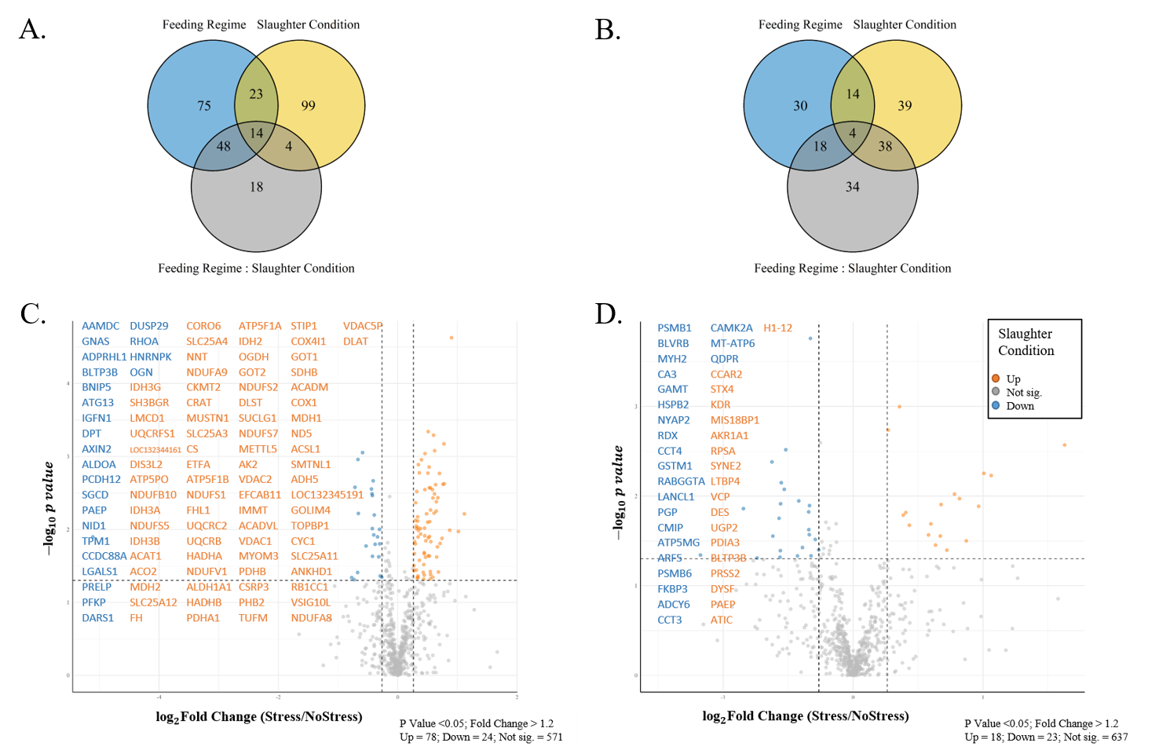

***Figure 1.*** Venn diagrams illustrating the overlap in the number of differentially abundant proteins for the comparison of two treatments and their interaction in the A) ST and B) LT muscles; Volcano plots depicting log2 fold changes and p-values for the comparison of proteins in stressed *versus* non-stressed animals in C) ST and D) LT muscles.

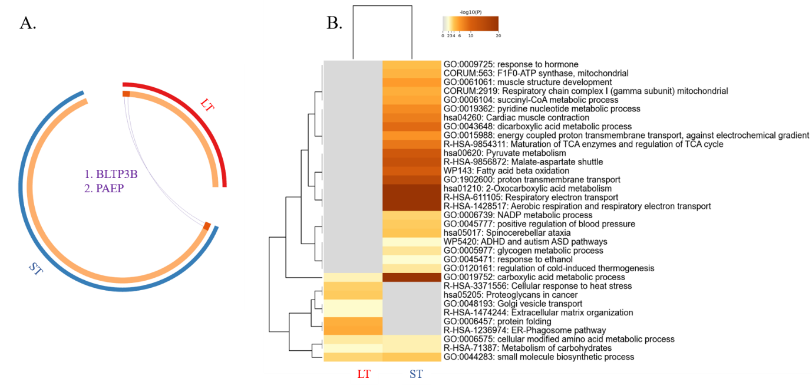

***Figure 2.*** A) Circos plot illustrating overlap between proteins, and B) Heatmap representing all enriched terms across for LT *versus* ST muscles.