**Application** Using an on-board milk replacer feeding system on a ferry measurably improved the blood physiology of unweaned calves the next day, but improvements were not maintained until later timepoints.

**Introduction** Europe and other parts of the world are currently seeing increased societal concern regarding the welfare of calves and other animals during transport. One of the largest welfare risks in transported calves is caused by prolonged fasting durations. This study aimed to assess changes in the blood physiology of unweaned calves as a result of using an on-board milk replacer feeding system during a road/ferry/road journey from Ireland to the Netherlands.

**Materials and Methods** Calves were transported from an assembly centre in Ireland, via a lairage in France, to a veal farm in The Netherlands. A total of 100 Holstein Friesian (HF) or HF cross calves (average age 27.6d, range 14 – 42d) were enrolled in the trial; 40 calves were fed on board the truck during the ferry section of the transport between Ireland and France using an on-board feeding system (FEED), and the remaining 60 calves were included as controls (CONT). Calves were blood sampled prior to departure at the assembly centre in Ireland (Day 0), upon arrival at the lairage in France (Day 1), upon arrival at the veal farm in The Netherlands (Day 2), and one week post arrival at the veal farm (Day 9). The transit from Ireland to France lasted approximately 22h, they remained at the lairage in France for 13h, after which the transit to The Netherlands lasted approximately 12.5h. Both FEED and CONT calves were fed milk replacer prior to departure at the assembly centre in Ireland, after sampling at the lairage in France, and following the sampling upon arrival at the veal farm in The Netherlands. At the veal farm, calves were fed milk replacer twice daily. CONT calves were fasted for approximately 28h between Ireland and France and for approximately 27h between France and The Netherlands. In contrast, FEED calves were fasted for approximately 15h between Ireland and feeding on the ferry, approximately 13h between feeding on the ferry and France, and for approximately 27h between France and The Netherlands. Blood samples were analysed for glucose, beta-hydroxy-butyrate (BHB), non-esterified-fatty-acids (NEFA), total protein, urea, lactate, and creatine kinase. Generalised linear mixed models were used in SAS on Demand to analyse the effect of feeding or not feeding on the ferry on changes in the blood physiology of calves. Statistical models accounted for differences in weight, age, and breed. An interaction between treatment (FEED, CONT) and time (Day 0 – Day 9) was included to determine differences between treatment groups at different time points.

**Results** At the lairage (Day 1), glucose was higher (4.8 vs. 4.0 mmol/L; p < 0.01) and BHB (0.20 vs. 0.34 mmol/L), NEFA (0.52 vs. 0.71 mmol/L), urea (3.06 vs. 3.49 mmol/L), and lactate (0.85 vs. 1.25 mmol/L) were lower for FEED calves compared to CONT calves (all p < 0.01; Figure 1). No blood variables differed between treatment groups on arrival at the veal farm. Total protein was within the reference range for both groups at all times and did not differ between treatment groups on any Day (all p > 0.1). Creatine kinase was higher than the reference range on all days, possibly affected by muscle damage as a result of transport. Creatine kinase did not show interactions between treatment and Day (p = 0.09), regardless of Day, creatine kinase did not differ between treatments (p = 0.99). No variables differed between treatment groups at Day 9 (all p > 0.1).

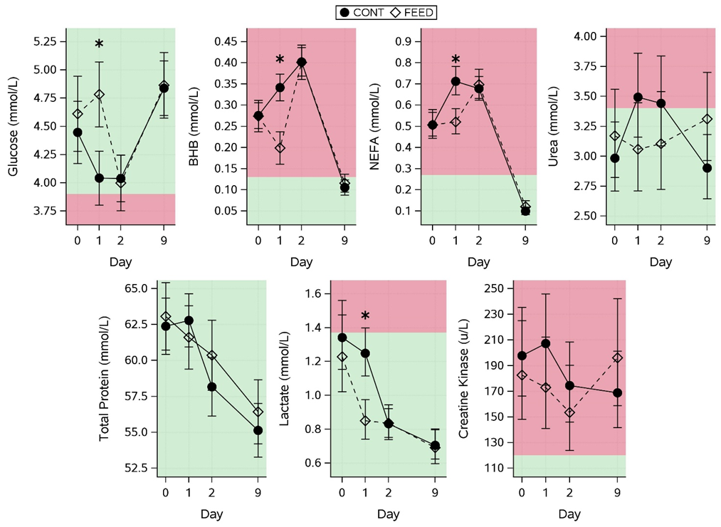

**Figure 1.** Effect of treatment (CONT, FEED) on blood variables (glucose, BHB, NEFA, total protein, urea, lactate, and creatine kinase) on days relative to departure (Day 0: assembly centre in Ireland, Day 1 = lairage in France, Day 2 = arrival at veal farm in The Netherlands, Day 9 = 7 days post arrival on veal farm). All variables are presented as means ± confidence interval. Red (dark) shaded areas represent areas outside of normal reference limits. * Significant difference (p < 0.05) between treatment groups within a day.

**Conclusions** In general, most blood variables were better for FEED calves than for CONT calves at the first sampling after feeding on the ferry, but no differences between treatment groups were apparent on arrival at the veal farm. On-board feeding of calves has the potential to improve the blood physiology of calves but more work is needed to avoid blood physiology indicators falling out of reference ranges.

**Acknowledgements** The authors acknowledge funding from Teagasc core funding and the Teagasc Walsh scholarship programme