Application
Microbiome-driven breeding, as a cost-effective strategy to mitigate methane (CH₄) emissions, is recommended to be used in a multiple trait model with correlated production traits, as it substantially increased the accuracy of estimation of breeding values (EBVs) and thus enhances selection response.
Introduction
Roehe et al. (2016) found that rumen microbial gene abundances are closely linked to CH₄ emissions and highlighted these as a highly informative proxy for breeding low CH₄ emitting cattle. Later, Martinez-Alvaro et al. (2022) demonstrated the effectiveness of using microbial genes in microbiome-driven breeding to reduce CH₄ yield (expressed as g of CH₄/kg of dry matter intake). In this study, we applied microbiome-driven breeding for mitigating daily CH₄ emissions (g of CH₄ /day), and incorporated information from key performance traits genetically associated with CH₄ emissions, such as daily feed intake (DFI), average daily gain (ADG) and carcass weight (CCW).
Materials and Methods
The experiment was conducted following the UK Animals Act 1986 and was approved by the Animal Experiment Committee of SRUC. Three hundred sixty-three steers raised under the same housing conditions on the same research farm were used in this project. The animals were balanced for different breeds (Aberdeen Angus, Limousin, Charolais crosses and purebred Luing) and basal diets (two diets of 520:480 and 920:80 forage:concentrate ratios). Blood and rumen fluid samples were collected at slaughter. Microbial DNA sequence reads from rumen fluid samples were aligned to the Kyoto Encyclopedia of Genes and Genomes database, resulting in the identification of 3362 microbial genes. To account for the compositionality of microbiome data, microbial gene abundance data were transformed using the additive log-ratio method. CH₄ production was measured individually for 285 of the 363 animals over a 48-hour period using six respiration chambers and expressed as CH₄ emissions per day (CH₄p).
Firstly, we conducted multiple bivariate genomic (37K SNPs) analyses to obtain genetic variances and covariances between CH₄p and microbial genes. Secondly, we identified the most informative microbial genes that yielded the largest correlated response in CH₄p. Thirdly, we conducted genomic bivariate analyses between the identified microbial genes and the performance traits DFI, ADG, CCW to obtain the genomic (co)variances. Lastly, we used these genomic (co)variances for different breeding strategies to reduce CH₄ production: 1) univariate analyses, using measured CH₄p only (CH₄p measured), 2) multivariate analysis using only the most informative microbial gene abundances genetically correlated with CH₄p, i.e., microbiome-driven breeding (MDB.43), 3) multivariate analysis, including DFI, ADG, CCW, and measured CH₄p (Four traits measures), and 4) multivariate analysis, including DFI, ADG, CCW, and predicted CH₄p using microbiome-driven breeding (Three traits & MDB.43). Three selection intensities (1.159, 1.400, and 1.755) were considered for each strategy.
Results
We identified 43 informative microbial genes, of which 17 were positively genetically correlated with CH₄p (r_{gCH4p}, ranging from 0.45 to 0.80) and 26 microbial genes were negatively correlated (r_{gCH4p} ranged from -0.32 to -0.75) with CH₄p. All correlations had more than 80% probability of being greater or lower than zero (Pr0). The heritability of these microbial genes ranged from 0.19 to 0.50.
Of all performance traits, DFI showed strong positive genetic correlations (ranging from 0.84 to 0.93, Pr0 = 100%) with ADG, CCW, and CH₄p. CCW had a marginally higher genetic correlation with CH₄p (0.61, Pr0 = 96%) than ADG (0.58, Pr0 = 96%).
Selection using microbiome-driven breeding (MDB.43) resulted in similar selection responses to those based on measured CH₄p using respiration chambers (Figure 1, -17.76 ± 2.30% vs -16.76 ± 2.26% at highest selection intensity). Including measured CH₄p in the multiple-trait model with ADG, DFI and CCW increased the accuracy of the EBVs from 0.63 ± 0.15 to 0.81 ± 0.06 and the selection response to -20.59 ± 2.13%). Replacing measured CH₄p by microbiome-driven breeding resulted in a further increase in response at -23.12 ± 2.88%.
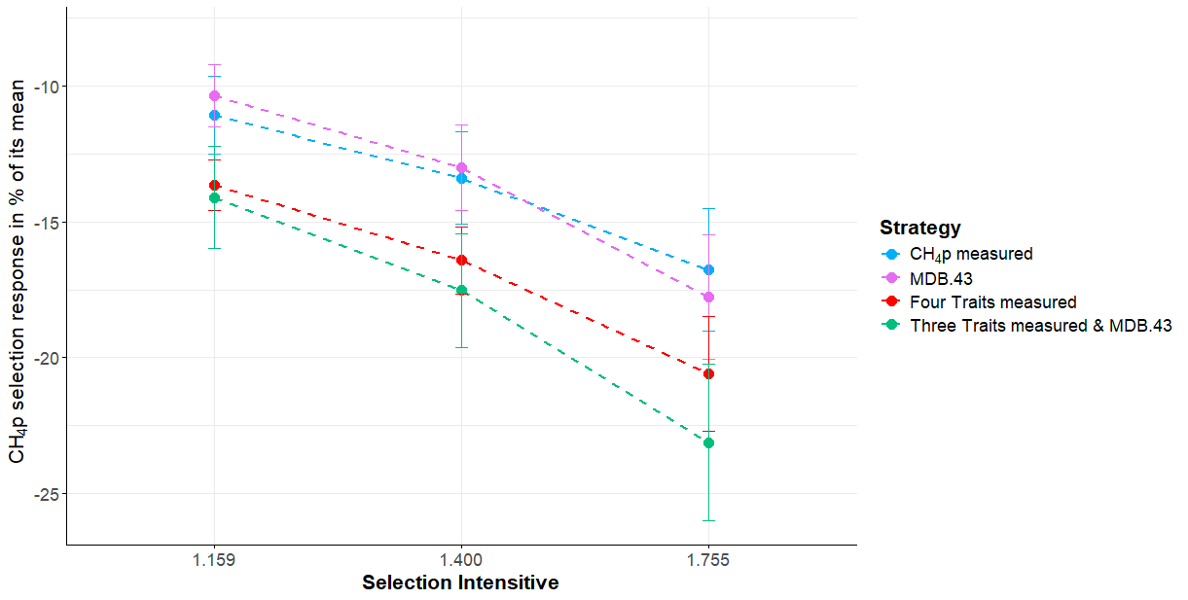
Figure 1. Methane mitigation using different selection strategies, considering three selection intensities (1.159, 1.400, 1.755, equivalent to selection of the best 30%, 20% and 10% of the population, respectively)
Conclusions
Microbiome-driven breeding for reduced CH₄p was successfully integrated into a multiple-trait model with production traits by considering all genetic and residual covariances between microbial gene abundances and those traits. Since microbiome-driven breeding is substantially more cost-effective than using measured CH₄ emissions and provide at least similar selection response to that obtained using the gold standard method of respiration chambers, this methodology provides large potential to effectively reduce this highly potent GHG gas in beef populations.
References
Roehe, R. et al. (2016). PLOS Genetics, 12 (2), e1005846.
Martínez-Álvaro, M. et al. (2022). Communications Biology, 5(1), 350.

