BSAS 2025 ABSTRACT SUBMISSION TEMPLATE
DO NOT DELETE OR CHANGE ANY OF THE FORMATTING ON THIS DOCUMENT

- IMPORTANT: DO NOT INCLUDE THE ABSTRACT TITLE OR AUTHORS & AFFILIATIONS/ PRESENTING AUTHOR DETAILS IN THIS DOCUMENT. THIS DOCUMENT IS TO INCLUDE THE ABSTRACT TEXT ONLY.
- YOUR ABSTRACT MUST BE SUBMITTED USING THE HEADINGS ON THE FOLLOWING PAGE.
- YUR ABSTRACT WILL BE REJECTED IF IT DOES NOT CONFORM WITH THE FORMATTING GUIDELINES.

[DELETE THIS PAGE BEFORE SUBMITTING]

Application
Artificial insemination is commonplace in commercial pig breeding, and as such, ensuring sperm sample quality is important to avoid reduced farrowing rates and litter sizes. Semen sample quality control often includes tests of sperm motility and sperm morphology using computer assisted semen analysis (CASA) systems that calculate semen parameters from microscopy data. While motility is well studied, it is harder to detect variation in morphology; most analysis considers overall sperm width and height, area, and presence of vacuoles, acrosomes or tail abnormalities. Here, we demonstrate the use of high-throughput nuclear morphometric analysis of boar sperm to identify subtle sperm shape phenotypes, demonstrating progressive abnormalities. The specific phenotypes identified suggest aspects of spermiogenesis that may be disrupted in the production of these sperm and indicate future avenues to investigate the functional impacts of genetics and environment on pig sperm quality.
Introduction
Sperm shape is known to play a role in male fertility, affecting fertilisation rates (e.g Coetzee et al. 1998). However, since sperm are asymmetric cells, detailed shape analysis requires correct orientation and identification of key landmarks, which has limited the scale of most studies. Studies in pigs have been limited, finding some association between sperm morphology and litter size ((Barquero et al., 2021), but more detailed studies are needed. We previously developed high-throughput image analysis methods for mouse sperm (Skinner, 2022; Skinner et al., 2019), enabling automated recognition and morphological analysis of asymmetric cell nuclei within an image. Since the majority of a sperm head is taken up by the nucleus, we can examine nuclear shape as a proxy for overall sperm head shape using nuclear stains to generate images amenable to automated image analysis. Here, we investigate the use of this method for characterising boar semen samples.
Materials and Methods
94 boar sperm samples were imaged in this study. Fresh ejaculates were collected by JSR Genetics Ltd, fixed with 3:1 methanol:acetic acid, and nuclei stained with DAPI. Images were captured on an Olympus IX83 fluorescence microscope at 100x magnification with at least 200 nuclei per sample. Images were analysed in Nuclear Morphology Analysis (NMA) v2.2.1 (Skinner 2022) and data was further processed in R (v4.4.0). The analysis converts the outline of an object into linear profiles of internal angle, diameter and radius, allowing consistent detection of landmarks. Nuclei were oriented by the tail attachment region at the base, characterised by a ‘dimple’ in the nucleus. (Figure 1A, reference point 1). Cells with abnormal phenotypes were detected by identification of outlier cells in either of the angle, radius or diameter profiles.
Results
We analysed 21002 nuclei in total. We aggregated outlier nuclei with similar shape profiles to identify continuous phenotypes, iteratively grouping nuclei with the greatest differences to normal profiles. This amalgamation of outlier shapes yielded a normal phenotype group (85% of nuclei), intermediate phenotype group (13%) and extreme phenotype group (2%). Example images showing the progressive phenotypes from normal to extreme are shown in Figure 1. We found two main paths of abnormality: firstly, basal compression and failure to elongate (Figure 1A; 7.75%); secondly, basal compression and abaxial tail attachment (Figure 1C; 6.25%). We also saw within the intermediate phenotypes minor tapering and formation of spikes in the basal region (Figure 1B 1%). We looked at the frequency of abnormal sperm per sample via ordinal logistic regression, and saw no association with breed (p>0.05); however, some collection dates had higher frequencies of abnormal sperm (p<0.001).

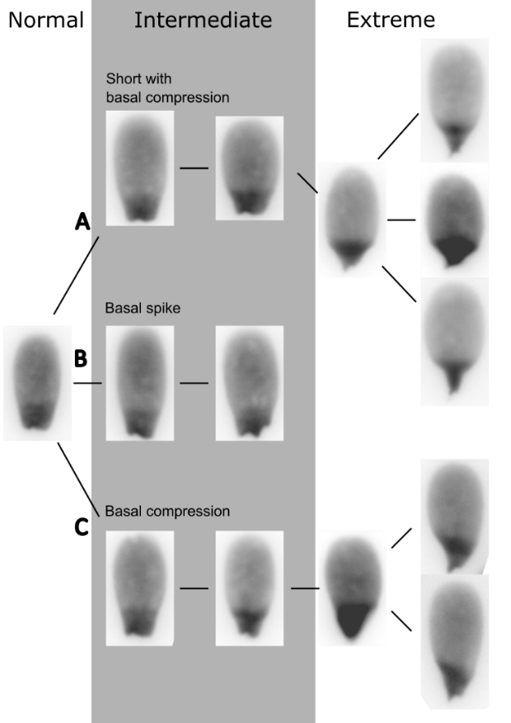
Figure 1. Example DAPI stained images of progressively abnormal sperm phenotypes. A) short progressing to compression around the base of the nucleus and a pyriform phenotype; B) extrusion of nuclear DNA forming a spike near the base of the nucleus with some tapering; C) abaxial compression around the base of the nucleus, leading to a pyriform phenotype.
Conclusions
We demonstrate that high-throughput morphometric analysis of pig sperm nuclei can reveal morphological abnormalities that are not detected by conventional semen analysis. Our initial findings suggest breed may be less important than environment in ejaculate quality. Further study is needed to understand how these phenotypes develop, and the functional consequences for boar fertility.
References
Barquero, V., Roldan, E.R.S., Soler, C., Vargas-Leitón, B., Sevilla, F., Camacho, M., Valverde, A., 2021. Relationship between Fertility Traits and Kinematics in Clusters of Boar Ejaculates. Biology 10, 595. https://doi.org/10.3390/biology10070595
Coetzee, K., Kruge, T.F., Lombard, C.J., 1998. Predictive value of normal sperm morphology: A structured literature review. Hum. Reprod. Update 4, 73–82.
Skinner, B.M., 2022. Nuclear Morphology Analysis 2.0.0: Improved image analysis software for measuring nuclear shape. J. Open Source Softw. 7, 4767. https://doi.org/10.21105/joss.04767
Skinner, B.M., Rathje, C.C., Bacon, J., Johnson, E.E.P., Larson, E.L., Kopania, E.E.K., Good, J.M., Yousafzai, G., Affara, N.A., Ellis, P.J.I., 2019. A high-throughput method for unbiased quantitation and categorization of nuclear morphology. Biol. Reprod. 100, 1250–1260. https://doi.org/10.1093/biolre/ioz013

