***Application***

Hyperspectral imaging has relevance to online prediction of rib product quality within meat management systems.

***Introduction***

The balance of fat and lean in the product is an important parameter of short rib product quality for certain markets. However, sortation for customer specification based on the fat content of rib products is normally deferred until the product is finally prepared, because EUROP grade is not considered informative on the variability of short rib product quality. In order to optimise carcass utilisation in the meat factory, a machine vision system to provide rapid non-invasive prediction of product quality would be advantageous. As compared with video image analysis, hyperspectral imaging (HSI) combines both spatial and spectral information, and has shown potential for meat quality prediction on the cut face of premium cuts (Hamill et al., 2024; Konda Naganathan et al., 2015). X-ray imaging technologies permits segmentation of the fat, muscle and bone through computed tomography (CT) scanning and has been used as reference data in carcass composition studies (Gardner et al., 2018). This research aims to evaluate the effectiveness of hyperspectral surface information in predicting CT-estimated fat % in short-rib products. The study includes development and comparison of several models trained with EUROP class, carcass weight and hyperspectral data or combinations.

***Materials and Methods***

Beef short-ribs (98) from bovine carcass (right side) sides at 24 hours post-mortem, representing a range of categories (young bulls, cows, steers and heifers), fat scores (2, 3, 4), conformation classes (E+, E=, U, R, O, P+), and side weights (122 - 297 kg) were collected. The short-ribs were scanned using a CT scanner (Aquilion Lightning, Canon Medical Systems Corporation) with a voxel resolution of 0.526 × 0.526 × 0.88 mm³. Scan data were exported to 3D slicer in DICOM format for further analysis, including volume rendering, segmentation, and volume estimation for individual tissue components of interest (bone, lean, fat). The segmentation of voxels based on Hounsfield Unit (HU) barriers were established by analysis of CT scan of isolated fat, lean and bone tissues. The associated HU ranges were -227 to -47 for fat, 24.8 to131.8 for lean, >287 for bones, following modified approach of Gardner et al. (2018). Following exclusion of bone voxels, fat-associated % volume for each short-rib was estimated with respect to the combined volume of fat- and lean-associated voxels.

Hyperspectral images of each shortrib dorsal surface were recorded in reflectance mode (wavelength range: 900–1700 nm; spectral resolution: 5 nm) and the average spectrum was used for model calibration. The dataset was divided into training and test sets in an 80:20 ratio. Four Partial Least Squares (PLS) regression models were calibrated on the training set to model the fat percentage (Y variable) using different combinations of predictor variables (X variables): Model 1 included EUROP class; Model 2 included EUROP class and carcass weight; Model 3 was built on average spectra; and Model 4 included EUROP class, carcass weight, and spectra. The models were assessed on the test set by examining the coefficient of determination (R²) and root mean square error of prediction (RMSEP).

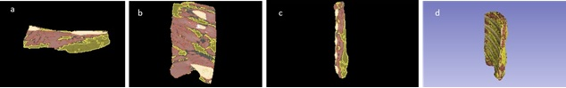

Figure 1: Segmentation of CT image for bone, fat and muscle a) axial b) coronal c) sagittal d) 3 dimensional view

***Results***

The CT-estimated fat percentage ranged from 11 to 51% with a mean of 30.4% and coefficient of variation of 27.3%, which implies that the short-ribs included in the model development show good variability.

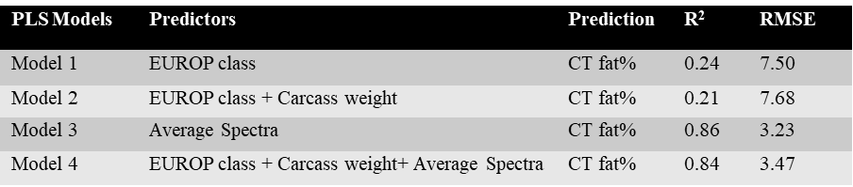

Table 1: PLS fitting statistics of CT derived fat percentage prediction obtained for each model

Models 1 and 2 developed using EUROP class and EUROP class combined with carcass weight showed relatively low prediction accuracy on the test set with R2 below 0.3 and RMSEP greater than 7. Inclusion of the spectral data greatly improved the accuracy of the models (R2 > 0.8, RMSEP reduced to <4), but it was noteworthy that inclusion of EUROP class and carcass weight did not improve the accuracy of the model achieved using the average spectral data alone.

***Conclusions***

Hyperspectral imaging of the short-rib surface provides an improved accuracy of prediction of rib product quality compared to EUROP class and carcass weight, suggesting the potential for improved meat sortation tools with machine vision approaches.

***Reference***

Gardner, G. E., Starling, S., Charnley, J., Hocking-Edwards, J., Peterse, J., & Williams, A. (2018). Calibration of an on-line dual energy X-ray absorptiometer for estimating carcase composition in lamb at abattoir chain-speed. *Meat Science*, *144*(March), 91–99. https://doi.org/10.1016/j.meatsci.2018.06.020

Hamill, R. M., Ferragina, A., Mishra, J. P., Kavanagh, A., Hibbett, M., Gagaoua, M., Colreavy, J., & Rady, A. (2024). Chapter 13 - Toward Meat Industry 4.0: opportunities and challenges for digitalized red meat processing. In A. B. T.-F. I. 4. . Hassoun (Ed.), *Developments in Food Quality and Safety* (pp. 259–281). Academic Press. https://doi.org/https://doi.org/10.1016/B978-0-443-15516-1.00013-X

Konda Naganathan, G., Cluff, K., Samal, A., Calkins, C. R., Jones, D. D., Lorenzen, C. L., & Subbiah, J. (2015). Hyperspectral imaging of ribeye muscle on hanging beef carcasses for tenderness assessment. *Computers and Electronics in Agriculture*, *116*, 55–64. https://doi.org/10.1016/j.compag.2015.06.006