Application
Understanding the biogenic and thermogenic carbon sources on a farm will assist in the transition towards net zero farming. It will help identify the areas of a farm that are reliant on the use of fossil fuels (decarbonisation), whilst recognising the natural carbon sinks (net zero carbon emissions).

Introduction
Climate change has a dramatic impact on many human activities, including agri-food, resulting in an urgent need to act. In a recent update of the planetary boundaries (Rockström et al. 2023), it was identified that due to anthropogenic activity the planet’s natural homeostatic capacity has surpassed six of the nine defined boundaries. The release of anthropogenic greenhouse gas (GHG) emissions has increased the levels of the three main GHG’s in the atmosphere: carbon dioxide (CO₂), methane (CH₄), and nitrous oxide (N₂O); identifying a need to significantly reduce these emissions by 2050 to pre-industrial levels. The three GHG’s can be identified as either biogenic sources (part of a natural cycle of capture and release) or thermogenic sources (fossil fuel derived). For environmental assessment the GHG’s are converted to CO₂e based on their associated global warming potential (GWP) over a defined period e.g., 100 years for GWP-100 (IPCC. 2021); CO₂ = 1 (thermogenic); CH₄ = 27 (biogenic), 29.8 (thermogenic); N₂O = 298 (biogenic and thermogenic). It is important to understand these sources due to the nature of agriculture utilising biogenic cycles, however, there is currently no advice on disaggregating thermogenic sources that could be decarbonised from biogenic sources, that can be balanced with their sink to achieve carbon net-zero. Here, we demonstrate biogenic and thermogenic GHG disaggregation at a farm level to identify a pathway towards decarbonisation and carbon net-zero farming.

Materials and Methods
The emissions of the three main GHG’s for Future Farm at Harper Adams University were calculated using a market-leading carbon calculator. The result output from the calculation evaluated the total GHG emissions for the beef, dairy, sheep, pig, and oilseed rape enterprises which were then disaggregated into individual gases and then further between biogenic and thermogenic sources. Future Farm is variable and unique, there is a mixed enterprise of beef, dairy, sheep, pigs, and arable contributing to our carbon footprint. Our intensive dairy beef production enterprise finishes approximately 70 British-Blue cross steers and heifers from an all-year round calving Holstein-Friesian herd, within 12 months, on a TMR ration. The dairy enterprise is a high performance indoor dairy system formed of a main unit and “smart unit” featuring elements of automation. The main unit accommodates up to 400 cows milked three times a day with a target annual yield of 10,000 litres per cow. The smart unit houses 45 cows and these are milked using a robotic milking system. The sheep enterprise is a grass-based outdoor system formed of a pedigree Lleyn flock, with 600 breeding ewes that rear over 1,000 lambs every year, and most ewes are housed indoors for the lambing season. The pig enterprise is a closed herd consisting of 230-sow farrow-finish in an indoor unit running a 3-week batch operation and finishing over 6,500 pigs annually. The oilseed rape enterprise uses a small proportion of our total land use, and its sole purpose is for commercial production and revenue. As a commercial farm, Future Farm also manages grass leys, produces forage crops (e.g., silage and maize) and other combinable crops (e.g., wheat and barley), which are fed to the farm livestock enterprises and are embedded in the CO₂, CH₄, and N₂O emission totals for these enterprises.

Results
We categorised biogenic source as CH₄ and the thermogenic source as CO₂ (Table 1; direct and indirect). When determining the source of N₂O, it was not possible to differentiate when N₂O emissions became an act of biogenic or thermogenic activity due to the nature of the N inputs in the Harber-Bosch process (focus of future work). Therefore, N₂O was defined as both biogenic and thermogenic (Figure 1).

Table 1 Emissions from the farm by enterprise
Emissions | Enterprise
 | Beef | Sheep | Dairy | Pigs | Oilseed rape
Total direct CO₂ (kg CO₂e) | 37,967 | 42,934 | 220,831 | 85,717 | 18,216
Total indirect CO₂ (kg CO₂e) | 84,122 | 39,411 | 1,262,368 | 1,329,279 | 28,160
Total CH₄ (kg CO₂e) | 68,266 | 294,695 | 2,707,546 | 966,256 | 0
Total N₂O (kg CO₂e) | 21,433 | 96,457 | 488,174 | 136,526 | 26,954
Total CO₂e emissions from farming | 211,787 | 473,596 | 4,679,919 | 2,517,778 | 73,330

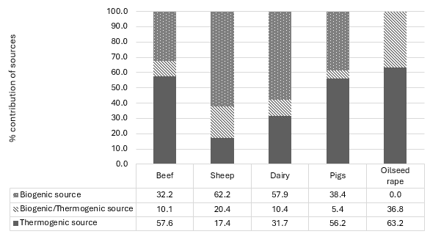
Figure 1. Percentage contribution of biogenic and thermogenic sources per enterprise

Conclusions
The balance between total biogenic and thermogenic sources differed with each enterprise within Future Farm, as did the proportion of emissions where biogenic and thermogenic sources were indistinguishable. As part of a net-zero transition, the thermogenic sources derived from fossil fuels would be the focus of decarbonisation and the biogenic sources would be balanced by sinks in concert with decarbonisation. The ability to disaggregate the sources within Agri-food is crucial to inform management decisions regarding natural sinks and those that need to be removed through decarbonisation, and to assist the development and implementation of a net-zero carbon strategy at farm level.

References
IPCC (2021). Climate Change 2021: The Physical Science Basis. Contribution of Working Group I to the Sixth Assessment Report of the Intergovernmental Panel on Climate Change. Cambridge: Cambridge University Press. DOI: https://doi.org/10.1017/9781009157896

Rockström, J., Gupta, J., Qin, D. et al. (2023) Safe and just earth system boundaries Nature, 619, pp 102-111.

