**No effect of multispecies swards on the host response to *Ostertagia ostertagi* in beef steers offered multispecies swards compared with perennial ryegrass white clover swards.**

*Marie O’Rourke1,2, David A. Kenny1, Alan K. Kelly2, Mark McGee1, Edward O’Riordan1, Cynthia Machin1 & Orla M. Keane1.*

*1Teagasc Animal and Bioscience Research Department, Dunsany, Co. Meath*

*2University College Dublin, Belfield, Co. Dublin*

Corresponding author: Marie O’Rourke. E-mail: [marie.orourke@teagasc.ie](mailto:marie.orourke@teagasc.ie)

***Key words:*** multispecies, herbs/forbs, gastrointestinal nematode infection, host response, beef cattle, feed intake, animal performance, condensed tannins

***Introduction***

Ireland’s temperate climate promotes abundant grass growth and a relatively long grazing season (O’Donovan et al., 2021), thus facilitating pasture based beef cattle production systems (Drennan and McGee, 2009). However, grazing animals typically ingest larvae of parasitic nematodes which are present on the sward (O’Farrell et al., 1986). Indeed, gastrointestinal nematodes (GIN) offer the most pervasive challenge to grazing livestock globally, negatively impacting animal health, welfare and production efficiency. *Ostertagia ostertagi* is the most pathogenic of cattle nematodes, with an associated economic burden (Sharma et al., 2017). Ostertagiosis typically affects cattle in the first and second grazing seasons and can cause severe pathologies, resulting in reduced feed intake and poor thrive (Fox, 1993, Gibbs, 1998). Whilst the strategic use of anthelmintics have been an effective intervention to manage consequences of parasitic nematode infection, there is increasing evidence of anthelmintic resistance in grazing cattle (Cotter et al., 2015, O’Shaughnessy et al., 2014). The rapid and widespread development of anthelmintic resistance warrants the development of alternative GIN control strategies. Lambs grazing multispecies swards, containing grasses, legumes and herbs/forbs, had a reduced requirement for anthelmintic interventions (Grace et al., 2019, Rodriguez et al., 2019). Some studies, have reported lower faecal egg count in grazing cattle offered chicory (Pena-Espinoza et al., 2016). It has been proposed that the reduced infection level in grazing cattle offered chicory may be attributed to the reduced survival of larvae on the sward, compared to conventional grass-based pastures. Additionally, it has been suggested that there may be biochemical properties in herbs/forbs and legumes that may elicit anthelmintic benefits. Chicory contains a range of secondary metabolites with potential anthelmintic activity, including sesquiterpene lactones (Foster et al., 2006), and condensed tannins, however in low quantities (Niezen et al., 1998, Barry, 1998). White clover (*Trifolium repens*) contains high condensed tannins levels (Woodfield et al., 2019), and a reduction in FEC was observed in lambs grazing perennial ryegrass/white clover swards (Niezen et al., 2002). The direct impact of condensed tannins are linked to the intake of the tanniferous forages (Hoste et al., 2012) which can reduce egg excretion by reducing worm burden and/or worm fecundity (Lange et al., 2006). Moreover, there is limited existing evidence and vast ambiguity on the potential of herbs/forbs to reduce parasitic nematode infection in grazing cattle.

***Materials and methods***

Therefore, the objective of this study was to determine the effect of offering multispecies swards on feed intake, growth, efficiency and host response to *Ostertagia ostertagi* in beef steers. Furthermore, the aim of the study was to accurately measure feed intake of multispecies swards, as well as the feed intake of individual botanical components, in a controlled parasitic inoculation study, to accurately quantify the existence of anthelmintic benefits of these swards. The diets offered were multispecies swards containing grass (*Lolium perenne*), legumes (*Trifolium repens, Trifolium pratense*) and herbs/forbs (*Cichorium intybus, Plantago lanceolata*) or perennial ryegrass (*Lolium perenne*)/white clover (*Trifolium repens*) swards. This experiment was part of a larger study, and a cohort of forty Charolais cross steers were assigned to two dietary treatments, multispecies (MSS) (n=20) or perennial ryegrass white clover (PRGWC) (n=20). This experiment took place at the end of July, two months after the beginning of the larger trial, in situ with *O. ostertagi* occurrence in grazing cattle. In this study, fresh forage was harvested once daily (0600h) via the cut & carry method, to a target residual sward height of 5 cm using a Zero-Grazer (Model AB70 Zero Grazer, Dromone, Oldcastle, Co. Meath). Steers were offered their respective dietary herbage allowance three times daily, at 0700h, 1100h and 1600h, *ad libitum.* Refusals were weighed, and discarded each morning. Individual animal feed intake was recorded via Calan gates (American Calan Inc., Northwood, NH). Cattle were weighed fortnightly, before feeding. Once weekly, botanical separations were conducted on a ~200g representative sub-sample of each of the two swards offered. Ten animals per dietary treatment were orally infected with 100,000 *Ostertagia ostertagi* L3 over three days.Faecal samples were taken trans-rectally at the beginning of the experiment pre-inoculation, twice per week from weeks 3-6, and weekly thereafter for faecal egg count (FEC) and dry matter (DM). Blood samples were taken weekly for haematology, serum anti-*Ostertagia* antibody and serum pepsinogen analysis. Faecal egg count was conducted using the mini-FLOTAC method, with a detection limit of 5 eggs per gram.

***Results and Discussion***

During the experimental period, the botanical composition of MSS was 35% *Lolium perenne*, 12% *Trifolium repens*, 32% *Trifolium pratense*, 5% *Cichorium intybus,* 15% *Plantago lanceolata and <1% weeds.* The botanical composition of PRGWC was 55% *Lolium perenne*, 33% *Trifolium repens, 12% weeds.* There was no significant difference in feed intake between animals offered either pasture type (MSS vs. PRGWC) or between non-infected and infected animals. There was no significant difference in average daily gain (ADG) between animals offered either pasture type (MSS vs. PRGWC), or between non-infected and infected animals. Results of the study are shown in Figure 1. Firstly as planned there was a discernible difference (P<0.01) in FEC per g of faecal dry matter (FECDM) in non-infected vs. infected animals. However, there was no difference in FECDM between infected animals offered either pasture type. There was a difference in anti-*Ostertagia* antibody concentrations (P<0.05) from 24 days post infection (DPI), peaking at 31 DPI (P<0.01) between non-infected and infected animals. However, there was no differences in anti-*Ostertagia* antibody concentrations between cattle offered either pasture type (MSS vs. PRGWC). There was a difference (P<0.01) in absolute eosinophil count in peripheral blood, peaking at 9 DPI between non-infected and infected animals.

***Conclusion and implications***

In summary, there was no benefit of including additional herbs/forbs in the diet of steers on their response to inoculation with *O. ostertagi* larvae. In previous studies, the proportions of herbs/forbs were significantly higher where an anthelmintic benefit was observed. The proportion of herbs/forbs in the sward in our study was representative of an established multispecies sward, accurate feed intake of the sward and their individual components were recorded, in a controlled inoculation study.

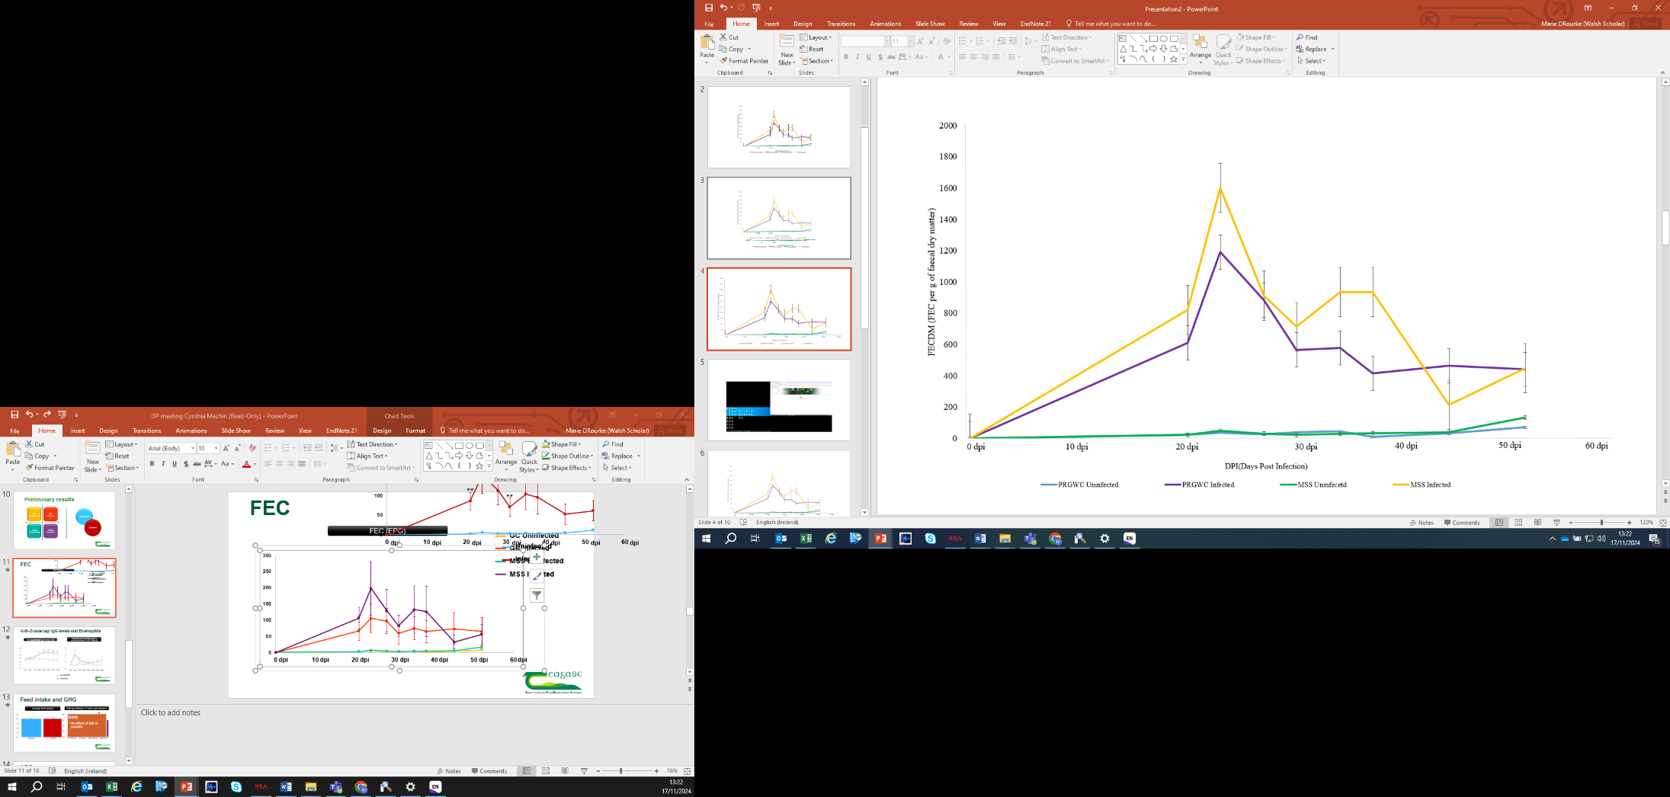

**Figure 1:** Faecal egg count (FEC) per g of dry matter for non-infected and infected cattle, offered MSS and PRGWC.

***References***

Barry, T.N., 1998. The feeding value of chicory (*Cichorium intybus*) for ruminant livestock. *The Journal of Agricultural Science*, *131*(3), pp.251-257.

Cotter, J.L., Van Burgel, A. and Besier, R.B., 2015. Anthelmintic resistance in nematodes of beef cattle in south-west Western Australia. *Veterinary parasitology*, 207(3-4), pp.276-284.

Drennan, M.J. and McGee, M., 2009. Performance of spring-calving beef suckler cows and their progeny to slaughter on intensive and extensive grassland management systems. *Livestock Science*, *120*(1-2), pp.1-12.

Foster, J.G., Clapham, W.M., Belesky, D.P., Labreveux, M., Hall, M.H. and Sanderson, M.A., 2006. Influence of cultivation site on sesquiterpene lactone composition of forage chicory (Cichorium intybus L.). *Journal of agricultural and food chemistry*, *54*(5), pp.1772-1778.

Fox, M.T., 1993. Pathophysiology of infection with *Ostertagia ostertagi* in cattle. *Veterinary parasitology*, *46*(1-4), pp.143-158.

Gibbs, H.C., 1988. The epidemiology of bovine ostertagiasis in the north temperate regions of North America. *Veterinary parasitology*, *27*(1-2), pp.39-47.

Grace, C., Lynch, M.B., Sheridan, H., Lott, S., Fritch, R. and Boland, T.M., 2019. Grazing multispecies swards improves ewe and lamb performance. *Animal*, *13*(8), pp.1721-1729

Hoste, H., Martinez-Ortiz-De-Montellano, C., Manolaraki, F., Brunet, S., Ojeda-Robertos, N., Fourquaux, I., Torres-Acosta, J.F.J. and Sandoval-Castro, C.A., 2012. Direct and indirect effects of bioactive tannin-rich tropical and temperate legumes against nematode infections. *Veterinary parasitology*, *186*(1-2), pp.18-27.

Lange, K.C., Olcott, D.D., Miller, J.E., Mosjidis, J.A., Terrill, T.H., Burke, J.M. and Kearney, M.T., 2006. Effect of sericea lespedeza (Lespedeza cuneata) fed as hay, on natural and experimental Haemonchus contortus infections in lambs. *Veterinary Parasitology*, *141*(3-4), pp.273-278.

Niezen, J.H., Waghorn, G.C., Graham, T., Carter, J.L. and Leathwick, D.M., 2002. The effect of diet fed to lambs on subsequent development of Trichostrongylus colubriformis larvae in vitro and on pasture. *Veterinary Parasitology*, *105*(4), pp.269-283.

O'Donovan, M., Hennessy, D. and Creighton, P., 2021. Ruminant grassland production systems in Ireland. *Irish Journal of Agricultural and Food Research*, *59*(2), pp.225-232.

O'Farrell, K.J., Downey, N.E. and Sherington, J., 1986. The effect of anthelmintic treatment at calving on the subsequent milk production characteristics of dairy cows.

O'Shaughnessy, J., Earley, B., Mee, J.F., Doherty, M.L., Crosson, P., Barrett, D., Prendiville, R., Macrelli, M. and de Waal, T., 2014. Detection of anthelmintic resistance on two Irish beef research farms. *Vet Rec*, *175*(5), p.120.

Pena-Espinoza, M., Thamsborg, S.M., Desrues, O., Hansen, T.V. and Enemark, H.L., 2016. Anthelmintic effects of forage chicory (Cichorium intybus) against gastrointestinal nematode parasites in experimentally infected cattle. *Parasitology*, *143*(10), pp.1279-1293.

Rodriguez, R.A., Grace, C., Lynch, M.B., Sheridan, H., Lott, S. and Boland, T., 2019. 159 The effect of multispecies swards on parasite faecal egg counts of grazing lambs. *Journal of Animal Science*, *97*(Supplement_3), pp.170-170.

Sharma, P., Jenkins, M., Zarlenga, D., Fetterer, R., Xiao, Z. and Tuo, W., 2017. Characterization of Ostertagia ostertagi annexin-like proteins at different developmental stages. *Parasitology research*, *116*, pp.1515-1522.

Woodfield, D.R., Roldan, M.B., Voisey, C.R., Cousins, G.R. and Caradus, J.R., 2019. Improving environmental benefits of white clover through condensed tannin expression. *Journal of New Zealand Grasslands*, pp.195-202.