In vitro evaluation of cereal grains and horsebean as ingredients in compound feeds for ruminants
Alemayehu Kidane, and Egil Prestløkken
Norwegian University of Life Sciences, Ås, Norway [Presenter’s e-mail address Alemayes@nmbu.no]
Application Ongoing efforts to improve feed use efficiency and reduce the environmental burden of ruminant production would benefit from characterisation of locally available feed ingredients.
Introduction Cereal grains and their products constitute a substantial part of livestock feeds in compound feeds. Furthermore, current efforts to substitute soya in compound feeds with locally grown proteins have incentivised the production of pulses/legumes. To this end, the production of horsebean (Vicia faba, L.) has increased by about 4 folds in volume from 2012 to 2020 (FAO, 2022) in Northern Europe. Here, we characterized four major cereal grains (i.e., barley, maize, oats and wheat) and horsebean (Table 1) for fermentation kinetics and organic matter degradation (OMD) using the ANKOM RF wireless gas production system (ANKOM Technology, Macedon, NY, USA).
Materials and methods Gas production was carried out with 1.0 g dry matter of samples (<1.0 mm screen) using 250 mL bottles enriched with 34 mL of rumen fluid (obtained from three rumen canulated standard cows) and 66 mL of buffer solution. The experiment was run twice for 48 h, and in triplicates. After 48 h, pH was recorded, and OMD was estimated from residues. The GP data was fitted to the model of Groot et al. (1996) for calculating asymptotic gas volume (A, mL/ g DM), time in hours to produce 50% of the maximum gas volume (B, h), and a constant related to the shape of the curve (C). All parameters were analysed using Proc GLM in SAS (SAS 9.4 for windows) with significance declared at P<0.05.
Results The ingredients differed in fermentation parameters (Table 1 & Fig 1). Maize achieved the highest gas volume with the lowest endpoint pH and fractional rate of gas production (R_{gp}) relative to others. Conversely, oats achieved the lowest gas volume and OMD accompanied by higher pH. For R_{gp}, the order was oats > barley, wheat > maize and horsebean (Fig. 1b). Oats had the lowest estimated metabolisable energy (ME, MJ/kg DM) value probably due to the higher neutral detergent fibre (NDF) from oat hulls.
Table 1. Chemical composition & fermentation parameters
Chem† | Barley | Maize | Oats | Wheat | Beans | S.E./P‡
CP | 101 | 91.0 | 128 | 158 | 297 | -
NDF | 209 | 93.3 | 360 | 142 | 129 | -
Starch | 542 | 643 | 419 | 571 | 308 | -
Ash | 23.0 | 15.0 | 21.0 | 18.0 | 33.0 | -
Fermentation parameters estimates
A | 310^{b} | 333ª | 221^{b} | 304^{b} | 288^{c} | 6.7/**
B | 9.2^{b} | 12.0ª | 7.1^{c} | 9.4^{b} | 11.6ª | 0.55/**
C | 2.16 | 2.15 | 2.09 | 2.20 | 2.07 | 0.09/ns
pH | 6.17^{c} | 6.01^{d} | 6.43^{b} | 6.10^{c} | 6.53ª | 0.03/**
ME | 9.73^{ab} | 9.60^{ab} | 8.06^{c} | 9.88ª | 10.1ª | 0.10/**
OMD,% | 73.8ª | 74.6ª | 59.6^{b} | 75.2ª | 76.9ª | 0.84/**
†Comp = composition (g/kg DM); CP = crude protein; Beans= Horsebeans; S.E./P‡ = standard error /P-value; ** = P < 0.01; ns = not significant; Means in a row with different superscripts are different at P ≲ 0.05.
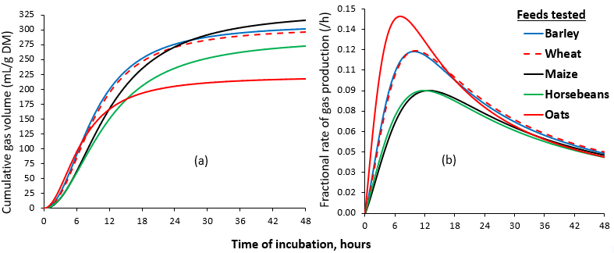Fig 1. Cumulative (a) and fractional rate of (b) gas production

Conclusion The faster R_{gp} of oats may synchronise with the soluble CP from grass silages in the rumen, but oats might restrict ME supply for milk production relative to barley and wheat. The fermentation characteristics of horsebean suggested that it can be a good source of energy in addition to its CP supply.
Acknowledgment This work was partly funded by the Research Council of Norway (NFR; project # 302341).
References: Groot, et al 1996. Anim. Feed Sci. Technol., 64, 77–89. DOI: 10.1016/S0377-8401(96)01012-7
FAO, 2022, Food and Agriculture Organization. http://data.un.org/Data.aspx?d=FAO&f=itemCode%3A181#FAO. accessed on 27.10.2023

