**Application**

Insects serve as bio-factories, converting food waste and by-products into highly nutritious proteins and fatty acids suitable for human consumption. This research explores how specific agri-food by-products affect the nutritional composition of edible insects, aiming to create a sustainable protein source.

**Introduction**

Insects are regarded as a more sustainable source of nutrients, especially protein, compared to traditional livestock. Insects intended for human consumption can be fed on a wide variety of substrates, provided they meet minimum nutritional requirements for protein, energy, minerals, and vitamins. The substrate used can also affect the nutritional composition of the final product, whether whole insects or insect flour. In this study, we fed two edible insect species (*Tenebrio molitor* and *Acheta domesticus*) with food by-products like chicken feather meal, red blood cells, horticulture foliage, potato cuttings, chicory roots, or vegetable mix, with the goal of reintroducing these materials into the food chain. Substrates were selected based on their availability, protein content, and format (wet or dry). Our hypothesis was that altering the diet's composition could potentially manipulate the protein, fat, and mineral content in the resulting insect biomass while minimising food waste and lossess.

**Material and methods**

A wheat bran control diet was used alongside experimental diets. Dry diets were supplemented with protein-rich by-products (e.g., feather meal and dried blood cells up to 20% and 25% inclusion, respectivelly). Wet diets utilized potato peels, fermented chicory roots, vegetable mix, and horticultural foliage, with particles reduced to under 2 mm for mealworms and 0.5 mm for crickets. Each diet was replicated in triplicate per insect species. Harvested insects were dried and processed into flour, then analyzed for protein, fat, ash, fiber, and moisture. Amino acid, fatty acid, and mineral profiles were also assessed.

**Results**

The dietary impact on insect composition varied between Acheta domesticus (crickets) and Tenebrio molitor (mealworms). For crickets, higher dietary protein led to increased body protein and reduced fat content, without affecting dry matter levels. Mealworms showed an increase in dry matter with higher protein diets, but their fat and protein content remained relatively stable, indicating species-specific metabolic responses to protein-rich diets.

Wet diets also influenced composition distinctly. Crickets reared on fermented chicory roots accumulated more fat, while those fed potato cuttings had higher protein content. In mealworms, potato cuttings led to increased lipid levels at the expense of protein, showing an inverse relationship between protein and fat accumulation. Overall, both species displayed a negative correlation between protein content and fat and dry weight, suggesting the possibility of tailoring insect nutrition by substrate selection.

*Table 1: Proximate analysis of crickets and mealworms reared on dry protein-rich side streams. Mean ± Standard Deviation (n=3 independent batches). Different letter indicates significant differences p<0.05*

|  |  |  |  |  |  |
| --- | --- | --- | --- | --- | --- |
| **Substrate** | **Ether extract** | **Crude protein** | **Crude ash** | **Chitin** | **NFCH** |
| **(g/100g DM)** | **(g/100g DM)** | **(g/100g DM** | **(g/100g DM)** | **(g/100g DM)** |
| **Crickets (*Acheta domesticus*)** | | | | | |
| **Control Feather Meal** | 21,8a±2,3 | 51,7d±2,8 | 4,8a±0,1 | 7,2 b±0,6 | 14,5 d±2,4 |
| **Feather Meal 5%** | 21,0a±0,9 | 51,2d±2,5 | 4,9 a ±0,2 | 6,9 b±0,7 | 16,0 c±2,1 |
| **Feather Meal 10%** | 21,1a±0,9 | 51,2d±2,5 | 4,9 a±0,2 | 6,6 b±0,7 | 16,1 c±2,0 |
| **Feather Meal 15%** | 18,7b±3,6 | 57,0c±6,7 | 5,1 a±0,4 | 7,8 a±1,0 | 14,1 d±3,4 |
| **Feather Meal 20%** | 10,7c±0,9 | 54,8c±2,6 | 5,0 a±0,1 | 7,0 b±0,5 | 14,5 d±2,0 |
| **Control Red Cells** | 10,6c±0,4 | 60,5±b0,7 | 5,3 a±0,1 | ND | 23,4 a±0,4 |
| **Red Cells 12.5%** | 10,1c±1,8 | 62,6±a1,7 | 5,2 a±0,2 | ND | 21,6 b±0,7 |
| **Red Cells 25%** | 10,1c±1,1 | 62,5±a1,4 | 5,2 a±0,3 | ND | 22,1 b±1,3 |
| **Mealworms (*Tenebrio molitor*)** | | | | | |
| **Control Feather Meal** | 20,3 a±1,1 | 51,9a±0,2 | 5,0b±0,5 | 7,2a±0,1 | 15,7e±1,5 |
| **Feather Meal 5%** | 18,0 c±0,8 | 53,0a±1,1 | 4,8b±0,1 | 7,2a±0,4 | 17,1d±1,0 |
| **Feather Meal 10%** | 18,7c±1,1 | 51,3a±1,4 | 4,6bc±0,2 | 7,0a±0,2 | 18,4c±1,8 |
| **Feather Meal 15%** | 20,2 b±0,3 | 52,3a±0,7 | 4,3c±0,2 | 7,1a±0,5 | 16,2de±0,9 |
| **Feather Meal 20%** | 18,7c±0,3 | 52,4a±0,6 | 4,8b±0,4 | 7,2a±0,2 | 16,9d±1,4 |
| **Control Red Blood Cells** | 12,9d±1,4 | 53,4a±0,8 | 5,6a±0,3 | ND | 28,2a±0,4 |
| **Red Blood Cells 5%** | 17,7c±1,7 | 50,6a±0,6 | 4,5c±0,1 | ND | 27,3a±1,6 |
| **Red Blood Cells 10%** | 17,7c±5,1 | 50,2ab±3,4 | 4,2c±0,2 | ND | 27,9a±2,0 |
| **Red Blood Cells 15%** | 20,0 b±0,9 | 49,7b±,05 | 3,9d±0,1 | ND | 26,4ab±1,3 |
| **Red Blood Cells 20%** | 22,1a±1,7 | 50,0ab±0,5 | 3,5e±0,1 | ND | 24,4b±1,1 |

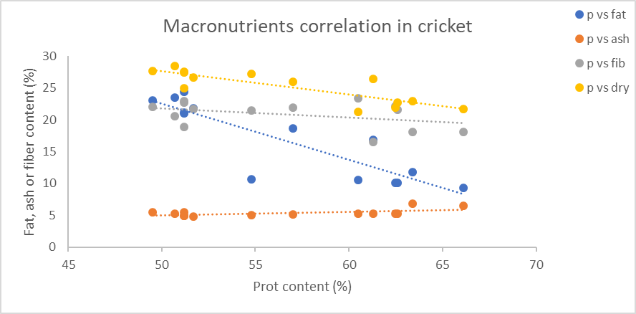

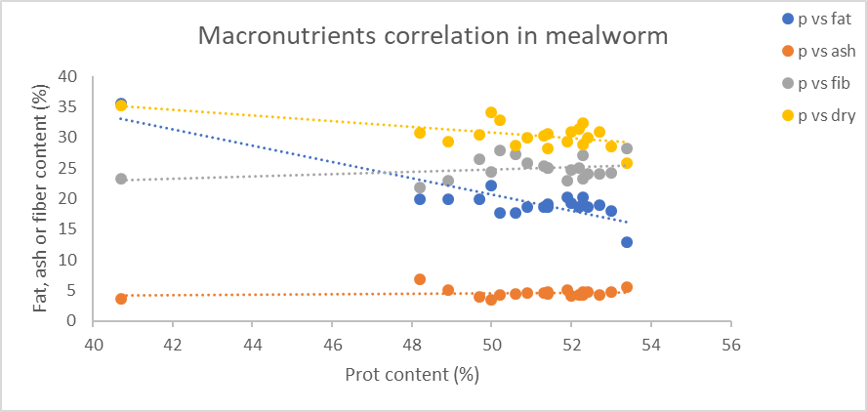

*Figure 1: correlation between protein content and dry matter (yellow), fat (blue), ash (orange) and fibre (grey) in crickets (left) and mealworms (right)*

From a nutritional point of view, Higher-protein diets also modified the fatty acid profile, particularly in mealworms, where increased C18:1 (oleic acid) and decreased C18:2 (linoleic acid) were observed. Crickets did not show a consistent trend in fatty acids across diets. Amino acid profiles remained stable across all diets and substrates, indicating that amino acid composition was less influenced by dietary changes. Finally, it was very interesting to see how both mealworms and crickets were able to accumulate some minerals such as iron, calcium or phosphorus when provided by the diet, i.e. red cells and fermented chicory roots.

**Conclusions**

Food losses and by-products are a suitable source of substrates for insect rearing, with the capacity of manipulate the proximate and the nutritional value of the insect derived products. By using these streams we have the potential of reducing food waste and transform them into valuable nutrients for human consumption.

**Acknowledgements**

This research was funded by the Interreg North–West Europe, ValuSect project.

**References**

Zielińska, E., B. Baraniak, M. Karaś, K. Rybczyńska and A. Jakubczyk (2015). "Selected species of edible insects as a source of nutrient composition." Food Research International **77**: 460-466.

Van Peer, M., Frooninckx, L., Coudron, C., Berrens, S., Álvarez, C., Deruytter, D. & Van Miert, S. (2021). Valorisation potential of using organic side streams as feed for Tenebrio molitor, Acheta domesticus and Locusta migratoria. *Insects*, *12*(9), 796.