**Informativeness of interactions between abundances of *Methanobrevibacter* and microbial genes for microbiome-driven breeding to reduce methane emissions in beef cattle**

**Application:** The use of the genomic interactions between abundances of *Methanobrevibacter* and microbial genes is recommended as further selection criteria to identify informative microbial genes included in microbiome-driven breeding to reduce methane emissions in ruminants.

**Introduction:** The rumen microbiome, which includes bacteria, archaea, protozoa, fungi, and their genes, is influenced by host animal genomics while significantly affecting methane (CH4) emissions (Martínez-Álvaro et al., 2022). Particularly, the substantial genomic informativeness of microbial genes for microbiome-driven breeding to mitigate CH4 has been demonstrated (Roehe et al., 2016). *Methanobrevibacter* is the most abundant hydrogenotrophic methanogen in ruminants. However, to the best of our knowledge, its genomic interactions with ruminal functional microbial genes are not known. Therefore, we estimated the heritabilities (h2) of the abundance of *Methanobrevibacter* and functional microbial genes, the genetic correlations (rg) between each other and with CH4 emissions to understand functional relationships and its usefulness for microbiome-driven breeding to mitigate the potent greenhouse gas.

**Materialsandmethods:** The experiment was conducted following the UK Animals Act 1986 and approved by the Animal Experiment Committee of SRUC. Three hundred sixty-three steers raised under the same housing conditions on the same research farm over five years were used in this project. The animals were balanced for different breeds (Aberdeen Angus, Limousin, Luing, and Charolais crosses) and basal diets (two diets of 480:520 and 80:920 concentrate:forage ratios). Blood samples for host animal and rumen samples for microbial DNA extraction were collected at slaughter. Sequence reads of microbial DNA were aligned to the Kyoto Encyclopedia of Genes and Genomes database, resulting in the identification of 3361 microbial genes. To account for the compositionality of microbiome data, microbial genes abundance data were additive-log-ratio (alr) transformed, whereas *Methanobrevibacter* abundance was centred-log-ratio transformed (clr). CH4 emissions were individually measured on 285 of the 363 animals during 48 h using six indirect open-circuit respiration chambers and expressed as CH4 yield (CH4Y, g CH4 /kg dry matter intake). Multiple genomic bivariate analyses were conducted between CH4Y and *Methanobrevibacter* clr or microbial genes alr abundances; and between those of Methanobrevibacter and microbial genes to obtain h2 and rg.

**Results:** *Methanobrevibacter* dominated the methanogen population, accounting for 93±7.36% of the total abundance of all identified methanogens. Estimated h2 of the abundance of this genus was 0.30 with 95% highest posterior density interval (95%HPD) between 0.16 to 0.49; and was positively genomically correlated to CH4Y at rg=0.21 (95%HPD -0.23 to 0.57, and probability of being positive (Pr0) at 0.81). The h2 of the abundance of microbial genes ranged from 0.16 to 0.42 (Figure 1) with 14% greater or equal than that of *Methanobrevibacter* (0.30). Their rg with CH4Y ranged from -0.37 (95%HPD -0.68,0.01) to 0.43 (95%HPD 0.05,0.73).

Of the microbial genes, we selected based on their estimated genetic parameters 500 each with highest predicted positive or negative correlated response with CH4Y to explore their genetic correlations with *Methanobrevibacter.* Some of these microbial genes exhibited strong genetic correlations with *Methanobrevibacter*, ranging from ‑0.49 to 0.69, with 53 microbial genes showing rg≥0.40 (Pr0>0.96) and 18 microbial genes showing rg≤‑0.40 (Pr0>0.97) (Figure 2).

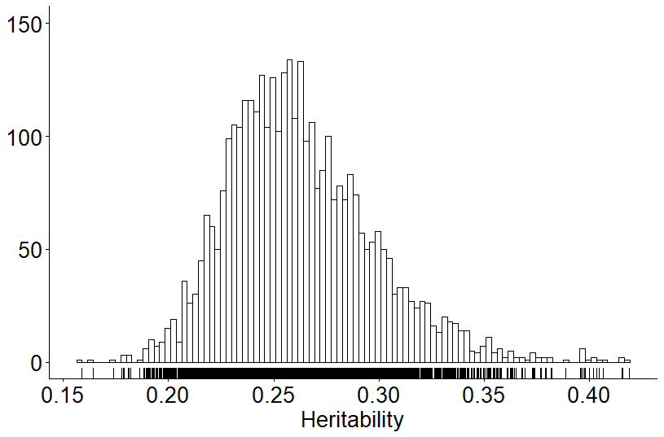The function microbial genes of informative magnitude negatively genomically correlated to both the abundances of *Methanobrevibacter* and CH4 emissions were *pepT* (K01258), *pflD* (K00656) and *pgm* (K07126) involved in metabolism of protein, propionate, and glycolysis, respectively. Whereas those positive genomically correlated were *atpK* (K02124), *oorD* (K00176) and *bcrC* (K19302) involved in oxidative phosphorylation, carbon fixation, and lipid metabolism, respectively.

**Figure 1:** Distribution of heritabilities of 3361 functional microbial genes estimated as posterior medians.

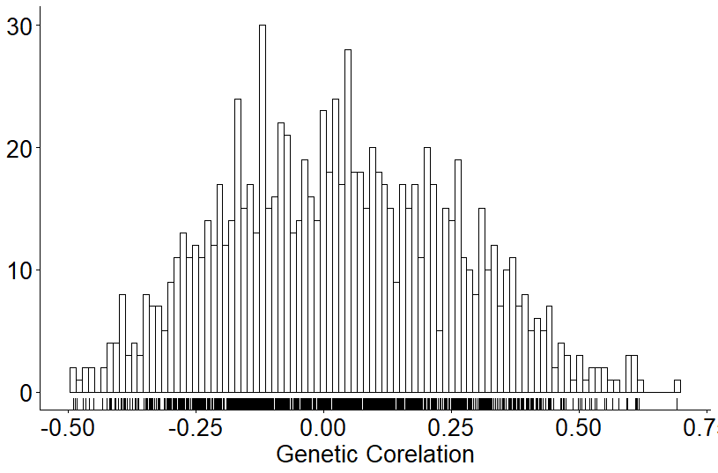**Figure 2:** Distribution of genetic correlations between abundances of *Methanobrevibacter* and microbial genes using bivariate analyses.

**Conclusion:** Abundances of some of microbial genes and *Methanobrevibacter* were identified to be animal genomically influenced and resulted in substantial host genetic correlations with CH4 emissions and among each other. Microbial genes that correlated with both CH4 emissions and *Methanobrevibacter,* such as *pepT* (K01258), *pflD* (K00656) and *pgm* (K07126), are recommended to be selected as informative traits within the microbiome-driven breeding strategy to reduce CH4 emissions.

**Acknowledgements:** This Innovate UK project was funded by Defra, UKRI Transforming Food Production Challenge, and Genus plc. This research is based on data generated from experiments funded by the Scottish Government, BBSRC (BB/N01720X/1, BB/N016742/1, BB/S006567/1, and BB/S006680/1), AHDB, and QMS.

**References:** Martínez-Álvaro, M. et al. (2022). Communications Biology, 5(1), 350.

Roehe, R. et al. (2016). PLOS Genetics, 12 (2), e1005846.