**Effect of Injectable Trace Mineral Supplementation on Transition Health, Antioxidant and Trace Mineral Status in Dairy Cows**

**Application**

Injectable trace mineral supplementation pre-calving enhances antioxidant levels in dairy cows, potentially improving animal health, fertility and farm sustainability.

**Introduction**

The transition period, which extends from 3 weeks before to 3 weeks after parturition, is marked by a decrease in dry matter intake, high incidences of metabolic and infectious diseases, inflammation, immune dysregulation, and oxidative stress (Abuelo et al., 2019). Trace minerals are essential in dairy cows' metabolism, supporting immune and reproductive function, hormone synthesis, and energy and protein metabolism. Copper (Cu), zinc (Zn), manganese (Mn), and selenium (Se) are crucial components of metalloenzymes that assist in free radical detoxification and chromium (Cr) plays role in insulin function and stress mitigation. Injectable trace mineral supplementation (ITMS) is used as nutritional tool to improve mineral status of cattle prior to challenging events such as calving (Arthington and Ranches, 2021). The study hypothesized that pre-calving ITMS would enhance antioxidant status and improve the status of biomarkers of negative energy balance (NEB) and plasma trace minerals in multiparous dairy cows and heifers. The objective was to assess ITMS effects on plasma non-esterified fatty acid (NEFA), plasma beta-hydroxybutyric acid (BHBA), serum haptoglobin, erythrocyte glutathione peroxidase (GPx), and plasma trace minerals.

**Materials and Methods**

Fifty-five Holstein Friesian cows (41 multiparous and 14 heifers) were enrolled in a study at the University of Melbourne dairy farm, Dookie Campus, Southeastern Australia. The cows were stratified by body condition score and parity into two groups. During the dry-off period, they were fed cereal hay and pelleted feed, and after calving, they received a pelleted concentrate feed during milking alongside pasture grazing, without additional mineral supplements. Sixty days before expected calving, cows in the treatment group (ITMS) received a subcutaneous injection of trace mineral solution (Multimin Chrome, Virbac Australia; 1 mL/75 kg body weight for heifers under 2 years and 1 mL/100 kg for cows), while the control group (CNTRL) received an equal volume of isotonic saline. Blood samples were collected 60- and 21-days pre-calving and 7- and 14-days post-calving. Data were analysed using R v.4.3.2 with linear mixed-effects models. Baseline values from the first sampling were used as covariates, with group, sampling day, and parity as fixed effects, and animal ID as a random effect. Estimated marginal means (EMMs) were calculated for all factors and interactions, with pairwise comparisons conducted without multiple comparison adjustments. Trace mineral status was compared between 60 days pre-calving and 14 days post-calving.

**Results**

Plasma NEFA concentration was lower in the ITMS compared to the CNTRL group (p < 0.01). No significant differences were observed between treatment groups across different sampling days in multiparous cows. However, in heifers, NEFA concentration was lower in the ITMS compared to the CNTRL group with a tendency of lower NEFA 7 days after calving (p = 0.083) and significantly lower values at 14 days after calving (p < 0.05). Plasma BHBA concentration was unaffected by treatment overall, but the multiparous cows of the ITMS group exhibited a marked decline in BHBA on day 7 after calving (p = 0.018) with a trend towards a reduction on day 14 after calving (p = 0.063). Plasma BHBA was unaffected for heifers between the treatment groups across different sampling days. Erythrocyte GPx activity was significantly increased by ITMS (p < 0.0001). In multiparous cows, GPx was significantly higher in the ITMS than the CNTRL group at 14 days after calving (p < 0.001). In heifers, GPx was higher in the ITMS group on 21 days before calving, and 7 and 14 days after calving. Serum haptoglobin concentration was not affected by treatment overall, although it was higher in multiparous cows in the ITMS group 7 days after calving. No appreciable variation in haptoglobin was observed in heifers between the ITMS and the CNTRL group across different days of sampling. Overall, plasma Se concentration was higher in the ITMS compared to the CNTRL group (p < 0.05). Injectable trace mineral supplementation was found to significantly elevate Se 14 days after calving in both multiparous cows and heifers (p < 0.05 for both). Concentration of Cu, Zn and Mn in plasma was not affected by treatment.

**Conclusions**

Pre-calving ITMS improved the post-partum metabolic and antioxidant profile of transition cows. Treatment reduced overall NEFA concentrations with a significant post-partum reduction in heifers, decreased post-partum BHBA concentrations in multiparous cows, increased Se concentrations and enhanced erythrocyte GPx activity thereby improving the antioxidant status. This reduction in NEFA and BHBA and improvement in the antioxidant status may lead to improved health, production and fertility outcomes.

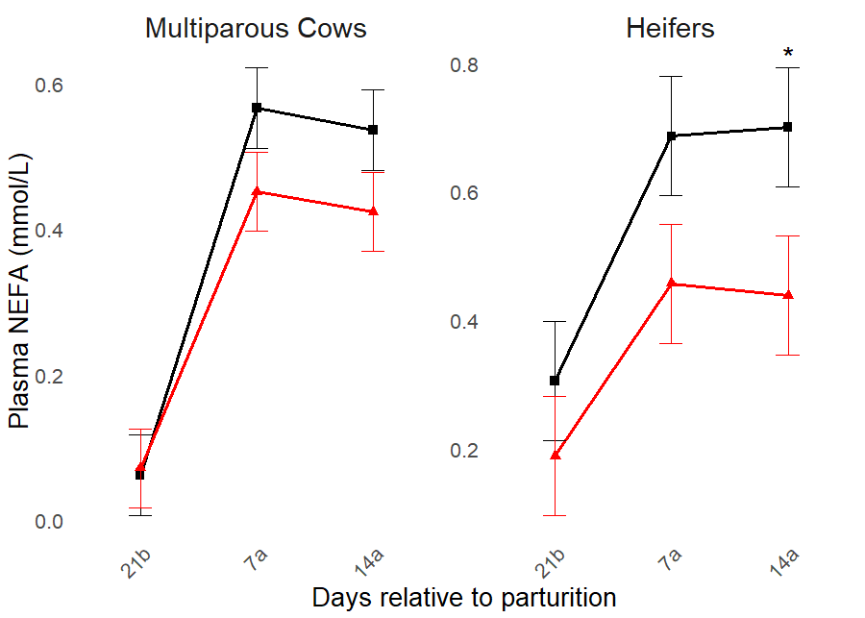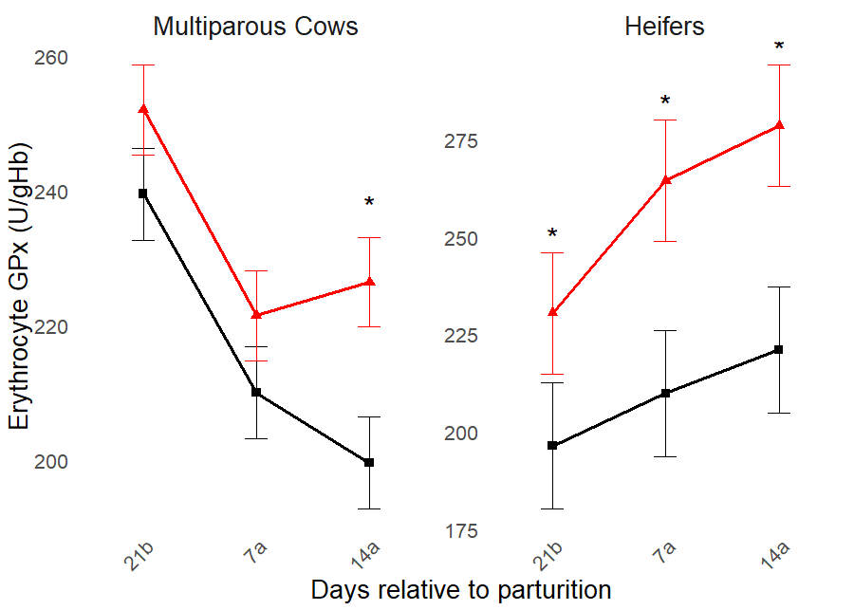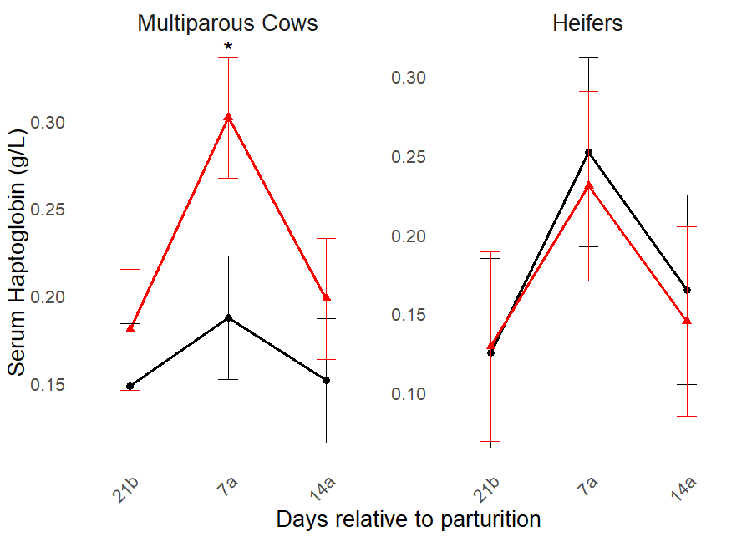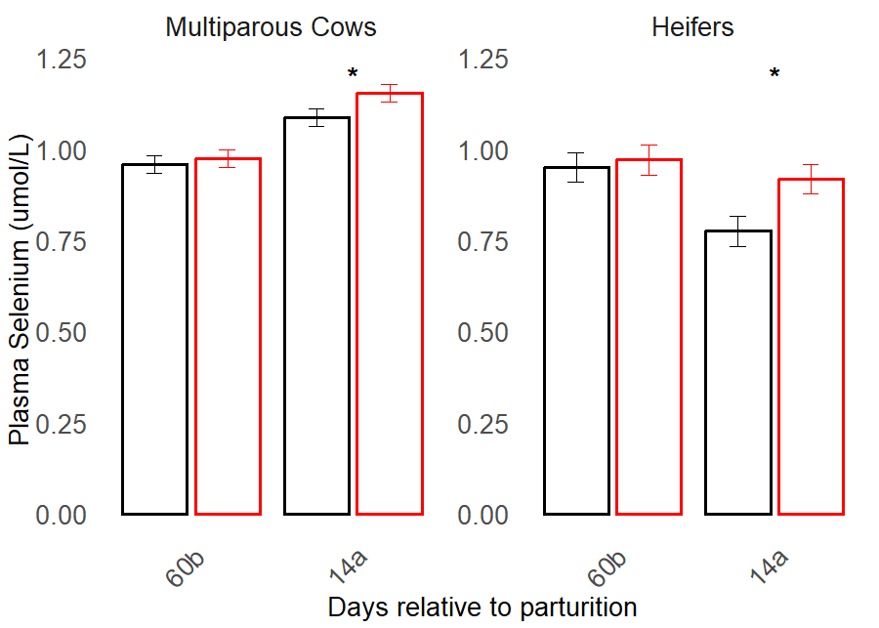

**Figure: Effect of treatment on plasma NEFA, plasma BHBA, erythrocyte GPx, serum haptoglobin and plasma Se concentrations**; red lines/bars show estimated marginal means (±SE) for cows treated with injectable trace minerals (ITMS) at dry-off, while black lines/bars represent control group (CNTRL); an asterisk (*) indicates p < 0.05. X- axis scale labels: 60b – 60 days pre-partum, 21b – 21 days pre-partum, 7a – 7 days post-partum and 14a – 14 days post-partum.

**Acknowledgements**

The authors acknowledge the funding from Virbac Australia Pty Ltd and University of Melbourne.

**References**

Abuelo, A., Hernández, J., Benedito, J. L., and Castillo, C, (2019). Redox biology in transition periods of dairy cattle: Role in the health of periparturient and neonatal animals. Antioxidants, 8(20).

Arthington, J. D., Ranches, J. (2021). Trace Mineral Nutrition of Grazing Beef Cattle. Animals, 11(10).