Application
Using low emission slurry spreading (LESS) equipment provides the simultaneous benefits of reducing the amount of ammonia emitted to the local atmosphere, which protects both human and sensitive habitat health, whilst increasing the amount of nitrogen available to the plants and thereby reducing additional fertiliser costs to the farmer.

Introduction
Gaseous ammonia (NH₃) negatively impacts both human and environmental health (Wyer et al., 2022). Agriculture is responsible for about 90% of NH₃ emissions on the island of Ireland, with over a third arising from the landspreading of cattle slurry (Bourdin et al., 2014). Whilst slurry is used as the main source of fertiliser, thus necessitating landspreading of slurry, the traditional spreading method involves a splashplate attachment to broadcast slurry, which encourages NH₃ volatilisation. It has been shown in several countries that LESS technologies reduce the NH₃ emissions from slurry spreading by depositing slurry closer to the ground and reducing the surface area of spread slurry, which minimises contact with ambient air (Nyameasem et al., 2022). However, the efficacy of different LESS technologies on NH₃ emission reduction is uncertain under Irish conditions. Therefore, the aim of this study was to investigate the ability of three different LESS techniques to reduce NH₃ emissions compared to splashplate on Irish soils.

Material and methods
Six paddock-scale plots (50 m x 50 m) were spread with cattle slurry at each of two permanent grassland sites, Loughgall in Northern Ireland and Johnstown Castle in Ireland. Loughgall has sandy clay loam soil and Johnstown Castle has loamy soil; the soil at these sites is representative of that found at a large proportion of grassland fields across the island of Ireland. Two of the plots at each site were spread by splashplate and two by trailing shoe. The other two plots at Loughgall were spread by trailing hose (dribble-bar) and the other two at Johnstown Castle were spread by open-slot injection. These trials were run for two years, with three applications at each site per year. The NH₃ emissions were monitored using integrated horizontal flux (IHF) shuttles for at least five days following each spreading event. Emission factors were calculated as the background-corrected cumulative NH₃ emissions for each trial divided by the total ammoniacal nitrogen (TAN) applied as slurry to each plot at the beginning of a trial. Linear mixed effects models were used to test for differences in TAN loss between slurry spreading techniques and spreading seasons.

Results
NH₃ emissions tended to peak on the day of spreading, with an average of 64% of NH₃ loss measured within 6 hours of spreading, and emissions then decreased exponentially to background emissions within five days. Mostly, the emissions were lower during spring (March/April) trials, when temperatures were cooler and plants were growing rapidly, and highest in late summer (August). However, splashplate-spread plots at Loughgall had the lowest emission factors in late summer in both years, when the ground was very dry. Due to the variability in NH₃ emissions from spreading techniques (Figure 1) and between years, the season slurry was spread did not significantly affect the NH₃ emissions (p > 0.05). At both sites, NH₃ emission factors were significantly higher from splashplate plots than from slurry spread by LESS techniques (F₂,₂₈ = 7.87; p < 0.01 for Johnstown Castle, F₂,₂₄ = 20.4; p < 0.01 for Loughgall; Figure 1). Despite reducing TAN loss by 37% on average compared to splashplate, there were no significant differences between the LESS techniques (p > 0.05; Figure 1).
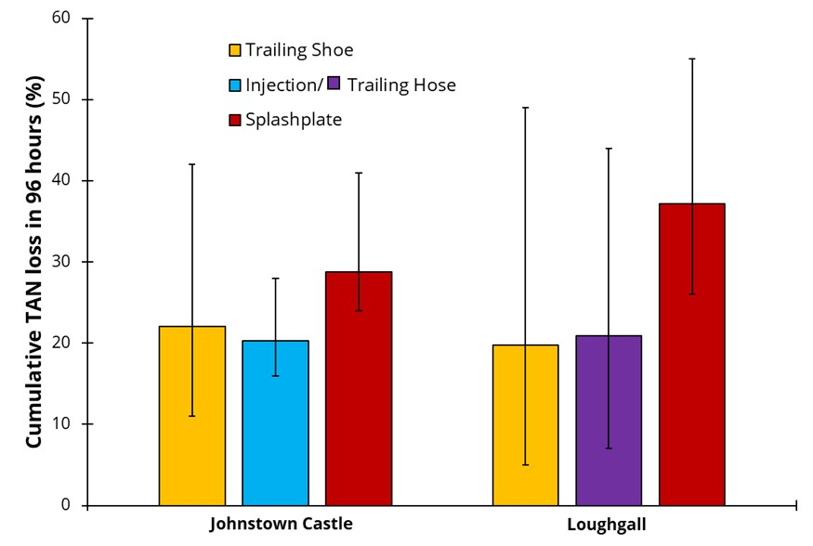
Figure 1: Mean (± standard deviation) percentage of total ammoniacal nitrogen (TAN) lost over five days from the slurry applied by splashplate and by three forms of LESS equipment.

Conclusions
On average, the LESS techniques do lower NH₃ emissions from Irish soils. However, contrary to that demonstrated in previous research in other countries, there is very little difference between LESS techniques and so there should be a focus on encouraging farmers and contractors on the island of Ireland to use any LESS equipment, rather than specifically pushing the more expensive form, as this may increase uptake.

Acknowledgements
This research was financially supported by the Irish Department of Agriculture, Food and Marine (grant number 2019R554) and the Northern Irish Department of Agriculture, Environment and Rural Affairs (grant number 19/4/16).

References
Bourdin, F., Sakrabani, R., Kibblewhite, M., & Lanigan, G. 2014. Agriculture, Ecosystems & Environment, 188, 122-133.
Nyameasem, J., Zutz, M., Kluβ, C., ten Huf, M., Essich, C., Buchen-Tschiskale, C., Ruser, R., Flessa, H., Olfs, H-W.. Taube, F., & Reinsch, T. 2022. Environmental Pollution, 315, 120302.
Wyer, K., Kelleghan, D., Blanes-Vidal, V., Schauberger, G., & Curran, T. 2022. Journal of Environmental Management, 323, 116285.

