**Application**: Crating sows for 4 days post-farrowing reduced piglet mortality by approximately 4% compared with sows housed loose in the pen, resulting in an extra 0.6 piglets weaned per litter.

**Introduction**: There is growing pressure to remove crates and cages from animal production to improve welfare and this includes the farrowing crate, originally designed to protect piglets from sow overlying. There is concern within the pig industry that removal of the farrowing crate may result in an increase in piglet mortality therefore reducing uptake (King et al., 2019). Temporary crating may provide an agreeable compromise by protecting piglets at their most vulnerable during farrowing and early lactation, whilst providing freedom of movement for the sow during the remainder of the lactation period. The aim of this study was to determine the effect of different temporary crating lengths on piglet mortality and sow lactation performance.

**Materials and Methods**: Ethical approval for this study was granted by the University of Leeds Animal Welfare and Ethical Review Body. This study used a total of 500 sows and their litters (8229 piglets) over 14 batches at the National Pig Centre, Leeds, UK. Sows were allocated to one of three treatment groups 1) loose housed across farrowing and lactation (n=167), 2) crated *ca* 24h before farrowing + 2 days of lactation (n=166), 3) crated *ca* 24h before farrowing + 4 days of lactation (n=167). Sows were housed in fully slatted farrowing pens (JFL15, JYDEN, Denmark; 2.4x2.4m). Piglets were weighed and ear tagged for identification within 24 hours of birth, at an average day 7 (week 1) and at weaning (approx. 28d). All piglet pre-weaning mortality including cause and date of death was recorded. Data were analysed in SPSS Statistics 29 using the general linear model function with treatment, parity and room (nested within batch) as factors. Covariates (e.g. piglet age, litter size) were included for each model and removed in a step wise basis where not significant. Data are presented as estimated marginal means. Bonferroni *post-hoc* tests were used to identify differences between means.

**Results:** Pre-weaning mortality was highest for loose housed sows (Figure 1). Piglets that died were younger (P<0.001) and of a lower body weight (P=0.008) on average for the loose sows (3.99 days, 1.48kg) than those that were crated for either two (5.14 days, 1.51kg) or four days (7.00 days, 1.72kg).

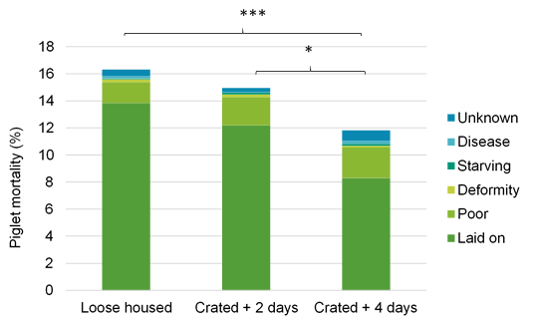

**Figure 1**: Piglet mortality (%) for litters of sows that were loose housed, or crated approximately 24h before farrowing and for either two days or four days of lactation. Colours within each bar represent the cause of death.

Sows crated for four days after farrowing weaned larger litters than those that were crated for two days or those housed loose, however the litter was *ca* 3kg lighter at weaning (Table 1). No interactions between parity and treatment were observed but there was a significant effect of parity throughout (P<0.001).

**Table 1**: Lactation performance of sows. a-b different superscript letters denote differences between means (P<0.05). Significant values (P<0.05) and trends (P<0.10) are shown in bold.

|  |  |  |  |  |  |
| --- | --- | --- | --- | --- | --- |
|  |  |  |  |  | P value |
|  | Loose  (n = 167) | Crated + 2 days  (n = 166) | Crated + 4 days (n =167) | SEM | Treatment | |
| Total born sum (kg)A | 24.7 | 24.7 | 24.8 | 0.230 | 0.855 | |
| Total born average (kg)A | 1.42 | 1.42 | 1.43 | 0.013 | 0.925 | |
| Born alive sum (kg)A | 23.3 | 23.3 | 23.4 | 0.223 | 0.885 | |
| Born alive average (kg)A | 1.44 | 1.43 | 1.44 | 0.014 | 0.891 | |
| Week 1 sum (kg)C | 38.3 | 37.6 | 37.1 | 0.409 | 0.095 | |
| Week 1 average (kg)C | 2.82a | 2.75ab | 2.72b | 0.029 | **0.042** | |
| Week 1 average daily gain (g/d)C | 0.194a | 0.187ab | 0.181b | 0.003 | **0.003** | |
| Wean sum (kg)D | 115.8a | 115.2a | 112.9b | 0.705 | **0.009** | |
| Wean average (kg)D | 8.63a | 8.62ab | 8.49b | 0.050 | 0.073 | |
| Wean average daily gain (g/d)E | 0.288 | 0.288 | 0.283 | 0.002 | 0.145 | |
| Number weaned F | 13.1a | 13.4a | 13.7b | 0.128 | **0.001** | |

A controlling for number born, B controlling for number born alive, C controlling for number of pigs and piglet age,   
D controlling for number weaned and week 1 weight, E controlling for number weaned, wean age and week 1 weight,   
F controlling for weaning age

**Conclusion**: Restricting the movement of sows in the early lactation period reduced pre-weaning mortality compared to those allowed to farrow and lactate freely within the pen. Analysis of the effects of housing on sow stress and behaviour are on-going and required to support management decisions.

**Acknowledgements:** Funding received from the Michael Beverly Innovation Fellowship and Research England.

**References:** King RL, Baxter EM, Matheson SM, Edwards SA, 2019. Animal 13, 189-197